GOVERNMENT OF KHYBER PAKHTUNKHWA

FOOD DEPARTMENT

PC-I FOR

ESTABLISHMENT OF DISTRICT LEVEL FOOD DEPARTMENT OFFICES IN MERGED AREAS

E/ COST Rs. 33.609 Million

ADP COST Rs. 30.000 Million

Approved COST Rs. 16.013 Million

ADP No: 419/190336

September, 2019

PROJECT DETAILS
- Name of Project: | Establishment of District level Food Department office in Merged Districts
- Location | The seven merged districts in Khyber Pakhtunkhwa
- Authorities responsible for:
- Sponsoring: | Food Department Government of Khyber Pakhtunkhwa
- Execution: | Food Department Government of Khyber Pakhtunkhwa
- Operation & Maintenance: | Food Department Government of Khyber Pakhtunkhwa
- a. Plan Provision:
- If the project is included in medium term/Five Year Plan, specify actual allocation. | The Project is included in short-term plan; an amount of Rs. 30.000 million has been allocated.
- If the project is not in the plan, what warrants its inclusion in the plan and how is it now proposed to be accommodated. | N/A
- If the project is proposed to be financed out of block provision, indicate: | N/A
b. Provision in the current year PSDP/ADP | Funds to the tune of Rs. 9.964 Million have been allocated in ADP 2019-20
- Project Objectives
- Sector/ sub-sector objectives | The Sector objectives reflected in Ten Years Plan for Merged Districts are as under:  Food Department Khyber Pakhtunkhwa, after merger, needs to extend its facilities to these merged areas/districts. Infrastructures will be developed for storage of wheat by constructing godowns at each district along-with offices establishment for district formations.  The TDS is a general strategy paper for intervention of line Department in erstwhile FATA. Therefore, Food Department shall also extend its operation in these merged districts under Section-A.1 “Governance & Protection of rights”. One of the core four functions/objectives of the Department as reflected in Rules of Business, 1985 is “Price Checking of Food items”.
- Project Objectives aligned with Sector Objectives, MDGs & Women Empowerment | The purpose of the project is to extend Food Department’s operations & activities to the newly merged districts. However, the following objectives/outputs would directly be achieved:  - Establishment of Food Department’s field offices in rented buildings in seven merged districts  - Purchase of vehicles for field officers and the required furniture & IT equipment etc.  Yes, the project objectives are aligned with sector objectives as it enables to intervene in the newly merged districts for the purpose of price checking of Food items and will significantly contribute to the incumbent Government’s goals of bringing better governance, transparency, service delivery to create easiness for masses and to establish Government writ in these districts.

- Description & Justification of Project
- Background/ Rationale
The merger of the Erstwhile FATA with the Province of Khyber Pakhtunkhwa opened a pathway for the Provincial Departments/Authorities to intervene & start their operations over there. Since, Food Department is not operationalized in these merged areas therefore, its presence in these districts is essential to establish Govt: writ in-terms of Food Securities.
Operationalization of Food Department in Merged Districts needs proper housing facilities along-with other requirements i.e. vehicles, furniture & IT equipment to be provided so as to ensure working environment.
The PC-I costing to Rs. 33.609 million was submitted to the Finance Department for clearance of the revenue components consisting of purchase of vehicles, furniture & IT equipment as well as the required operational expenses & to accord concurrence. The Finance Department accorded concurrence, attached at Annex-V to the tune of Rs. 16.013 million, indicates that funds estimated for purchase of furniture, IT equipment as well as for the staff salaries/allowances have not been curtailed while the request regarding the purchase of vehicles is regretted whereas, funds required for the operational expenses are squeezed to Rs. 7.545 million from Rs. 10.791 million.
In light of the said concurrence of the Finance Department, cost of the PC-I is restricted to Rs. 16.013 million and amended accordingly.
- Description/ Justification with desegregated data
The project aims to extend Food Department’s operations to the Merged Areas by producing the required office accommodation through rented buildings, vehicles for fields’ visits/ market inspections and the required furniture & IT equipment etc.. The project bears the operational cost i.e. office rent, utilities, POL etc. until the Admin complexes at District Headquarters are constructed and funds for operational expenses are sanctioned in the current budget.
Presently, Food Department neither holds any building for accommodation of its field staff nor operationalized in the merged districts for carrying out its core activities i.e. checking of food items, market inspections, wheat procurement & disbursement and wheat grains storage etc. The entry of Food Department in these districts would facilitate a number of 51,22,246 individuals both male & female in-terms of fair prices of various food items.
- Technical Parameters
Food Department deputes field officers in each district to carry out the following core activities as per Khyber Pakhtunkhwa “Rules of Business”-1985:
- Procurement, Storage and Distribution of Wheat
- Prices checking of Food Items
Initially, officials will be housed in rented buildings for a period of three years until Admin Complexes at District Headquarters are constructed by the Directorate of Projects P&D Department Khyber Pakhtunkhwa. Organogram of the district set-up is attaché vide Annex-
- Scope of the Project
The required staff will be recruited on permanent basis through standing procedures: their salaries etc. will be covered under current budget. However, the following assets will be produced under the project.
S. No | Components | Unit | Quantity
1 | Furniture | No | as classified at page-11
2 | IT equipment | No | as classified at page-12

- Capital Cost Estimates

7 (a). Abstract of Cost
S. No. | Description/Component | Cost (Rs. in Million) | Annexures
1 | Operational expenses | Rs. 7.545 | I
2 | Furniture | Rs. 3.533 | II
3 | IT equipment | Rs. 4.200 | III
4 | Project Staff Cost | Rs. 0.735 | IV
Total |  | Rs. 16.013

- Indicate date of estimation of project cost September, 2019
- Basis of determining the capital cost be provided. It includes market survey, schedule rates, estimation on the basis of previous work done etc.
Market Survey/ Previous work done
- Provide year-wise estimation of Physical activities by main components as per following:
7(b). Component-wise, year-wise physical phasing
S. No. | Item/ Description | Unit | Yr-1 | Yr-2 | Yr-3 | Total
1 | Operational expenses | %age | 22% | 38% | 40% | 100%
3 | Furniture | %age | 100% | - | - | 100%
4 | IT equipment | %age | 100% | - | - | 100%

- Capital cost be worked out on the basis of each item of work as stated above and provide information as per following.
7(c). Year-wise/component-wise financial phasing (Rs. in Million)
S. No | Item/ Description | Year-1 |  |  | Year-2 |  |  | Year-3 |  |  | Total
 |  | Total | Local | FEC | Total | Local | FEC | Total | Local | FEC | Total | Local | FEC
1 | Operational expenses | 1.662 | 1.662 | - | 2.841 | 2.841 | - | 3.042 | 3.042 | - | 7.545 | 7.545 | -
3 | Furniture | 3.533 | 3.533 | - | - | - | - | - | - | - | 3.533 | 3.533 | -
4 | IT equipment | 4.200 | 4.200 | - | - | - | - | - | - | - | 4.200 | 4.200
5 | Project Staff Cost | 0.435 | 0.435 | - | 0.300 | 0.300 | - | - | - | - | 0.735 | 0.735 | -
Total |  | 9.820 | 9.820 | - | 3.141 | 3.141 | - | 3.052 | 3.052 | - | 16.013 | 16.013 | -

- Annual Operating Cost
The operating cost after completion of the project will be borne by the Provincial Government through current budget.
- Demand and supply analysis
Currently, there is no space, vehicles, furniture & IT equipment available in the newly merged districts for the field staff.
- Financial Plan and mode of Financing
The project will be financed through merged districts ADP. Funds to the tune of Rs. 30.000 million have been sanctioned in ADP 2019-20 with allocation of Rs. 9.964 million.
- (a) Project benefits and analysis
- Financial/ Economic N/A
- Social
The project equips the target group i.e. Food Department’s field staff in-terms of office accommodation, vehicles, furniture & IT equipment etc. whom will be deputed in the NMDs.
- Environmental
It is envisaged that the project will have no adverse impact on the environment.

(b) Project analysis

- Quantifiable output of the project
The following results will be achieved from the project.
    - Seven nos. of rented buildings (3 to 4 rooms) for the district staff
    - The required quantity of furniture & IT equipment
- Employment Generation (Direct & Indirect)
The project doesn’t generate any direct employment opportunities during implementation as well as after completion.
- Impact of delays on project cost & viability
Timely procurement of the required tools i.e. furniture & IT equipment can escape the Government from the future inflated rates of these items.
- (a) Implementation Schedule
S. No | Activity/Description | 2019-20 |  |  |  |  |  |  |  | 2020-21 | 2021-22
 |  | AUG | SEP | OCT | NOV | DEC | JAN | FEB to JUNE
1 | Preparation of PC-I
2 | Scrutiny of PC-I by P&D Deptt: and Concurrence/clearance of F.D for revenue components
3 | Approval of PC-I by the competent forum & issuance of administrative approval
4 | Recruitment of Internees
5 | Advertisement, purchase of furniture & IT equipment etc.
6 | Hiring of rented buildings (3 to 4 rooms)
7 | Fulfillment of operational expenses

(b) Result Based Monitoring (RBM) Indicators
        - Indicate Result Based Monitoring (RBM) framework indicators in quantifiable terms in the following table.

S. No | Input | Output | Outcome |  | Targeted Impact
 |  |  | Baseline Indicator | Target at Completion of Project
1 | Human & Financial resources | - Hired rented buildings in the seven merged districts  - Purchased the required nos. of furniture & IT equipment | Food Department is not operational in the NMDs | Equipment of Food Department in the NMDs in-terms of provision of office accommodation, furniture & IT equipment | Field formation of Food Deptt: in merged districts enabled to carry out their routine business activities

- Management structure and manpower requirements
- Management Structure
The project will be executed by the Food Department under the supervision of Project Director: additional charge will be assigned to one of the existing officers of BS-19. The Secretary Food would be the sanctioning authority for each financial transaction. The required management structure is classified as under:

Organogram
Secretary Food

  - Manpower requirements
The following Human Resources are required to implement the project efficiently & effectively:
- Project Director
- AD (F&P)
- Accountant
- Internees
The posts of Project Director, AD (F&P) and Accountant will be filled through assigning additional charge to the existing staff of Food Department/Directorate. Project allowance @20% against their basic pay will be paid to them for a period of 6 months only. However; no fresh recruitment would be required except internees who will be hired from market under the Provincial Internship Policy, 2018.
- Project Director- Additional charge will be assigned to any existing officer of BS-19 of Food Department/Directorate.
- Assistant Director (F&P) – The post will be filled through assigning additional charge to one of the existing suitable officer of BS-17.
- Accountant- A project accountant is also required to execute financial transactions; additional charge will be dispensed to the existing accountant working in Secretary Food Office.
- Internee- Two internees are required to assist in procurement of goods & services, file work and preserve office record.

Required experience & Qualification
S. No | Description of Post | Remarks
1 | Project Director | Post will be filled by assigning additional charge to any existing officer of rank-19
2 | Assistant Director (F&P) | Additional charge will be assigned to one of the existing officer BS-17 of Food Department/ Directorate holding relevant expertise and qualification
3 | Project Accountant | Additional charge will be assigned to the existing accountant of Food Department
4 | Internees | Graduates or postgraduates 16 years of education- at least one of the both must have studied Procurement as a subject

- Additional Decisions Required
In addition, the following things shall also be taken into consideration:
- Project will be extended beyond June, 2022 if the Admin Complexes in the District Headquarters are not constructed by that time.
- Arrival of permanent staff shall be ensured till June, 2020.

- Certificate

Certified that the project proposal has been prepared on the basis of instructions provided by the Planning Commission for the preparation of PC-I for Social Sector projects

Prepared by __________________________
(Muhammad Kamran)
Planning Officer,
Food Department
091-9225377

Checked by _______________________
(Mian Abdul Qadir Shah) Director Food,
Khyber Pakhtunkhwa
091-9225378

Recommended by _______________________
(Mr. Nisar Ahmad) Secretary Food,
Khyber Pakhtunkhwa
091-9225373

Approved by ________________________

Details of Operating Cost
Item Name | Unit Cost | Cost for 2019-20 | Cost for 2020-21 | Cost for 2021-22 | Total Cost
Rent of office Buildings | 25000/month | 1,050,000/- | 2,100,000/- | 2,415,000/- | 5,565,000/-
POL Charges | 100 Ltr/ month | 200,000/- | 200,000/- | 100,000/- | 500,000/-
Utilities (Electricity/Gas/LPG) | Lump sum | 150,000/- | 300,000/- | 300,000/- | 750,000/-
Stationary Charges | Lump sum | 70,000/- | 140,000/- | 140,000/- | 350,000/-
Postage & Telegraph | Lump sum | 7,000/- | 11,000/- | 12,000/- | 30,000/-
TA/DA | Lump sum | 50,000/- | 50,000/- | 50,000/- | 150,000/-
Advertisement & Publicity | Lump sum | 100,000/- | 0 | 0 | 100,000/-
Conveyance Charges | Lump sum | 15,000/- | 20,000/- | 15,000/- | 50,000/-
Contingencies/Others | Lump sum | 20,000/- | 20,000/- | 10,000/- | 50,000/-
Grand Total |  | 1,662,000/- | 2,841,000/- | 3,042,000/- | 7,545,000/-
Say in Million |  | 1.662 | 2.841 | 3.042 | 7.545
Annexure-I

Annexure-II

Details of Furniture & Fixture
Item Name | Description as per Pak German | Quantity (for 07 NMDs) | Unit Cost (in PKR) | Total Cost (in PKR)
Office Tables (officer) | M. No. 1.10 A | 01*7=07 | 23,650/- | 165,550/-
Revolving Chairs | M. No. 1.872 | 01*7=07 | 16,200/- | 113,400/-
Cupboard (Glass) | M. No. 1.32 | 01*7=07 | 13,450/- | 94,150/-
Small Table (Long) | M. No. 2.53 | 01*7=07 | 4,300/- | 30,100/-
Office Table (simple) | M. No. 1.14 A | 04*7=28 | 11,250/- | 315,000/-
Reclining chairs | M. No. 1.82 | 04*7=28 | 10,300/- | 288,400/-
Computer Table | Size 1200*700*760 mmh | 02*7=14 | 12,300/- | 172,200/-
Tables (simple) | M. No. 1.13 HMF | 03*7=21 | 10,150/- | 213,150/-
Side Rack | M. No. 1.60 | 05*7=35 | 4,850/- | 169,750/-
File Almirah | M. No. 1.20 | 05*7=35 | 17,000/- | 595,000/-
Visiting chairs | M. No. 1.71 | 30*7=210 | 3,500/- | 735,000/-
Benches MDF | General item | 05*7=35 | 3,650/- | 127,750/-
Total cost for 07 Merged Districts |  |  |  | 30,19,450/-
17% Sales Tax |  |  |  | 513,306/-
Cost with Taxes |  |  |  | 35,32,756/-
Say in Million |  |  |  | 3.533

Annexure-III

Details of Equipment Required
Item Name | Description | Quantity | Unit Cost | Total Cost
Desktop Computers | Desktop Computer Core i5 7th Generation  Core i5-4570 (Quad Core 3.2GHz/6MB Cache) or Higher Q87 Express Chipset or Higher, 4GB 1600MHz DDR3, 500 GB 7200rpm HDD, 16x DVD)/-RW-Drive Super Multi Integrated Graphics, Integrated High Definition Audio, Integrated Gigabit NIC USB KEYBOARD, USB Optical Mouse, 18.5”Wide Screen LED Monitor | 2 | 85,000/- | 170,000/-
UPS for Desktop Computers | 750-1000 VA Line Interactive, 20-30 min backup time or Higher with one Year Warranty. | 2 | 20,000/- | 40,000/-
Printers | Print speed black:35 CPM Speed or Higher, Print quality black: up to 1200x1200 dpi or Higher Duty Cycle: up to 50,000/- pages, LCD display (text and graphic), Compatible operating system, 256 MB Memory, Duplex Facility, maximum output capacity: upto 150 sheets. | 2 | 50,000/- | 100,000/-
Fax machine | Laser beam printing /12ppm /Print resolution 600 x 600 dpi/Paper capacity 100 or higher /Modem speed 33.6 kbps. | 1 | 30,000/- | 30,000/-
Photocopier | Heavy Duty Photocopier Machine  Heavy Duty Photo Copier, Speed: 20- CPM or Higher, Maximum Resolution: 600x 600 dpi or higher, RAM: Memory 128 MB or higher, 3 or 4 way support, direct print from USB Flash drive, Rescaling – 25% to 400%. Built in Duplex, Network Support. OS supports (window 7,8) | 1 | 260,000/- | 260,000/-
IT Equipment cost for One Merged District |  | 8 | 600,000/-
IT Equipment cost for Seven Merged Districts |  | 7*8= 56 | 600000*7= 4,200,000/-
Say in Million |  |  | 4.200

Annexure-IV

Project Staff Cost
S. No | Position/Title | Salary/ Allowance per Month | Salary / Yr-1 | Salary / Yr-2 | Salary / Yr-3 | Total
1 | Project Director | 12,000/- | 72000/- | 0 | 0 | 72,000/-
2 | AD (F&P) | 7,000/- | 42,000/- | 0 | 0 | 42,000/-
3 | Project Accountant | 3,500/- | 21,000/- | 0 | 0 | 21,000/-
4 | Internees (2) | 50,000/- | 300,000/- | 300,000/- | 0 | 600,000/-
Total |  |  | 435,000/- | 300,000/- |  | 735,000/-

Annexure-V

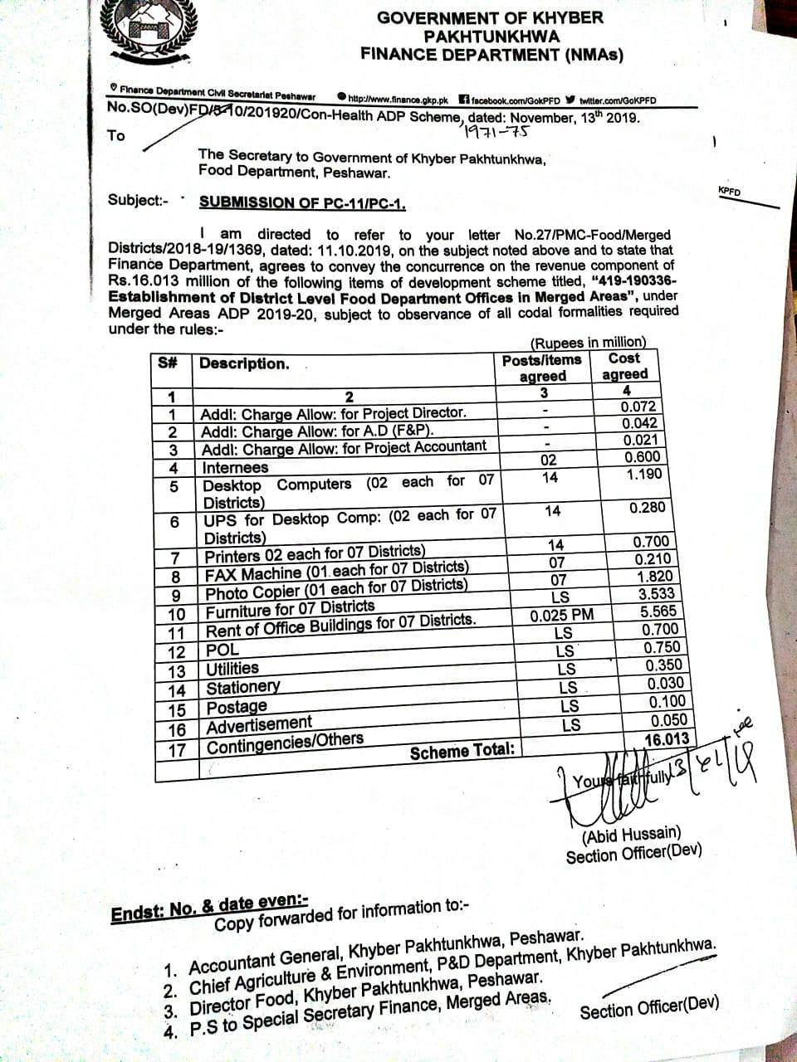

Annex-VI

ORGANIZATIONAL STRUCTURE DISTRICT FORMATION (DIRECTORATE OF FOOD)
Assistant Food Controllers
Assistant/Head Clerk
Senior Clerk
Food Grain Inspector
Junior Clerk
Food Grain Supervisor

District Food Controller

Computer Operator

