(CORRECTED & APPROVED COPY)

ADP# 32-190340

PC-1

ON

PRESERVATION AND PROMOTION OF INDIGENOUS BEANS, PULSES, GROUND-NUTS AND MEDICINAL HERBS OF MERGED AREAS AND FRUIT FLY CONTROL IN KURRAM, NORTH AND SOUTH WAZIRISTAN DISTRICTS

TOTAL COST: Rs. 29.665 MILLION

DIRECTORATE OF AGRICULTURE RESEARCH (MERGED AREAS)
AGRICULTURAL RESEARCH INSTITUTE, TARNAB PESHAWAR
GOVERNMENT OF PAKISTAN
PLANNING COMMISSION
PC-1 FORM
(PRODUCTION SECTORS)

 | Name of the Project: |  | ADP# 32-190340 Preservation and Promotion of Indigenous Beans, Pulses, Ground-nuts and Medicinal Herbs of Merged Areas and Fruit Fly Control in Kurram, North and South Waziristan Districts.
 | Location: |  | The project head-office will remain at the Directorate of Agriculture Research Merged Areas at ARI, Tarnab Peshawar. This office will execute Project activities in their respective Districts through staff of Directorate in the following three Tribal Districts of Newly Merged Areas:  - District Kurram  - District North Waziristan  - District South Waziristan  - Institute of Biotechnology and Genetic Engineering, the University of Agriculture, Peshawar will be involved to conduct all the molecular and Biochemical studies.
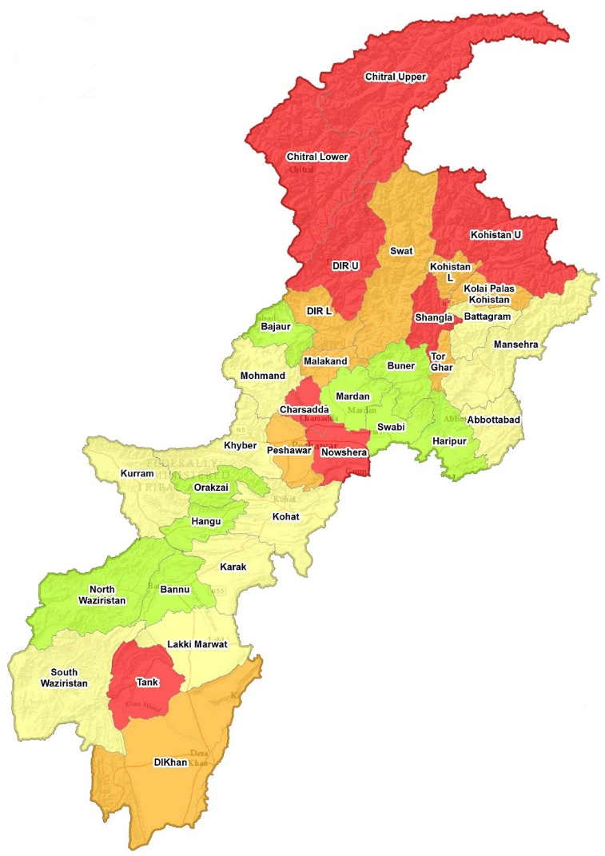
Map of the Newly Merged Districts of Khyber Pakhtunkhwa
 | Authorities responsible for:
 | - Sponsoring: |  | Agriculture, Livestock, Fisheries and Cooperatives Department, Government of Khyber Pakhtunkhwa Through ADP (Merged Districts)
 | - Execution: |  | Director General, Agriculture Research, Khyber Pakhtunkhwa, through Directorate of Agriculture Research Merged Areas at ARI, Tarnab, Peshawar.
 | - Operation and Maintenance: |  | The Director Agriculture Research Merged Areas at ARI, Tarnab will operate and maintain all project activities. However, all the SROs/ROs of each respective Tribal District will collaborate in carrying out research trials on beans, pulses, groundnuts, medicinal herbs and fruit fly control. Further, Institute of Biotechnology and Genetic Engineering (IBGE), University of Agriculture, Peshawar will be involved to conduct molecular and biochemical studies.
 | - Concerned Federal Ministry: |  | Ministry of Food National Security and Research
 | - Plan Provision:
 | - If the project is included in the medium term/ five year plan, specify actual allocation. |  | The project is not included in the five year plan, however, it is directly related to the objectives of the five years plan which emphasizes on increase in agricultural production through sustainable use of natural resources.
 | - If not included in the current Plan, what warrants its inclusion and how is it now proposed to be accommodated. |  | The project objectives are in line with the objectives of the five years plan. Wherein enhancement of agricultural productivity through sustainable use of natural resources is highly emphasized. Agriculture sector in merged Districts is lagging behind the rest of the Province due to less or no interventions by the Agriculture Research Scientists. Moreover, climate change has threatened the existing biodiversity. Biodiversity protection is of utmost importance. There are a number of indigenous species that are being cultivated in the tribal districts. Being part of the Biodiversity and having ethno-botanical importance for the local people. Preservation of these indigenous germplasm for future generations, is imperative to study economic botanical aspects of these species. In this scenario, molecular/biochemical characterization and preservation of indigenous pulses including red-beans and groundnut, and medicinal herbs are important. Like-wise fruit-fly is playing havoc with the fruit and vegetables of the area, therefore, integrated control of the fruit-fly is very important for horticulture industry of the area.
 | - If the project is proposed to be financed out of block provision, indicate:
Total Block Provision | Amount already committed: | Amount Proposed for this Project: | Balance Available:

Not applicable
 | b)Provision in the Current Year’s PSDP/ADP: |  | The project will be financed through Khyber Pakhtunkhwa (Merged Areas) ADP. It is reflected in the KP -ADP 2019-20 with a total cost of Rs. 37.00 million and current year’s allocation of Rs. 12.923 million.
5 | Project Objectives and its Relationship With Sector’s Objectives: |  | The overall goal of the project is to ensure sustainable management of the natural resources to foster economic, social and environmental wellbeing of the people of the Merged Tribal Districts by ensuring sustainable livelihood and better utilization of the available resources.  The objectives of the project are also in line with sustainable development goals (SDGs) focusing on end to poverty in all its forms everywhere, end hunger achieve food security and promote sustainable agricultural with main objectives as under:  - End poverty in all its forms anywhere  - End hunger, achieve food security and improved nutrition and promote sustainable agriculture through conventional as well as advanced molecular approaches.  - Promote, restore and conserve sustainable use of terrestrial echo system.  - Take urgent actions to combat climate change and tis impacts.  - Ensure sustainable consumption and production patterns.  In addition to the above, the project is also in line with the agreed vision of the Government of Pakistan for the Development of merged districts and strategic objectives of the peace building strategy discussed in the PCNA document. The sector Objectives (vission-2025) for agriculture include:  - To bring about structural transformation of economy from low productivity to high productivity export oriented and globally competitive industry and services and from agriculture to diversification in agro based industry.  - To transform agriculture and rural economy, ensure food and water security, value addition, research and modernization, promoting rural enterprises and best practices of water management.  - To achieve an annual average growth rate of 7 to 8 percent that is inclusive and endogenous as well, by bringing about knowledge based science and technology driven and ICT intensive transformation, up scaling regional connectivity and intensifying entry into the global economy.  - The project mainly aims to contribute to integrated multi nutritional strategy and protein intake in the food insecure districts of Kurram, North and South Waziristan.
Project Specific Objectives:
- Collection and molecular characterization of available local germplasm of beans, groundnuts, pulses and medicinal herbs from far flung areas of merged districts
- Biochemical study of the selected local germplasm of beans, groundnuts, pulses and medicinal herbs.
- To evaluate performance of collected germplasm along with improved varieties at different locations of merged districts.
- To select stable and high yielding varieties of beans, pulses, groundnuts and medicinal herbs for different agro-ecological zones of the Merged Areas through field trails and marker assisted selection (MAS).
- To enhance socio-economic condition of the farming community.
- Promotion of best suited germplasm and to preserve these for future generations and breeding program.
- To improve the nutritional status of the local population living in far flung areas of newly merged districts.
- Testing of different eco-friendly technologies developed at ARI Tarnab for control of fruit fly on fruits and vegetables.
- Capacity building of farmers, extension workers and other stake holders for safe use of recommended techniques for fruit fly control.
The project will benefit farming families of Kurram, North & South Waziristan Districts.
This project will create direct and indirect impact on the economics of the merged areas.
The following activities will be carried out as adaptive research for the uplift of farming community in proposed districts.
- 21 Nos. of Field visits/Survey for Collection of Local Germplasm of beans, pulses, ground nuts and medicinal herbs in the proposed districts.
- 28 Nos. of Evaluation trials at farmers’ fields.
- 20 Nos. of quality germplasm selection.
- DNA mapping, MAS and nutritional value of the selected germplasms.
- 210 Nos. plots of selected germplasm will be promoted through Adaptive research.
- 133 Nos. of improved technology testing for fruit fly control techniques (MAT, BAT & Sanitation).
- 21 Nos. of training for Capacity building at ARI Tarnab.
- 4 Nos. of Publication/pamphlets on different topics.

 | Incase of revised project indicate objectives of the project if different form original PC-I |  | NA
6 | Description, Justification, Technical Parameters and Technology Transfer Aspects
6.1 Agriculture in Newly Merged Areas:
The newly merged tribal districts of Khyber Pakhtunkhwa, has the most heterogeneous environment. The highly varied relief has a profound effect on climate. The variation in the relief gradually increases from the eastern entrance to each districts reaching its maximum height in the western boarders with the neighboring Afghanistan. Thus almost each tribal districts registers substantial differences in term of temperature and rainfall providing basis for the diverse agro-climate in each agency. Each agency has been blessed with climatic zones from sub-tropical to temperate while the temperate zones in each Tribal District can be further sub-divided into mild temperate and severe temperate sub-zones. Merged Areas spread over an area of 2,722 million hectares. Merged areas lies between Latitude of 31º and 35º North and the Longitude of 69º and 50º East. Landforms in all over Merged areas is varied i.e piedmont plains, valleys, gravel, rough broken and gullied whereas the leveled areas are loamy while lowlands are slightly calcareous lacking organic matter and available phosphorus and potash. The cultivated land is 0.18 million hectares of which 0.09 million hectares (44%) is irrigated. Most parts of the Merged areas are arid and semiarid with warm summer and cool winter although some areas fall within the humid and sub-humid zone, suitable for various agronomic and horticultural crops.
Soils are generally very low in organic matter and have poor moisture retention capacity. The prevailing climate influences concentration of crops from drought tolerant species to exhaustive crops. However, sharp variation in altitude allows cultivation of wide-ranging crops including cereal, oilseeds, fruits and vegetables.
The toll on the fragile environment has been enormous. For example, fuel wood consumption in the Merged Areas is ten times higher than elsewhere in the country - hence rapid population growth means rapid deforestation in a region where trees grow very slowly.
Agriculture is regarded as the focus for economic activity in merged areas. The economic development, growth and prosperity of a major proportion of its people depend on agriculture. Thus, it would be right to call agriculture the backbone of merged areas economy. Major proportion of the population depends, wholly or partially, on the earnings from agriculture. Therefore, the development of agriculture is synonymous to the development of the area.
About 75% of farms in merged areas are small (0.5 to 5 hectares) covering only 48% of the total farm area. A huge gap between current and obtainable yield of major crops in merged areas register remarkable scope for agricultural research. The Agriculture Research System has a history of developing improved varieties with recommended packages of production technology, especially for the more economically important crops. The proposed project will address major issues in production of indigenous beans, groundnuts, pluses and medicinal herbs along with fruit-fly control in districts Kurram which has threatened productivity of these crops in the prevailing climatic change scenario in merged area districts.
Preservation and promotion of these crops in various agro-ecological zones of tribal districts will lead to the high productivity and suitability of selected crops. All these issues will be addressed in the proposed project.
6.2 Research and Development on Beans:
Bean (seed or pod) are leguminous plants of the family Fabaceae. The genera Phaseolus and Vigna have several species each of well-known beans, though a number of economically important species can be found in various genera throughout the family. Rich in protein and providing moderate amounts of iron, thiamin, and riboflavin, beans are used worldwide for cooking in either fresh or dried form.
The Merged Areas of Khyber Pakhtunkhwa produces quality red beans, locally called Lobia which is known for its nutritious value being a rich source of protein. It is generally cultivated during June and harvested in October/November. Lobia is widely cultivated in mountainous areas of Orakzai, Kurram, North and South Waziristan , Bajaur and Khyber. Lobia grown in Tirah valley, Orkazai and Kurram is especially liked for its softness, taste and quality. The cooler the area, the better is the crop production. Hundreds of tons of red beans produced in the area has a vast market throughout Pakistan and Azad Kasmir. Merged Areas of the KP are mostly rain-fed and Lobiais also dependent on rainwater. A prolonged drought usually create negative impacts on the crop. The crop is usually intercropped with maize, But now most of the farmers avoid doing so and grow it separately or on the sides of maize fields. From their experience they have learnt that when grown together with maize, per acre yield comes down for both maize and lobia as the long stature t of maize crop deprive lobia of sunlight while intercropping of Lobia retards growth of Maize crop and affect their quality and yield.
Farmers of the Tribal Districts are of the opinion that intercropping harms both the crops. “If grown separately, per acre maize yield is 40-50 maunds and that of lobia 16-22 maunds. Now lobia is economically more beneficial to farmers as per the current market rates, it fetches Rs.180,000-200,000 for the above produce while maize can get only Rs.50,000-60,000 against it.
But the problem is that farmers in cooler areas also need maize crop as a staple food for themselves and as a fodder for their animals . Hence both crops are grown simultaneously. But as intercropping has been reducing the per acre yield of lobia to 6 maunds and of maize to 20 maunds. farmers now usually grow lobia on the sides of maize fields. This way they not only get lobia yield of 6-8 maunds per acre but also get a bumper maize crop from their fields.
The high demand for the crop countrywide has increased its price. It is being sold at Rs9,000-10,500 per 50 kg locally against Rs,6000-7,500 for the Chinese and other varieties produced in other areas in Pakistan. The local lobiais of course of superior quality and taste vis-à-vis its Chinese or Indian counterparts. But the problem is that it is mainly produced on non-commercial basis and only for household use in these areas. It doesn’t even suffice the local use. In this project different types of local lobia will be collected from merged areas and will be screened for best traits. Adaptive research on selection of best traits of red beans, showing high yield, good taste and Resistant to insect pest will be carried out with comparison to improved varieties in the merged areas. Promotion of best varieties of Lobia with improved practices will improve the socio-economic condition of rural communities and will fetch them high prices and will improve their livelihood sources.
Following interventions are proposed for R&D of Beans in the Merged Districts of KP:
  - Collection and DNA based genetic characterization of Local Germplasm/ different types of Lobia.
  - Marker assisted selection (MAS) and Evaluation of Local Germplasm for High Yield and Best Quality Traits.
  - Trials on nutritional requirements, cultural practices and plant protection for development of cost-effective production technology
  - Trials on Promotion of the selected germplasm
  - Awareness campaign (Publication of Pamphlets, Field Days, Trainings).

6.3 Research and Development on Pluses:
Pulses are the most important source of vegetable protein in Merged areas. Their use ranges from baby food to delicacies of the rich and the poor. Because of the population growth, demand for pulses is increasing day by day. There is a need to develop varieties with higher yield potential that respond to improved management practices so as to meet the increasing demand of pulses.
Major pulse crops grown in the merged areas are chickpea lentil (Lens culinaris Medic.), mung bean (Vigna radiata (L.) or mash (Vigna mungo L. Hepper). In the newly merged areas of Khyber Pakhtunkhwa centuries non-descriptive species of different pulses are being grown having good taste and adoptability in the existing cropping pattern . in District Kurram black mung bean is widely used and liked by the local people as compared to green Mung, the price and taste of Kurram black Mung Bean is higher than the Mung Beans of Punjab and India. There is a dire need to preserve these indigenous pluses specially Mung Bean and select best performing cultivars from the locally available germplasm.

Following interventions are proposed for R&D of Pulses (Mung Bean) in the Merged Districts of KP:
- Collection and DNA based genetic characterization of Local Germplasm of Mung bean.
- Marker Assisted Selection (MAS) and Evaluation of Local Germplasm for High Yield and Best Quality Traits
- Trials on nutritional requirements, cultural practices and plant protection for development of cost-effective production technology
- Trials on seed production of the selected germplasm
- Awareness campaign (Publication of Pamphlets, Field Days, Trainings, Workshops.

6.4 Research and Development on Groundnuts:
The Peanut, also known as the groundnut, goober, or monkey nut, and taxonomically classified as Arachis hypogaea, is a legume crop grown mainly for its edible seeds. It is widely grown in the tropics and subtropics, being important to both small and large commercial producers.
Groundnut is an important cash crop in barani areas of upper Punjab and parts of Khyber Pakhtunkhwa Merged areas. The newly merged areas of Khyber Pakhtunkhwa is mostly dependent on rain water and has great potential for the production of peanuts in their different ecological zones. The Valley of Kurram District has some non-descriptive groundnut types having large no of Pods and liked by the people for its taste and adoptability. These local germplasm needs to be screened for the selection of high yielding, and resistant to insect pest problems. Also The local selection of ground nut will be preserved for the future breeding program.
Following interventions are proposed for R&D of Beans in the Merged Districts of KP:
- Collection and DNA based genetic characterization of Local Germplasm of ground nuts.
- Marker Assisted Selection (MAS) and Evaluation of Local Germplasm for High Yield and Best Quality Traits
- Trials on nutritional requirements, cultural practices and plant protection for development of cost-effective production technology
- Trials on seed production of the selected germplasm
- Awareness campaign (Publication of Pamphlets, Field Days, Trainings, Workshops and Exposure Visits)
6.5 Research and Development on Medicinal Herbs:
A medicinal herb is a plant that is used with the intention of maintaining health, to be administered for a specific condition, or both, whether in modern medicine or in traditional medicine. The Food and Agriculture Organization estimated in 2002 that over 50,000 medicinal plants are used across the world. Medicinal plant resources have remained an integral part of human society throughout history. World Health Organization (WHO) estimated that about 80% of the developing world’s population use traditional herbal medicines. In developing countries, traditional medicines provide a cheap and alternative source for primary health care due to lack of modern health facilities, their effectiveness, cultural priorities, and choices. In developed nations, usage of traditional herbal medicines is also a fast growing phenomenon.
Pakistan is comprised of various climatic zones with unique biodiversity and consists of 6000 plant species, of which approximately 400–600 species are considered to be medicinally important. In the country, several studies have reported the medicinal uses of plant resources. The folk knowledge on traditional herbal remedies usually transfer from one generation to another generation. In the last few decades, a significant trend in scientific and commercial interests has been observed due to the cultural acceptability and economic potency of plant-based herbal products across the country.
Medicinal plants may provide three main benefit: health benefits to the people who consume them as medicines; financial benefits to people who harvest, process, and distribute them for sale; and society-wide benefits, such as job opportunities, taxation income, and a healthier labour force.
Results from ethno medicinal surveys conducted in former FATA reveal biodiversity containing huge resources of medicinal herbs. However, Saffron, Turmeric and Ispaghol are most important medicinal herbs of merged areas. In this project adaptive research trials on Fennel seed (Sonf), Flax seed (Alsi), Chia seed (Tukham malanga), Artimisia , Mastiyara, Mint and/or Black cumin (Kalongi), will be carried out as a pilot intervention in medicinal herb sector. These herbs are used all over the world for their texture, smell and medicinal values.
Following interventions are proposed for R&D of Medicinal Herbs in the Merged Districts of KP:
- Collection and DNA based genetic characterization of Local Germplasm of selected herbs.
- Introduction, Selection and Evaluation of Local Germplasm for High Yield and Best Quality Traits
- Trials on nutritional requirements, cultural practices and plant protection for development of cost-effective production technology
- Trials on seed production of the selected germplasm
- Awareness campaign (Publication of Pamphlets, Field Days, Trainings, Workshops and Exposure Visits)
6.6 Testing of Eco-Friendly techniques for the Control of Fruit-fly in Kurram, South and North Waziristan Districts:
About 11 species of fruit flies have been reported from Pakistan and the most prominent among them are Bactrocerazonata, Bactroceracucurbitae, Bactrocera dorsalis, Carpomiyavesuviana, Dacusferrugincus and Dacusdiversus (Panhwar, 2005).
To fetch international market it is dire need to develop GAP (Good Agriculture practices)where in integrated pest management provides the solution (Verghese et al., 2006).The world is switching over on microbial control agents such as Entomo-pathogenic Fungi (Evangelos et al., 2013) and nematodes (Gazit et al., 2010) for the control of fruit fly. Jalaluddin et al. (1999) reported that guava fruit fly caused 60-80 % losses. However, fruit flies managed by Khan, 2002 while working in four localities of Punjab i.e Murree, Faisalabad, Sheikhupura and Multan, revealed that bait application technique, pheromone traps and hoeing was found effective. Ishfaq et al. (2004) reported methyl eugenol traps were extremely effective to trap and kill fruit fly of mango. The mortality rates achieved with insecticide sprays were up to 55%. The nonchemical methods have been found superior in fruit fly control. The WTO regulations of agriculture commodities to export to other countries are very strict for pest and pesticide residues. The produce must not contain any stage of insects especially of quarantine importance and must be free from pesticide residues. Currently farmers use indiscriminately synthetic pesticides for pest management. This un-judicial use resulted in building up the resistance in insects and higher production cost on the other hand. Fruit flies are the most serious pests of fruits and vegetables. Their attacks on fruits not only reduce the yields but also affect their quality. Their direct damage to fruits cost farmers alone about 7 billion rupees annually in Pakistan besides the losses to traders, retailers and exporters (Stonehouse, 1997).
The list of host fruits and vegetables attacked by fruit flies is long, however, the important of them include mango, guava, plum, peach, citrus, loquat, peaches, apricot, persimmon, melons, bitter gourd, sponge gourd, cucumber, etc. For protection of fruits from flies pesticides cover sprays are most popular with farmers. According to an estimate 10% of the total pesticides used in Pakistan annually is applied for control of fruit flies costing about 63% within rupees (Stonehouse, 1997).Pesticides use against fruits is highly undesirable because in today’s health conscious world the contaminated fruits are not acceptable locally and abroad. Pakistan’s exports of fruits and vegetables face a serious threat due to use as pesticides against fruit pests. Most countries need certification that the imported fruits are free of pests and pesticides. Though recently ban has been lifted with certain conditions Japan banned the import of mango from Pakistan. Similarly Indonesia banned the import of citrus. Sri Lanka and Philippines have already started subjecting fruits to pre-inspection. As a result of these restrictions the overall export of fruits and vegetables from Pakistan have decreased. The massive thrust to increase the export of fruits from Pakistan to new markets may suffer a setback unless the government finds a solution to pest attack other than pesticides. Finding solutions to pest attack other than pesticides is the top international research priority.
The known alternate control measures include male annihilation technique (MAT), bait application technique (BAT), biological control (BC), sterile insect release technique (SIT) and cultural control (CC). Of these MAT and BAT have been tried in Pakistan by different research organization and have been reported effective against some fruit fly species. It is a recognized fact that no one control measure alone gives substantial control fruit flies so different control measures have to be applied together in such a way that they supplement each other. Biological control (which includes augmentation and conservation of local parasitoids and introduction of exotic ones) of fruit flies is completely an ignored area in Pakistan whereas in several countries fruit flies are being controlled by combining different control measures with biological control (Purcel et al, 1994, Wong et al, 1991, 1992).CIBC (Now CABI Bioscience) (1972) reported that some parasitoids such as Diachas minorpalongicau data and Trybiographadaci destroyed more than 44% populations in mango, guava, apricot, loquat. Encouragement of locally existing parasitoids and introduction of exotic parasitoids are the top priorities for long term management of fruit flies. For short term solutions and localized control of fruit flies the augmentation of parasitoids’ combined with BAT, MAT and cultural control is proposed. In this regard practical demonstration of management fruit flies on growers’ fields without use of pesticides is necessary. With such combined approaches fruit flies have been controlled in a number of countries (Purcel et al, 1994).The project is based on the philosophy of IPM with a view to devise sustainable package of technology to control fruit flies of economic and quarantine importance. Main goal of the proposed project is to transfer the devised IPM technology and popularization of eco-friendly techniques for the control of fruit flies. This will ultimately reduce the quantitative and qualitative losses to fruit and vegetables incurred by fruit flies in various areas of Khyber Pakhtunkhwa. The proposal is in line with the objectives of plant protection sector of Pakistan.
In short, Present project aimed to develop Bio-rational IPM Modules for sustainable management of fruit fly in merged districts. This will be helpful in fulfilling requirements of WTO/SPS and ultimately boost up the exports.
Following interventions are proposed for the Control of Fruit-Fly in Kurram , North and South Waziristan districts:
- Collect data on prevalence of various species of fruit-fly active in the area.
- Introduce modern pheromone traps.
- Application of Integrated Pest Management techniques for Fruit-Fly Control.
- Awareness campaign (Publication of Pamphlets, Field Days, Trainings, Workshops and Exposure Visits)

6.7 Existing Facilities/ Staffing:
In order to execute the project necessary staff is available however, activities of the department is increasing day by day due to projects of ADP, therefore recruitment of internees and daily paid labors is necessary for proper implementation of project activates efficiently and effectively. Vehicles are also available to reach remote areas of tribal districts. Necessary POL and repair and maintenance of Vehicles will be provided by this project. Collection of required gerplasm of Beans; Ground nuts, Pulses, Medicinal Herbs from each Agro-Ecological Zone of Merged Areas (Project areas) will be carried out through the existing staff. Improved varieties seed of Beans, Ground Nuts, Pulses and Medicinal herbs will be arranged from the Research Stations in KP and rest of The country according to the recommendations of the scientists at research stations.
- 3 Nos. of Internees (Agriculture gradates)
- 3 Nos. of Skilled Labour (Field Asstt. Diploma)
- 3 Nos. of Daily Paid labour.

DNA based genetic characterization, nutritional value study and marker assisted selection study will be carried out at the Institute of Biotechnology and Genetic Engineering (IBGE), University of Agriculture, Peshawar for which proper budget will be provided as per their need.

6.8 Justification of The Project:
The people of Merged Districts are very Poor having very less opportunities for Jobs and livelihood. They are far away from main Stream. Agriculture is the only livelihood Source available to them. As the farmers are unaware about recent developments in agriculture sector, and are using centuries old methods for cultivation of their crops, therefore their incomes are also very low. Majority of farmers are growing old Varieties of Pulses, Beans, and ground nuts with old inherited cultivation practices resulting into high Cost of Production and low yields. By the Selection and introduction of Best Cultivars and Best practices the production can be increased many fold. This way the income level of farmers will be increased which will improve their living standards. Only Requirement is to find out Best Local Cultivars in Merged districts and screen them for quality traits and high yields in different ecological zones using conventional and modern molecular approaches. These interventions will be addressed in this proposed Project. Thus this project is fully justified as it will directly benefit farmers of the merged districts by increasing their incomes, providing job opportunities to many involved in Pulses, beans, groundnuts, medicinal Herbs Production and with the control of Fruit fly in Kurram, North and south Waziristan Districts.

6.9 Procurement Committee:

The procurement committee comprising of the following officers of the department will be constituted for all procurement related with the project, and quality assurance of the bidders as per KPPRA rules;

- Director Agri. Research Merged Areas… Chairman
- SRO (Entomology)…. Member
- SRO (Pathology)…. Member
- Office Asstt (Acctts)… Member

6.10 Criteria for Selection of Farmers:
Farmers of the selected merged districts with minimum land holding of 1 acre and above, having computerized CNIC and willing to demonstrate selected crops on his land.
He must be willing to help out Agriculture Research staff in cultivation of these crops i.e. irrigation, watch & ward and other cultural practices etc.

6.11 Monitoring Strategy:

Director Agricultural Research, Khyber Pakhtunkhwa, Peshawar (BS-20), Director Agri. Research Merged Aras (BS-19) and SROs (BS-18) and concerned SRO (BS-18) of the proposed districts will regular monitor project activities until its completion with required timing interval.
The Project Incharge will furnish updated reports for the project activities for sharing with secretariat and monitoring and evaluation directorate of merged areas alongwith administrative departments.

DNA based studies, nutritional and marker assisted selection studies will be conducted and monitored by Prof. Dr. Iqbal Munir and his team at IBGE, the University of Agriculture Peshawar.

6.12 Provide Technical Parameters i.e. input and output of the project in quantitative terms. Also, discuss the technology aspects of the project:
S# | Input | Output
 | 21 Nos. of Field visits/Survey for Collection of Local Germplasm of beans, pulses, ground nuts and medicinal herbs in the proposed districts. | 21 Nos. of Field visits/Survey for 63 Nos. of local Germplasm collection are carried for the targeted crops.
 | 28 Nos. of Evaluation trials at farmers’ fields | 63 Nos. of Germplasm evaluated in 28 Trials.
 | 20 Nos. of quality germplasm selection. | 20 Nos. of high yielding germplasm selected from 63 Nos. of locally collected germplasm.
 | 20 Nos. of selected germplasm will be evaluated for DNA, MAS and nutritional value at IBGE University of Agri. Peshawar | Complete DNA mapping and MAS conducted at IBGE, University of Agri. Peshawar alongwith nutritional value of 20 Nos. of selected germplasm carried out.
 | 210 Nos. plots of selected germplasm will be promoted through adaptive research. | 210 Nos. adaptive plots of selected germplasm planted with 210 farmers.
 | 133 Nos. of improved technology testing for fruit fly control techniques (MAT, BAT & Sanitation). | 133 Nos. of fruit and vegetables growers adapted improved technology for fruit fly control techniques (MAT, BAT & Sanitation).
 | 21 Nos. of training for Capacity building at ARI Tarnab. | 315 fruit and vegetables growers are trained on Mat & Bat technologies at ARI Tarnab for fruit flies’ control.
 | Publication/pamphlets on 4 Nos. of topics. | 8000 Nos. of pamphlets on 4 topics published in Urdu for farming community.

7. | Capital Cost Estimates:
 | Indicate date of estimation of project cost estimates | Cost estimate has been prepared in Sep. 2019 on prevailing markets rates.
 | Basis of determining the capital cost be provided. It includes market survey, schedule rates, estimation on the basis of previous work done etc: | No
 | 7.1 Provide year-wise estimation of physical activities as per following:

Component wise/year wise Physical Phasing
S# | Particulars | Unit | 2019-20 | 2020-21 | 2021-22 | Total
1 | Field visits/Survey for Collection of Local Germplasm of beans, pulses, ground nuts and medicinal herbs | No. | 21 | -- | -- | 21
2 | Evaluation trials at farmers’ fields | No. | -- | 14 | 14 | 28
3 | Selection of best germplasm | No. | -- | 10 | 10 | 20
4 | DNA mapping, MAS and Nutritional value of selected germplasm carried out IBGE, UAP | No. | -- | 10 | 10 | 20
5 | Promotion of selected germplasm through Adaptive research plots | Kanal | -- | 70 | 140 | 210
6 | Testing of fruit fly control techniques (MAT, BAT & Sanitation) | No. | 35 | 49 | 49 | 133
7 | Capacity building trainings at ARI Tarnab | No. | 7 | 7 | 7 | 21
8 | Publication of Pamphlets | Topic | -- | 1 | 3 | 4

COMPONENT WISE/YEAR WISE FINANCIAL PHASING
(Rupees in million)
S# | Description | 2019-20 | 2020-21 | 2021-22 | Total
A. | Establishment Cost | 0.200 | 1.200 | 1.200 | 2.600
1 | Internees (Agri. Graduate) | 0.200 | 0.800 | 0.800 | 1.800
2 | Skilled Labourers on Daily Paid Basis | 0.000 | 0.300 | 0.300 | 0.600
3 | Un-skilled labourers | 0.000 | 0.100 | 0.100 | 0.200
B. | Operational Cost | 0.155 | 0.205 | 0.205 | 0.565
1 | TA/DA | 0.100 | 0.100 | 0.100 | 0.300
2 | Advertisement Charges | 0.000 | 0.050 | 0.050 | 0.100
3 | Stationery | 0.025 | 0.025 | 0.025 | 0.075
4 | Telephone & Internet | 0.030 | 0.030 | 0.030 | 0.090
C. | Program Cost | 10.743 | 7.206 | 8.551 | 26.500
1 | IBGE Component: Study Related to DNA Mapping, Marker Assisted Selection & Nutritional Value (Annexure-6) | 2.900 | 1.100 | 1.100 | 5.100
2 | Printing & Publications | 0.000 | 0.100 | 0.100 | 0.200
3 | Survey/Visit Charges (Annexure-1) | 0.600 | 0.000 | 0.000 | 0.600
4 | Evaluation Trial Charges (Annexure-2) | 0.000 | 0.400 | 0.400 | 0.800
5 | Adaptive Research Trial Charges (Annexure-3) | 0.000 | 1.333 | 2.667 | 4.000
6 | Development of Fruit Fly Material | 2.000 | 0.000 | 0.000 | 2.000
7 | Application Charges for Fruit Fly Control Techniques (Annexure-4) | 1.577 | 2.207 | 2.216 | 6.000
8 | Capacity Building Training Charges (Annexure-5) | 1.666 | 1.666 | 1.668 | 5.000
9 | Cost of Other Stores | 0.200 | 0.400 | 0.400 | 1.000
10 | Entomology Equipment (Annexure-7) | 1.800 | 0.000 | 0.000 | 1.800
 | Grand Total | 11.098 | 8.611 | 9.956 | 29.665
SUMMARY OF PROJECT COST
S# | Description | 2019-20 | 2020-21 | 2021-22 | Total
A. | Establishment Cost | 0.200 | 1.200 | 1.200 | 2.600
B. | Operational Cost | 0.155 | 0.205 | 0.205 | 0.565
C. | Program Cost | 10.743 | 7.206 | 8.551 | 26.500
 | Grand Total: | 11.098 | 8.611 | 9.956 | 29.665

(Revised concurrence of the Finance Department vide letter No. SO(Dev) 5-10/2019-20/Con.-Agri. Res.2643 dated 24.02.2020 is attached at Annexure-10)

 | 7.2 Annual operating and maintenance Cost after completion of the Project: | Nil as the selected growers will be trained on best agriculture practices for Beans, Ground nuts, pulses, Medicinal herbs and also the orchardists of the area will be trained on Eco-friendly techniques of fruit flies control. More over the farmers will be linked with Specialized research stations of KP on Pulses, ground nuts and medicinal herbs as well as with entomology Section of ARI, Tarnab to get Guidance on Emerging insect/pest infestation in their Orchards in Future.
 | a) Demand and Supply Analysis: | Description of the Product:  Beans (Lobia), Mung Beans, Ground nuts and Saffron are Known Crops to the Farmers of Merged districts but non descriptive lines are the major impediment in enhancing yield. In past Government and Non-government organization did not pay any attention to the preservation and promotion of Local germ plasam, therefore there is a high demand of the local small farmers of remote areas for Preservation and Promotion of these local lines to overcome Food insecurity of the Merged areas.
 | b) Current Demand/Supply of the Product: | Currently production of Local Germ plasms is very low, very little Surpluses are being sold in the down districts of KP and Punjab, so majority of the small farmers are demanding good quality of Seed through selection of these local lines to cater their local needs as well as to sell them in outer markets for high prices.
 | c) Projected Demand/Supply after the completion of the Project: | At least 50 % of the local small farmers in Merged areas will have access to high promising varieties of Lobia , Mung beans, ground nuts and medicinal herbs in their respective Districts.
 | d) Proposed Marketing Plan: | There is a huge demand for local lobia, Mung beans, ground nuts and saffron as well as quality fruits inside the merged areas and adjacent down districts of KP and Punjab. Surplus Produces Could be sale out in Azad Kashmir and Punjab for their good taste and high Demand.
10. | Financial Plan:
 | Sources of Financing:
 | Total Cost of the Project: | Rs. 29.665 million
 | Provincial Government through Merged Areas ADP: | Rs. 29.665 million
 | Donors/Others: | Nil
 | Community Share: | Nil
11. | Project Benefits and Analysis:
 | Financial: | The net income of the farmer will be increased as result of this proposed project. The financial impact will be positive and will increase with every passing year.  The recommendations of the project will multiply and replicated in selected areas of the merged districts.
 | Economic: | When farmers will grow best suited cultivars of pulses, Beans, ground nuts and medicinal herbs their income will increase with increase in Production and reduction in its cost of production. An economic cycle will generate involving thousands of farmers of the merged areas. The farmers will benefit directly due the interventions of this Project while many others will be involved as labor force in field operations, marketing, packing and packaging and transportation of these produces.
 | Social | It is a universal phenomenon that when income Level of individual increases, the living standard get high. Increase in living standard of the majority population will bring prosperity to the area. By the implementation of interventions in this project, income level of the farmers will go high, therefore socio economic impact will be visible.
 | Environmental: | The project has no environmental issues, rather it will add into biodiversity of the region.
 | Impact of Delay in Project: | The delay in the project implementation will lead to exploitation of the natural resources in the unsustainable manner resulting in environmental degradation. The existing and old varieties of crop are now susceptible to many insects and diseases which results in indiscriminate pesticide sprays thus accelerating environmental degradation. The project aims to introduce resistant varieties of proposed crops helping in low use of pesticides. The project also aims to employee the concept of integrated crop management which will reduce the use of pesticides and fertilizers and promote the best agricultural practices without compromising the yield increase and sustainably preserve the natural resources for future generations.
12. | Implementation of the Project
 | Implementation Schedule: | July, 2019 to June, 2023
Results Based Monitoring (RBM) Indicators:
S# | Input |  | Out put | Outcome |  |  | Targeted impact
 |  |  |  | Baseline Indicator |  | Targets after Completion of Project
 | 21 Nos. of Field visits/Survey are conducted for Collection of Local Germplasm of beans, pulses, ground nuts and medicinal herbs |  | 21 Nos. of Field visits/Survey for 63 Nos. of local Germplasm collection are carried for the targeted crops. | At Present per acre yield of beans, pulses, ground nuts and medicinal herbs is very low. |  | 20 Nos. of high yielding indigenous germplasm are selected and preserved which will ensure in higher yield. | Local germplasm are preserved and yields of the targeted crops enhanced sustainable basis.
 | 28 Nos. of Evaluation trials at farmers, fields |  | 63 Nos. of Germplasm evaluated in 28 Trials. | Currently there is no evaluation on the target crops in the Merged Districts. |  | 20 Nos. of high yielding germplasm are selected from the 63 Nos. of collected germplasm. Yields are enhanced on sustainable basis with the preservation of indigenous germplasm. | 20 Nos. of indigenous germplasm are preserved for future generation and saved from extinction. Yield of the targeted crops are enhanced.
 | 20 Nos. of Selection of best germplasm |  | 20 Nos. of high yielding germplasm selected from 63 Nos. of locally collected germplasm. | --do-- |  | --do-- | --do--
 | 20 Nos. of selected germplasm will be evaluated for DNA, MAS and nutritional value at IBGE University of Agri. Peshawar |  | Complete DNA mapping and MAS conducted at IBGE, University of Agri. Peshawar alongwith nutritional value of 20 Nos. of selected germplasm carried out. | --do-- |  | --do-- | --do--
 | 210 Nos. of Plots for Promotion of selected germplasm through Adaptive research plots |  | 210 Nos. adaptive plots of selected germplasm planted 210 farmers. | Currently there is no adaptive trials on the targeted crops. |  | 210 growers adapt the modern production technology for growing the 20 Nos, of indigenous germplasm. | The growers of the area are exposed to modern production technology and adaptation of these technologies ensure enhanced yield.
 | 133 Nos. of Orchards for Testing of fruit fly control techniques (MAT, BAT & Sanitation) |  | 133 Nos. of fruit and vegetables growers adapted improved technology for fruit fly control techniques (MAT, BAT & Sanitation). | Fruit flies causing heavy damages to orchard owners in merged areas |  | Fruit and vegetables on 133 acres are protected directly, however, with the adaption of the technology fruit fly damage is reduced by 20% of the total fruit and vegetables areas in three years after the completion of the project. | With the adaption of the technology quality of the fruit and vegetables is enhanced with increased farm income.
 | 21 Nos. of Capacity building trainings at ARI Tarnab |  | 315 fruit and vegetables growers are trained on Mat & Bat technologies at ARI Tarnab for fruit flies’ control. | --do-- |  | --do-- | --do--
 | Publication of pamphlets on 4 topics |  | 8000 pamphlets on four topics are distributed in the area | Currently there is no such information available in Urdu in the Merged Areas in the targeted crops. |  | 8000 growers get the latest information on the targeted crops in the Merged Areas. With the adaption of the technology yields will be enhanced on sustainable basis. | With the adaption of modern production technologies, yields are enhanced with increased farm income.
13 |  | Management Structure and Manpower Requirements: |  |  | The Director Agriculture Research FATA will be overall incharge of the project, however the respective Senior Research Officers/Research Officers at the Districts will be responsible for implementation of the project activities.
14. |  | Additional projects/ decisions required to maximize socio-economic benefits from the proposed project: |  |  | Department of Agriculture Extension Merged Areas may be directed for Extension of Production technologies and Multiplication of Selected germ plasm of Lobia , Mung beans, Ground nuts and medicinal herbs and control of fruit fly to benefit maximum farming community of the merged areas.

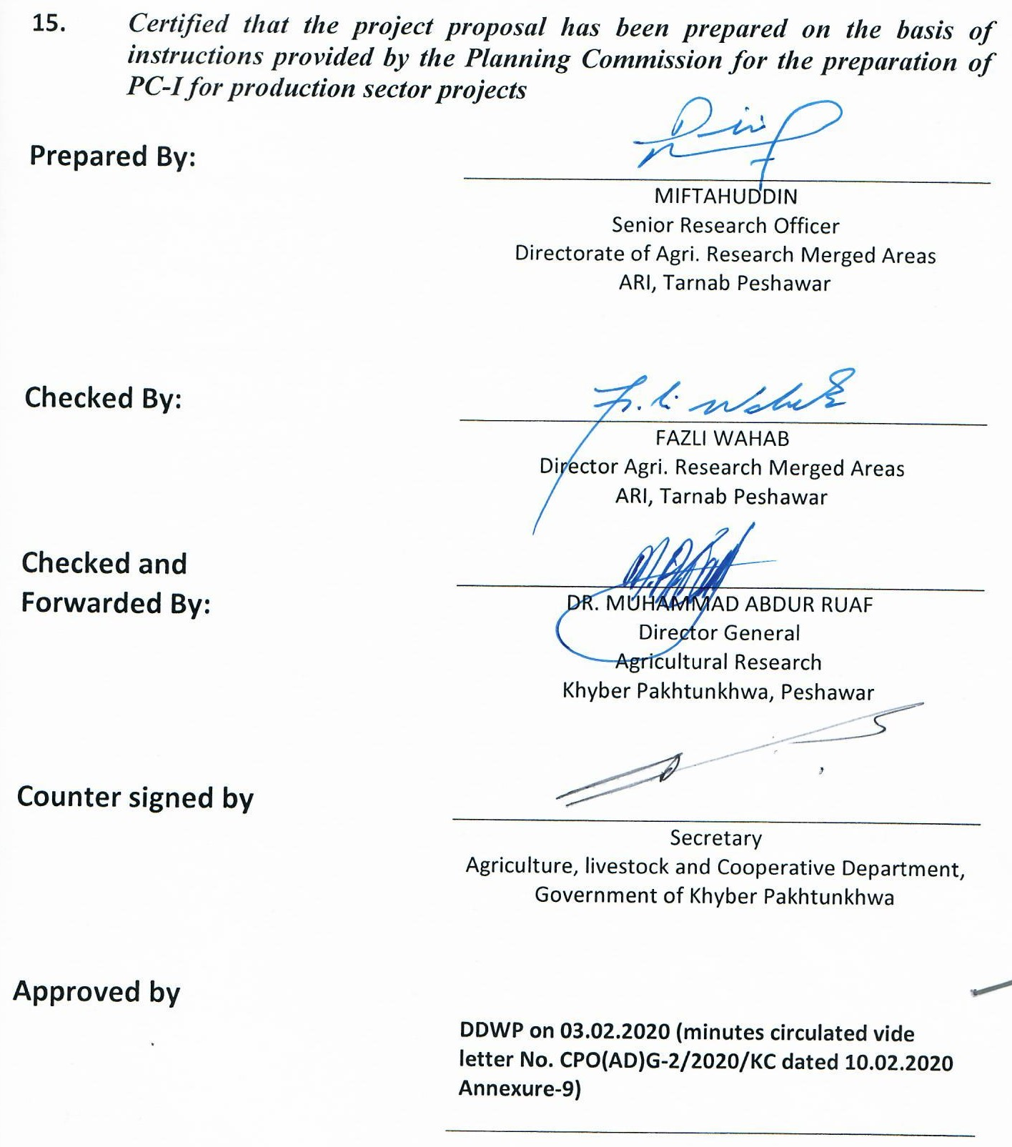
Annexure-1

Detail of Targets and Expenditure Requirements for Visits/Survey for Collection of Germplasm at the Targeted Areas:
# | District | 2019-20 | 2020-21 | 2021-22 | Total
1 | Kurram | 7 | -- | -- | 7
2 | North Waziristan | 7 | -- | -- | 7
3 | South Waziristan | 7 | -- | -- | 7
Total |  | 21 | -- | -- | 21

Expenditure Requirements for 21 Field Visits/Surveys
S# | Expenditure Head | Requirement for One Visit/Survey | Nos. of Visits/ Surveys | Total Amount Required
1 | POL | 10,000 | 21 | 210,000
2 | Purchase of Seed Samples | 15,000 | 21 | 315,000
3 | Seed Bags/Tagging/Labels | 3,570 | 21 | 74,970
 | Total: | 25,000 | 21 | 599,970
Say: |  |  |  | 600,000

Annexure-2

Detail of Targets for Evaluation Trials on Beans, Pulses, Groundnut and Medicinal Herbs and their Budget Requirement
# | District | 2019-20 | 2020-21 | 2021-22 | Total
1 | Kurram | -- | 6 | 6 | 12
2 | North Waziristan | -- | 4 | 4 | 8
3 | South Waziristan | -- | 4 | 4 | 8
Total |  |  | 14 | 14 | 28

Expenditure Requirements for Evaluation Trials on One Kanal
S# | Head of Account | Amount (Rs.)
1 | Cost of fertilizer for one plot | 6,200
2 | Cost of herbicide/ fungicide/ pesticide | 3,500
3 | Cost of tractor operations | 3,350
4 | Land Preparation/ Operations | 15,520
 | Total: | 28,570
 | Budget Requirement: | (Rs. in million)
 | Year-1 | 0
 | Year-2 (28,570 x 14=399,980) | 0.400
 | Year-3 (28,570 x 14=399,980) | 0.400
 | Total: | 0.800

Annexure-3

Detail of Targets for Adaptive Research Trials on Beans, Pulses, Groundnut and Medicinal Herbs and their Budget Requirement
# | District | 2019-20 | 2020-21 | 2021-22 | Total
1 | Kurram | -- | 30 | 60 | 90
2 | North Waziristan | -- | 20 | 40 | 60
3 | South Waziristan | -- | 20 | 40 | 60
Total |  |  | 70 | 140 | 210

Budget Requirement for Adaptive Research Trials One Kanal
S# | Head of Account | Amount (Rs.)
1 | Cost of Seed for one plot | 8,000
2 | Cost of fertilizer for one plot | 3,000
3 | Cost of herbicide/ fungicide/ pesticide | 3,000
4 | Cost of tractor operations | 2,500
5 | Land Preparation/ Operations | 2,550
 | Total: | 19,050
 | Budget Requirement: | (Rs. in million)
 | Year-1 | 0
 | Year-2 (19,050 x 70 = 1,333,500) | 1.333
 | Year-3 (19,050 x 140 = 2,667,000) | 2.667
 | Total: | 4.000

Annexure-4

Detail of Application Charges for Fruit Fly Control Techniques and Budget Requirement (Acres)
# | District | 2019-20 | 2020-21 | 2021-22 | Total
1 | Kurram | 15 | 30 | 30 | 75
2 | North Waziristan | 10 | 9 | 9 | 28
3 | South Waziristan | 10 | 10 | 10 | 30
Total |  | 35 | 49 | 49 | 133

Budget Requirement for Application Charges for Fruit Fly Control Techniques One Acre Fruit Orchard:
S# | Head of Account | Amount (Rs.)
1 | Cost of MAT, BAT & Sanitation of Orchards | 25,000
2 | Cost of fertilizer for one plot | 5,500
3 | Cost on Orchard Management | 14,550
 | Total: | 45,050
 | Budget Requirement: | (Rs. in million)
 | Year-1 (45,050 x 35 = 1,576,750) | 1.577
 | Year-2 (45,050 x 49 = 2,207,450) | 2.207
 | Year-3 (45,050 x 49 = 2,207,450) | 2.207
 | Total: | 5.991

Annexure-5

Detail of Targets for Capacity Building Trainings to the Farmers of Targeted Areas and their Budget Requirement (15 Participants)
# | District | 2019-20 | 2020-21 | 2021-22 | Total
1 | Kurram | 3 | 3 | 3 | 9
2 | North Waziristan | 2 | 2 | 2 | 6
3 | South Waziristan | 2 | 2 | 2 | 6
Total |  | 7 | 7 | 7 | 21

Details of Miscellaneous Items for One Day Training:
S# | Item | Amount  (Rs. in million
1 | Banner 3-4 colors Size 15 sq feet | 0.238
2 | Hiring of vehicle (Pick & Drop)
3 | Food Charges
4 | Honoraria to 15 participants @ 500/- per participant per day
5 | Resource Person fee @ 5000/- per lecture (4 lectures/day)
6 | Stationery charges
7 | Training facilities charges
8 | Payment to facilitators/attendants
9 | Materials for Demonstrations
10 | Other unforeseen

Expenditure Requirements for training components.
- Budget requirements for 2019-20 = 1.666 million
- Budget requirements for 2020-21 = 1.666 million
- Budget requirements for 2021-22 = 1.666 million
Total: = 4.998 million

Annexure-6
Budget Detail for Institute of Biotechnology and Genetic Engineering (IBGE), University of Agriculture Peshawar for Study related to DNA Mapping, Marker Assisted Selection and Nutritional Value

S# | Head of Account | 2019-20 | 2020-21 | 2021-22 | Total
 | Chemicals and Kits | 1.50 | 0.50 | 0.50 | 2.50
 | Glassware and Lab-Wares | 0.50 | 0.00 | 0.00 | 0.50
 | Honoraria etc | 0.50 | 0.50 | 0.50 | 1.50
4. | Miscellaneous | 0.40 | 0.10 | 0.10 | 0.60
 | Total: | 2.90 | 1.10 | 1.10 | 5.10

(Modus operandi for release of budget to the IBGE, UAP will be through an MoU signed between the Directorate of Agriculture Research Merged Areas and IBGE and the component’s budget as mentioned above will be transferred to the official account of the IBGE for carrying out the activities of the component)

Annexure-7
List of Entomology Equipment

(Rs in million)
S# | Description of Items with Specifications | Quantity  (Units) | Estimated
 |  |  | Unit Price | Total Price
 | Heavy duty Sweep net Hard wood hangle 2’ long, Stiff, Zinc plated steel net hoop 15” dia (USA) | 10 | 0.010 | 0.100
 | Magnifying glass/Hand lens | 20 | 0.003 | 0.060
 | Wheel Barrow Power Sprayer | 03 | 0.300 | 0.900
 | Insect showcase box | 60 | 0.010 | 0.600
 | Safety Kit for Spraymen | 07 | 0.020 | 0.140
Total: |  |  |  | 1.800

Annexure-8
Development of Fruit Fly Materials

S# | Item/Particulars | Units/Quantity | Unit Cost | Total Cost (Rs.)
1. | Fruition Traps | 400 | 5000 | 2,000,000

Annexure-9
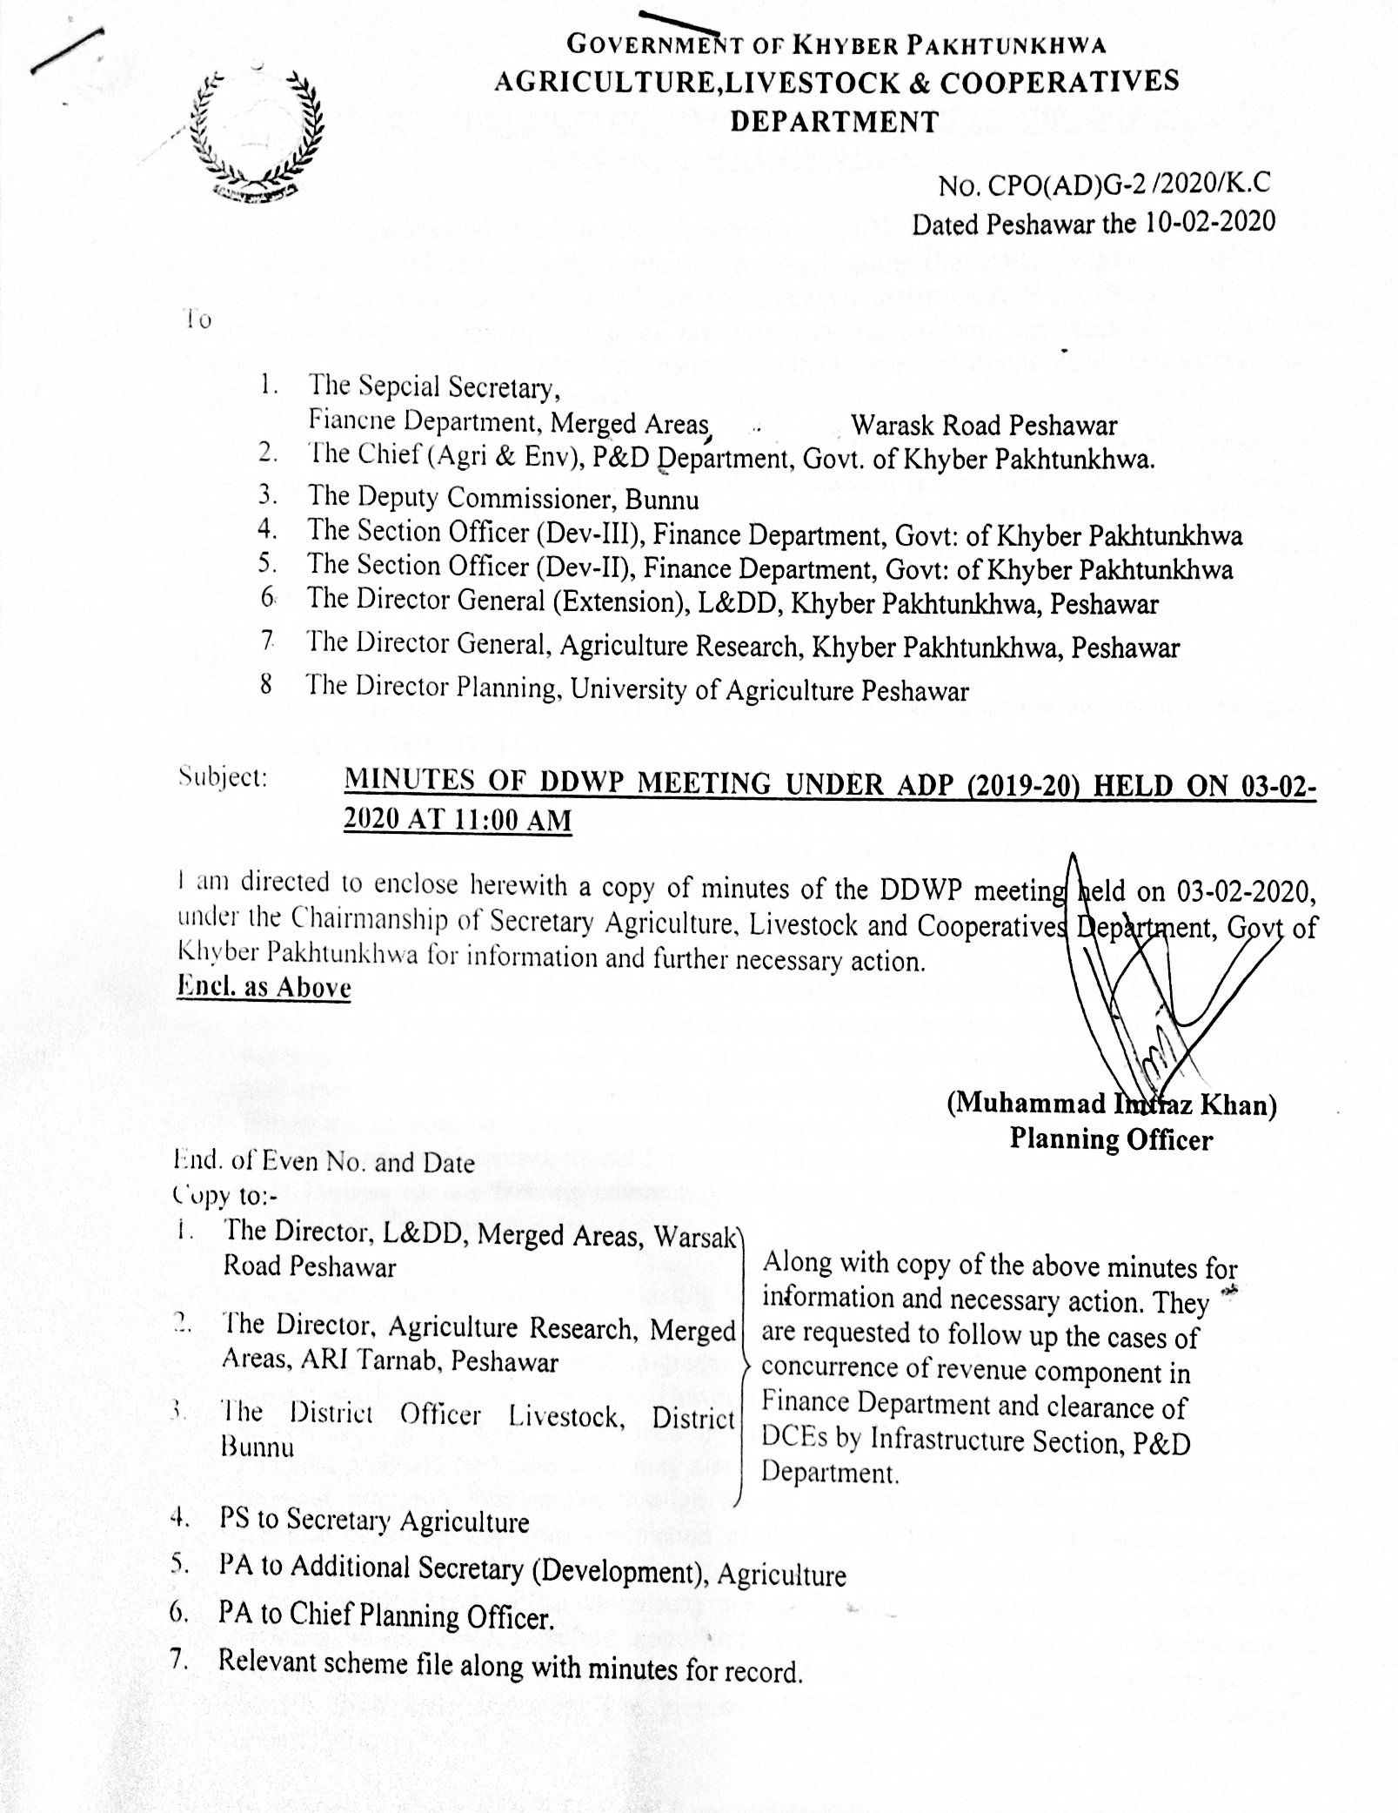
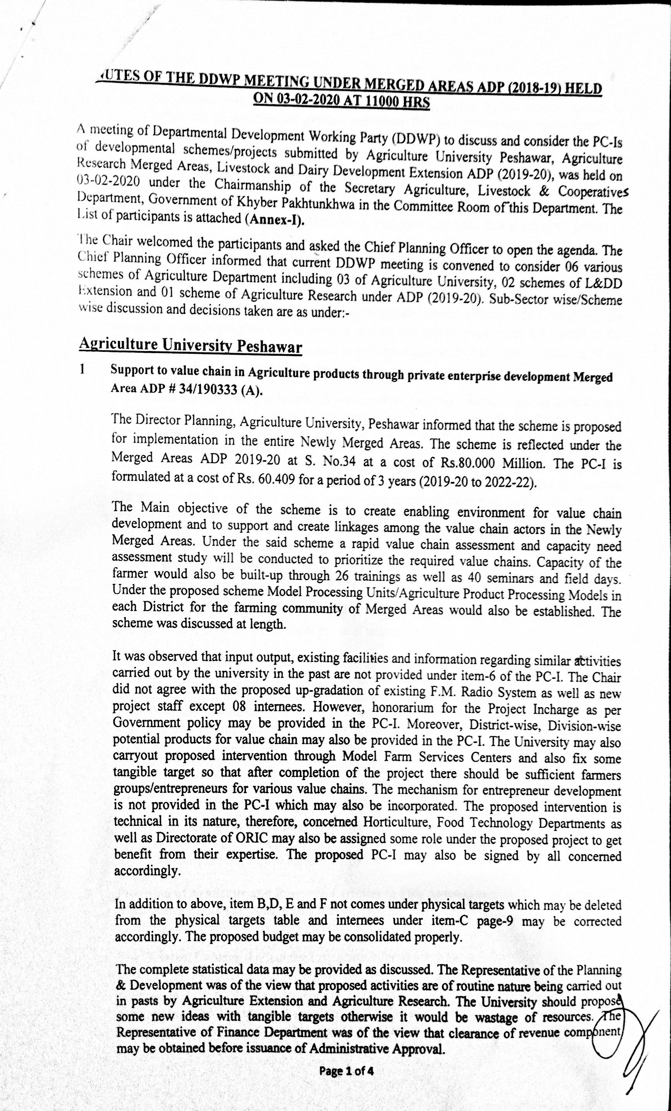
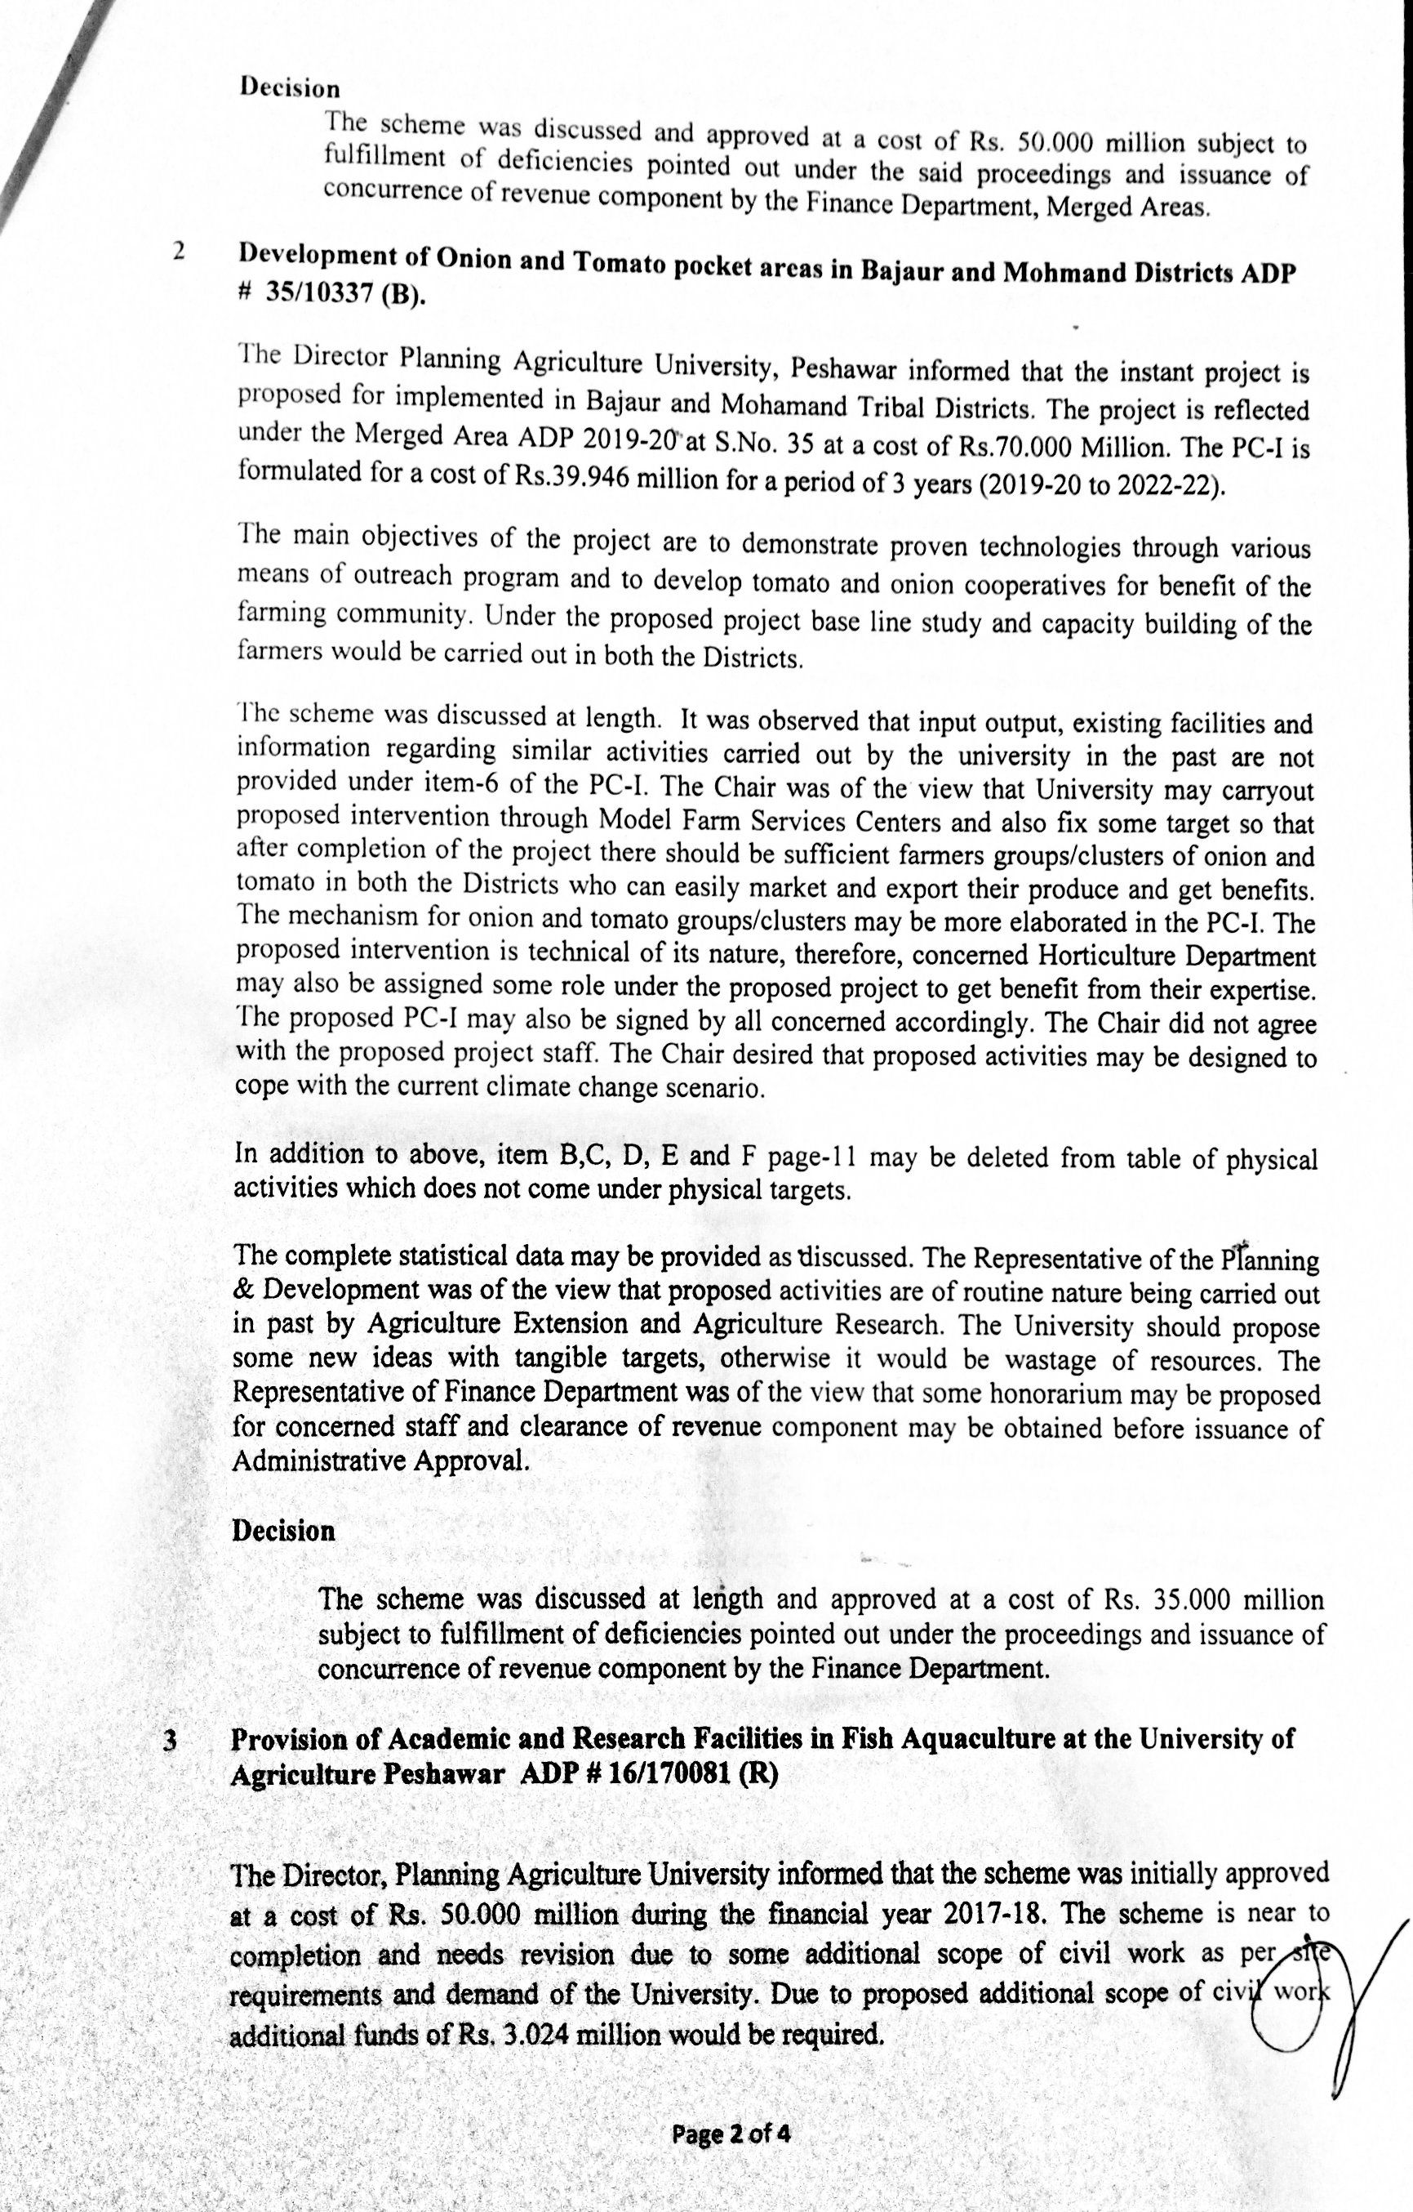
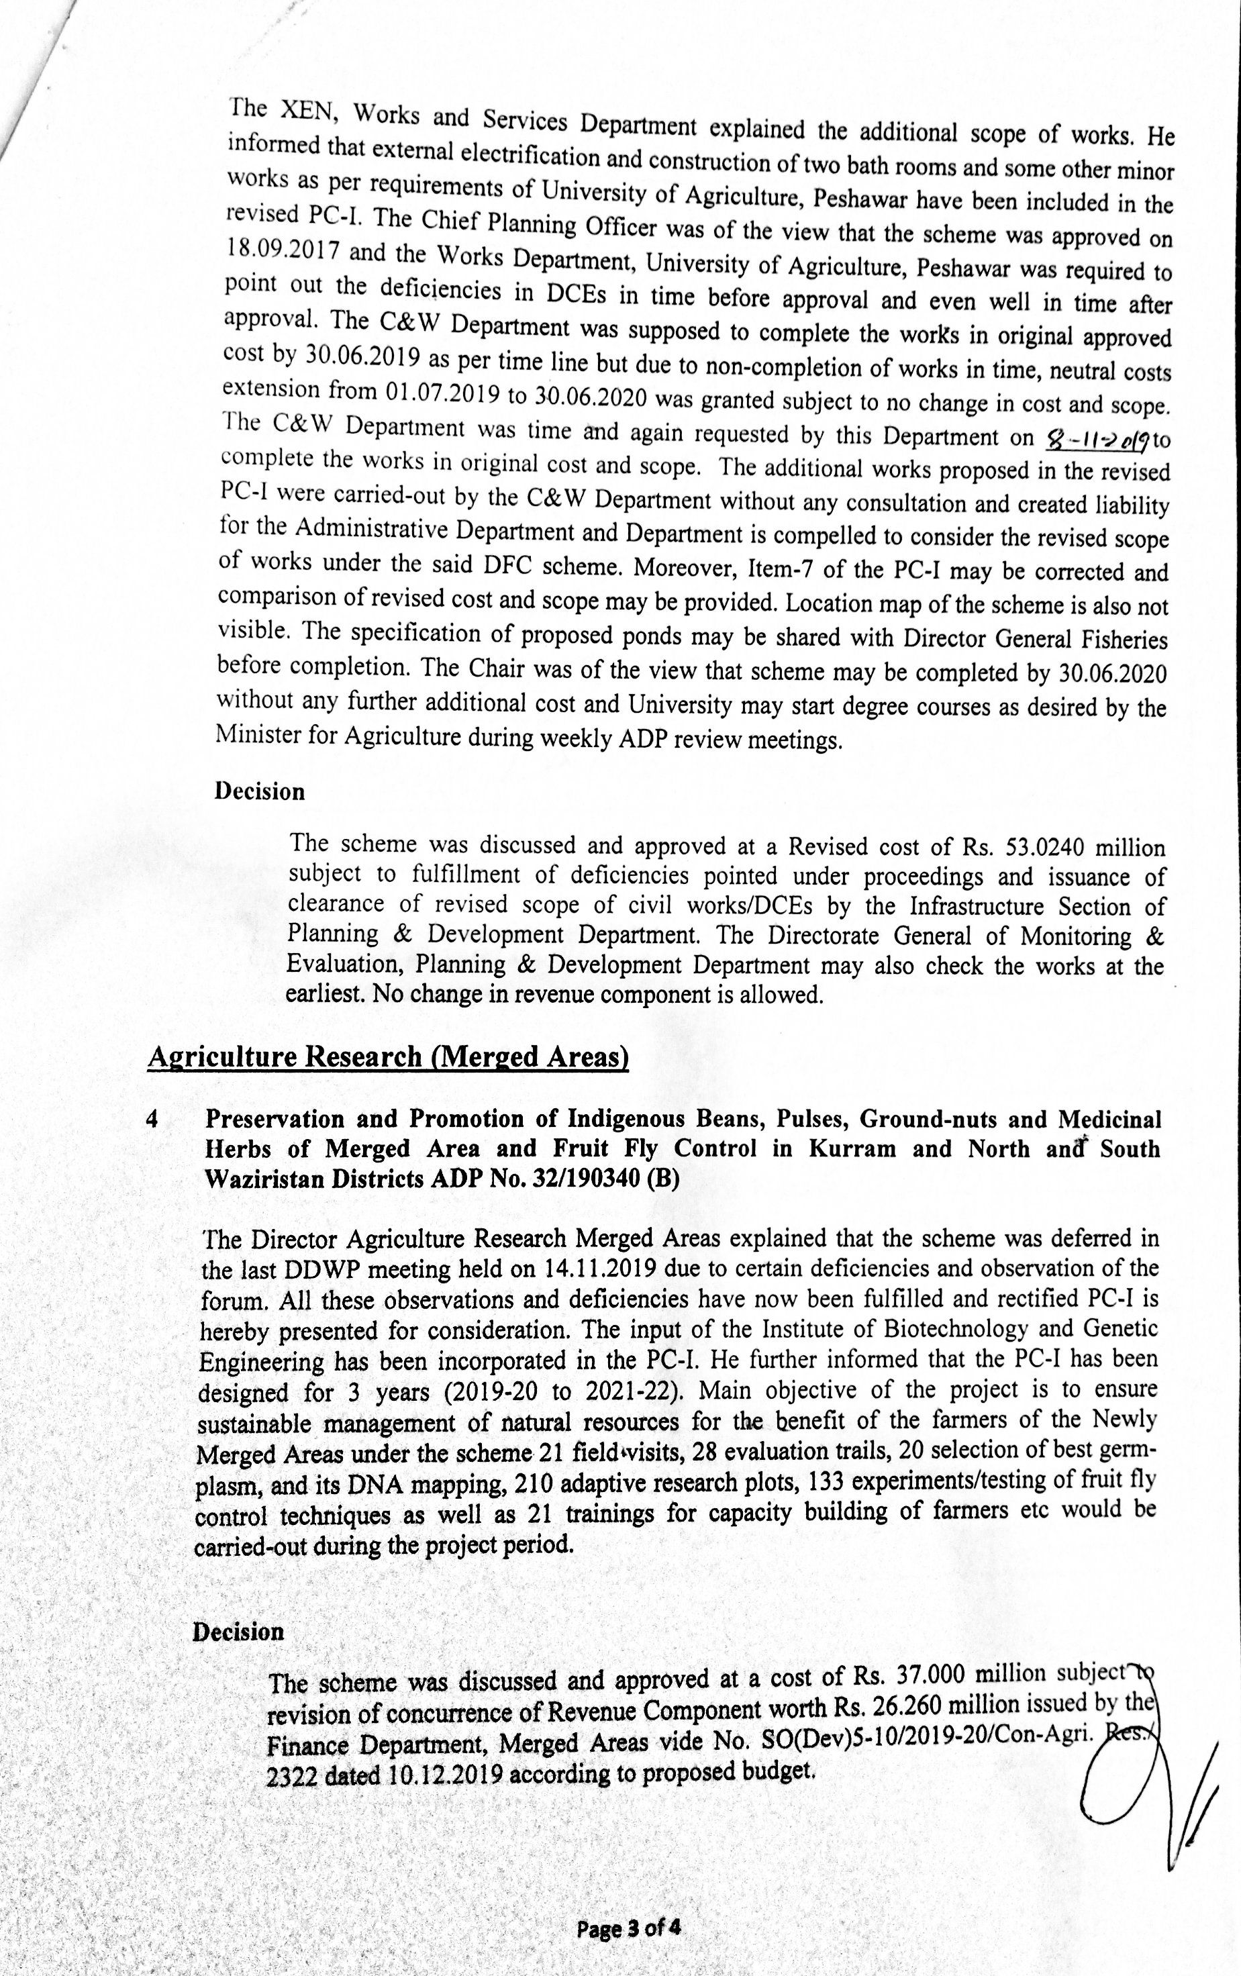
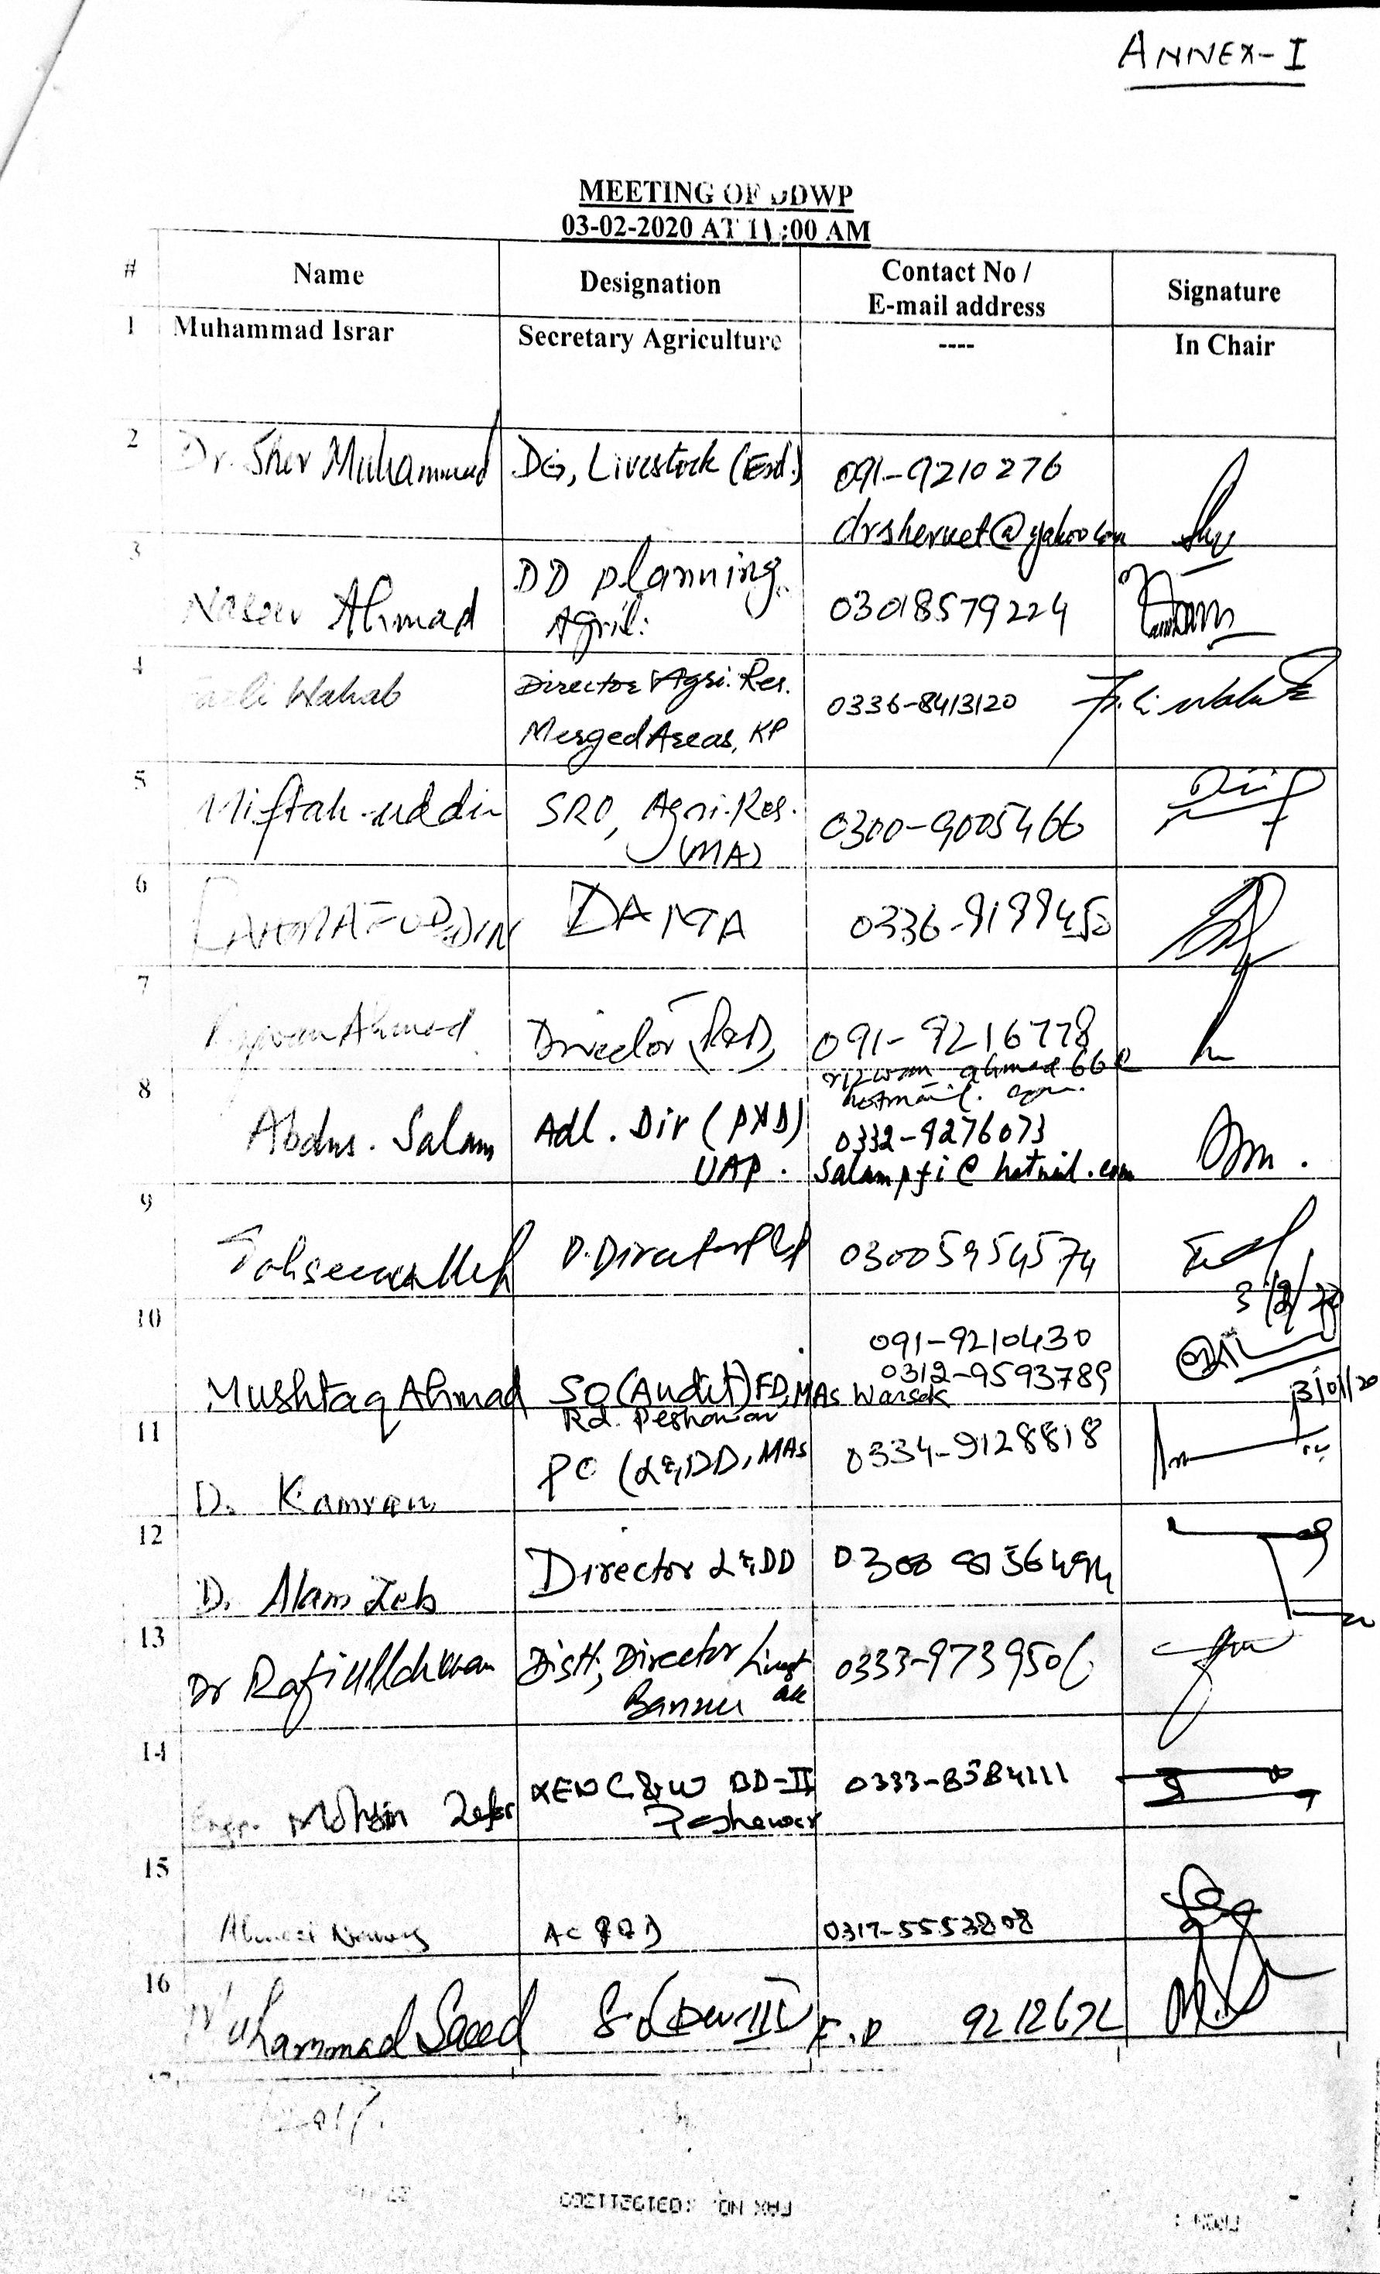
Annexure-10
