GOVERNMENT OF KHYBER PAKHTUNKHWA


PROJECT PC - I

210226 -Establishment of Information Management & Analysis Unit at Industries Department, ADP No. 934

2021-22 to 2023-24

Cost of the Project
Rs. 71.150 Million

July 2021

Industries, Commerce & Technical Education Department
GOVERNMENT OF KHYBER PAKHTUNKHWA

PC-1 FORM

1 | Name of the project: | 210226 - Establishment of Information Management & Analysis Unit at Industries Department, ADP No. 934
2 | Location: | Industries, Commerce & Technical Education Department, Govt. of Khyber Pakhtunkhwa, Peshawar  Coordinates: 34.009836; 71.558324
3 | Authorities responsible for:  - Sponsoring  - Execution  - Operation and maintenance  - Concerned federal ministry | Government of Khyber Pakhtunkhwa.  Industries, Commerce & Technical Education Department, Govt. of Khyber Pakhtunkhwa  Industries, Commerce & Technical Education Department, Govt. of Khyber Pakhtunkhwa  N/A

4. Plan Provision:

5 years plan is under operation in the country. However, such Projects (Projects of the capacity buildings) always remained part of the successive five year plans. The project is a component of the overall infrastructure and institutional capacity building efforts being pursued under the I.T. Policy and Action. The Project will enhance the capacity of Industries, Commerce & Technical Education Department in the process of planning and evidence based decision making. The total cost of the project is 71.150 million and for current financial year ADP 2021-22, Rs. 10 million is allocated.

5. Project objectives and its relationship with sector objectives:

- Prime Minister’s Task Force on Technology Driven Economy

The focus of the Government of Pakistan is shift towards technology to transform economy and capitalize huge human resource potential of the country. The development in all sectors is dependent on adaptation and use of technology that will ultimately improve governance and benefit the masses.

- Planning Commission’s Vision 2025

“Planning Commission’s Vision 2025” states that “In addition to the traditional fields of Science & Technology, the policy focus represents a paradigm shift in Research & Development in emerging technologies and its strategic exploitation through commercialization opportunities to create new companies, new solutions and new jobs.
Therefore a dire need of automated and integrated system to shrink substantial workload/workforce and its underutilization, ensure transparency and coping with delays is a dynamic approach for Department’s performance.

- Industries, Commerce and Technical Education Department, Khyber Pakhtunkhwa to introduce reforms in the industries and its allied formation processes through innovation and e-governance that ultimately improve public service delivery, and develop tools for performance management of all tiers of the industries department. For long-term sustainability of reforms, there is need for constant re-enforcement and rigorous follow-ups. The primary objective of this project is to ensure that all reforms, digitization and performance management tools are fully embodied in the government structure.

- Ensure effective service delivery to the citizens;
- Promote e-governance and use of latest Information Communication Technology (ICT) in industries department;
- Undertake performance management through Key Performance Indicators (KPIs) 4
- Effectively monitor service delivery and gauge performance.

6. Description, justification, technical parameters and technology transfer aspects (enclose feasibility study for projects costing Rs 300 million and above)

The key functions of the Industries, Commerce & Technical Education Department are: (a) to stimulate industrialization in the province, (b) support to commerce and trade in the province, (c) facilitation of private sector investment, (d) promotion of employment in private sector, (e) to encourage and sponsor entrepreneurship, (f) to promote ease of doing business and (g) development of skilled work force. The Department is presently operated by the following two attached Government organizations and seven autonomous organizations:

Government Organizations:

• Directorate of Industries & Commerce
• Printing & Stationery Department

Autonomous Organizations:

• KP Economic Zones Development & Management Company (KP-EZDMC)
• KP Small Industries Development Board (KP-SIDB)
• KP Technical and Vocational Training Authority (KP-TEVTA)
• KP Board of Investment and Trade (KP-BoIT)
• Shuhada-e-APS University of Technology (UoT) Nowshera
• KP Trade Testing Board (TTB)
• KP Board of Technical Education (BTE)

IT plays an important role in various sectors and industries for development industrial growth and bring innovations through modern technologies. Similarly, IT strives to make things simpler in the manufacturing sector as well. In an industry that automates things for the benefit of humankind, IT helps to make the manufacturing process less cumbersome and more automated. IT helps drastically in delivering just-in-time insights, swift visibility, and seamless innovation for implementing new-age solutions. The latest trends also indicate various multi-dimensional services spanning IT that aim to transform businesses, change the design, and boost value-added services including infrastructure management and the like.

Though the Industries Department is one of the big Departments in the province and has a role in sharing in the economy of the province but presently it is lacking of the technological interventions in this modern era. In order to cope with the new era interventions and compete with the national / international industrial production / marketing trends, this Department is also in dire need IT/Digital interventions. This will bring ease in the planning process and taking evidence based decisions. The planning wing of the department will oversee and channel the operations of the unit for effective implementation of the project activities.

6.1 Management Information System (MIS):

In order to monitor the performance on real time basis, development of centralized Management Information System (MIS) is required for Industries, Commerce & Technical Education Department, Directorate General of Industries & Commerce, District Formations, Consumer Courts and Govt. Printing Press. In this regard a performance review dashboard system and digitalization of all sections are proposed to be developed to cater the need of data-driven and efficient decision making system.

The digital dashboards will be designed for all the ongoing routine work and service delivery. These digital dashboards will guide and equip the Departments to review, reports, organize and monitor and also facilitate faster exchange of critical information between various departments in the government sector, substantially reducing the amount of paperwork / men hours that the department personnel have to handle i.e. sharing of information.

Under the proposed system, Digital Dashboards created, will visualize and summarize the data against (KPI’s), after statistics information is stored, which can be easily reused for future effective decision making.
The MIS will introduce modules/sub modules to digitalize the laws and rules for efficiency, transparency and smooth the official activities. All the district offices will be integrated and monitor the performance and activities from one place.

Need of Digitalization for the Industries, Commerce & Technical Education (IC&TE) Department.

Currently The IC&TE Department has no consolidated reports in the digital form which may help the Department in the following areas;
- To introduce new & more effective management tools that will enable this project to modernize the IC&TE Department to meet the challenges of an ever changing society.
- To make strategic decisions to improve departmental efficiency and productivity through consolidated and accurate information.
- To introduce the concept of e-governance as per policy of the Provincial Government and also enables industrial enterprises to elevate efficiency and productivity.
- Manage all activities at single platform and evaluation for performance monitoring,
Speedy and proper execution of Reports.

Figure 6.1
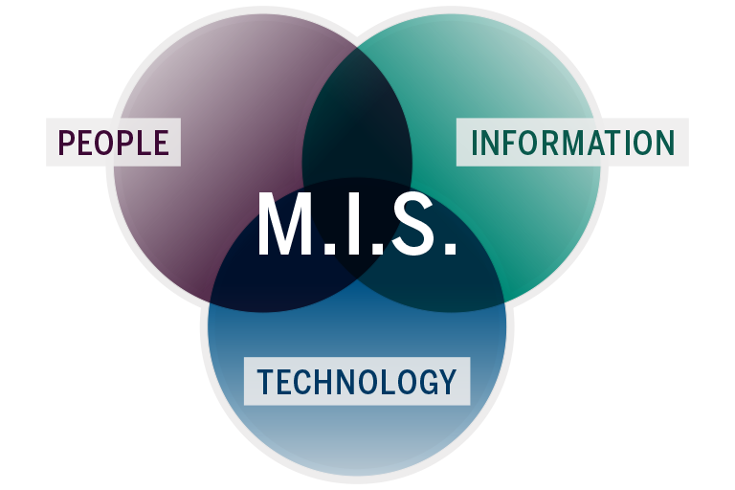

Functions

The Information Management & Analysis Unit will perform the following functions;

- Develop Integrated Management Information System for Industries Department.
- Digitization apparatus development for facilitating existing statistics, information and projects (intended for data basing). Proper utilization of digital technologies and data for escalating output, structural processes that create value and a digital business environment.
- Provide Technical assistance to the Industries secretariat for implementation of IT based interventions introduced by the government from time to time.
- Automation of all possible tasks at IC&TE, DGIC and GPP.
- Tracking on Quantifiable Performance Indicators (QPIs).
- Tracking implementation of sectoral reforms through IT-based solutions in industries department, their attached departments and allied institutions;
- Integration and implementation of all existing MIS modules
- Computerization of existing manual records and develop systems for digitization of services in Industries Department.
- To assist implementation of e-governance as per policy of the Provincial Government and also enables industrial enterprises to elevate efficiency and productivity.
- Assist the planning wing of the department in data provision, management for efficient and effective use in the planning process.
- Collection of data & analysis for its effective utilization in making evidence based decisions in the planning process.

7. Capital Cost Estimates

Component wise break up attached.

8. Annual operating and maintenance cost after completion of the
Project

After completion of the 3 years’ project life, the recurring cost (i.e. HR salary) will be borne from current budget and placed in the schedule of respective cadres at provincial level (IT/PPS). Recurring cost with regard to computers maintenance will be paid through current budget.

9. Demand and supply analysis

There is critical demand to modernize and improve the functioning of various tiers of provincial government. A culture of quantified performance management needs to be established and structural reforms should be implemented. Further, there is a need for transition towards e-governance.
Currently there is no central body that addresses these critical needs. The extension of IMAU in the IC&TE office will satisfy this demand and supply gap.
Lastly, there is dire need for governance accountability. Though the government has established various bodies for financial accountability, but there is none other than IMAU that serves for governance accountability.

10. Financial plan and mode of financing

The costs reflected in Annex-A, B, C will be covered through ADP. Additionally, IMAU will seek support of the donor’s agencies to fill the gaps in case of insufficiency of budget in the ADP. It will be financed by the Provincial Government. During the project period Rs. 71.150 million would be allocated by the Finance Department and placed at the disposal of the Industries, Commerce & Technical Education Department.

11. Project benefits and analysis

i) Financial & Economic Analysis
In terms of smooth and efficient tracking process of progress through this system can no more prolong business activities and regarding developmental projects it will make certain that no financial delays will occur. Hence the economic activities will occur in appropriate fashion and will benefit the economy as a whole without any scarcity and deferrals. This will improve and strengthen the implementation of the project cycle at all level.

ii) Social benefits with indicators
Successful implementation of the reforms would help in improving institutions by providing better public service delivery on one hand and promote the development of social, human, financial and physical capital on the other. This will ultimately improve the means of livelihood and lead to poverty alleviation. It would also bring in accountability, restore citizens’ confidence and would also create a conducive environment for private sector investment, which in turn would also stimulate socio-economic uplift

iii) Employment generation (direct and indirect)
18 personnel would be employed through direct implementation of the project.

vi) Environmental impact
N/A

vi) Impact of delays on project cost and viability
Failing to notice the existing capacity of Government & IC&TE department and making delays in such projects will affect the proper utilization of information and conducts in order to make right decisions on right time.

12. Implementation schedule

Starting: 1st July, 2021.
Completion: 30th June, 2024.
Year wise breakup is as under:

Rs. In Millions
Year | Financial Requirements | Physical Achievements
2021-22 | 29.397 | Project Initiation
2022-23 | 20.877 | Project continuation
2023-24 | 20.877 | Project completion
Total | 71.150
Details of the above are at Annexure-A, B & C.

13. Result Based Monitoring (RBM) Indicators.
Figure 13.1
INPUT
MIS

OUTPUT
Development of a Solid medium for data collection point and integration of all existing modes of medium

OUTCOME
Multiple dashboards for data collection to identify critical paths

Quick deliverables and sensitization of decision making process
TARGET IMPACT

TARGET AFTER COMPLETION
Efficiency in overall department’s official mechanism

The MIS will help in defining the processes, production and its efficiency in the planning & decision making process by generating the required statistics and information for planning officials. It also creates different reports to obtain necessary information for scheduling and forecasting in timely manner. Reduction of illicit manpower and creation of advance job opportunities for new generation. With reference to several research studies a significant and positive relation is concluded with Organizational performance and efficiency.

The main outcome of the project would be:
- Integration of all entities to a single medium
- Efficiency in overall department’s official mechanism
- Transparency in official activities
- Technical assistance for Ease of doing business
- Improvement in productivity and reduction in occupational segregation (inequality, discrimination, biasness etc. through provision and effective utilization of reliable data

The proposed concept is in relevance with the following SDG’s:
• Goal.9 Industry, Innovation and infrastructure
• Goal.8 Decent work and Economic Growth.
• Goal.16 Peace, Justice and Strong Institutions
• Goal.10 Reduced Inequalities

Figure 13.2
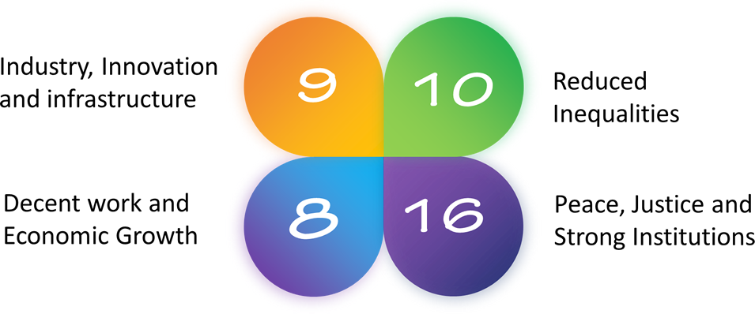

14. Management structure and manpower requirements including specialized skills during construction and operational phases

Administrative arrangement for implementation of the Project already exists. Execution of the project will be the responsibility of planning wing, Industries, Commerce & Technical Education Department.

Steering Committee:

Steering Committee will oversight the overall progress of the project. The Committee will provide advice, decisions, ensuring delivery of the project outputs, achievement of project outcomes. The committee will consist of the following members:

- Secretary IC&TE Department Chairman
- Rep. of Directorate of Industries Member
- Rep. of KP EZDMC Member
- Rep. of KP BOIT Member
- Rep. of SIDB Member
- Rep. of KP TEVTA Member
- Economic Advisor IC&TE Member
- Rep: of Finance Department Member
- Rep: of P&D Department Member
- Research Officer-I, IC&TE Member-Cum-Secretary

Interview/Selection Team:

For short listing of candidates, conducting interviews and selection of project staff from the open market, the Industries, Commerce & Technical Education Department will notify a Recruitment Committee. The composition of the Recruitment Committee will be as per project policy. The existing government officers having required qualification working against the IT positions can also be posted through transfer as per project policy.

Tendering Mechanism for purchase of Equipment:

Procurement will be done through transparent tendering process (calling tender through widely circulated newspapers and also on web requiring warranty/labor onsite for a period of at least year and warranty of parts (motherboard/processor) for 3 years. Bids will be invited by the Industries, Commerce & Technical Education Department through the tender inviting authority (Purchase Committee). Only those tenders will be entertained which meet all the specified terms and conditions. Evaluation criteria will be made known to vendors upfront. Specifications for the computers and other equipment will be finalized by the Purchase Committee. The composition of Purchase Committee will be according to the project and KPPRA rules.

Manpower requirements

Manpower requirement are at Annex-D.

Job description, qualification, experience, age and salary of each job

Job description is at Annex-A&D

15. Additional projects/decisions required to maximize socio-economic benefits from the proposed project

This project genuinely focuses on socio-economic benefits in terms of transparent, unambiguous and effective system to initiate and to support the “Right to Information Act” and “Rules of conduct”.
- After the completion of the project, the IMA Unit should be made part of the current budget and the positions be placed in the schedule of respective cadre (IT/PPS).

- To attract specialists from the market, the special IMA Unit allowance needs to be approved.
- The IMA Unit will support the enactment of provincial “e-Governance & Performance Management Act” which will ensure sustainability of reforms initiated by the IMA Unit.
- In case of delays in shifting of project to current side, the same should be revised for further reasonable period as per requirement and decision of the competent authority.
- To support the project through foreign funding in case of availability of donors in future.

16. Certified that the project proposal has been prepared on the basis of
Instructions provided by the Planning Commission for the preparation of PC-I for production sector projects

Prepared by:
Muhammad Umar Khan
Research Officer

Checked by:
Hashmat Ali
Economic Advisor

Approved by:
Humayun Khan
Secretary
Industries, Commerce & Technical
Education Department

