ADP # 210671/19
PC-1 Cost: Rs. 196.050 Million
CFY Allocation: Rs. 50.00 Million
Project Duration: 3 Years (2021-22 to 2023-24)

PROMOTION of Honey Production for livelihood improvement in Khyber Pakhtunkhwa

PC-1
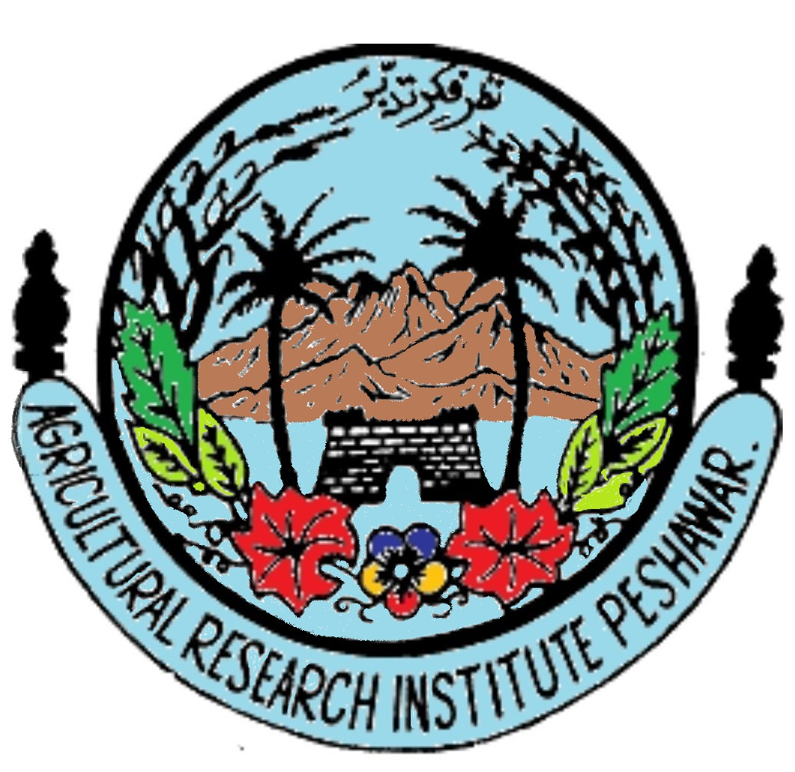 | 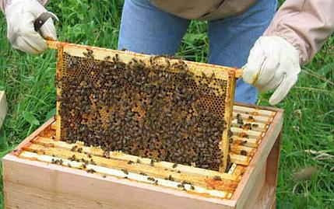
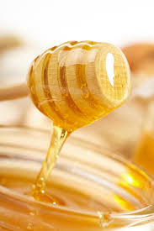 | 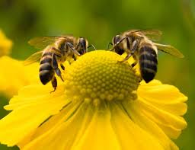

agriculture, livestock, fisheries & coop: department
Government of khyber pakhtunkhwa

Directorate General Agricultural Research, KHYBER PAKHTUNKHWA
(2021-22)

The manpower required of skills/professionals during execution and operation of the Project.

The following manpower (Agricultural Graduate and Technical/Professional, skilled and non-skilled) will be required for the execution and operation of the proposed Project. For effective implementation and smooth running of the proposed project, some of the existing officers, officials and laboratory and Honey Bee field staff will also be engaged in the project activities.

S# | Name of Posts | Nos. | Justification
1 | Internee | 02 | In order to execute the project necessary staff is available however, activities of the department is increasing day by day due to projects of ADP, therefore recruitment of Internees is necessary for proper implementation of project activities efficiently and effectively.  Therefore, Agriculture graduate having M.Sc/B.Sc.(Hons) with specialization in Entomology/Biochemistry from recognized university.

