PROVINCIAL LAND USE PLAN (PLUP)

REVISED PC-I

ADP No. 2151(80059) 2020-21

Estimated Cost (Revised) Rs. 428.444 Million

URBAN POLICY AND PLANNING UNIT
PLANNING & DEVELOPMENT DEPARTMENT
GOVERNMENT OF KHYBERPAKHTUNKHWA

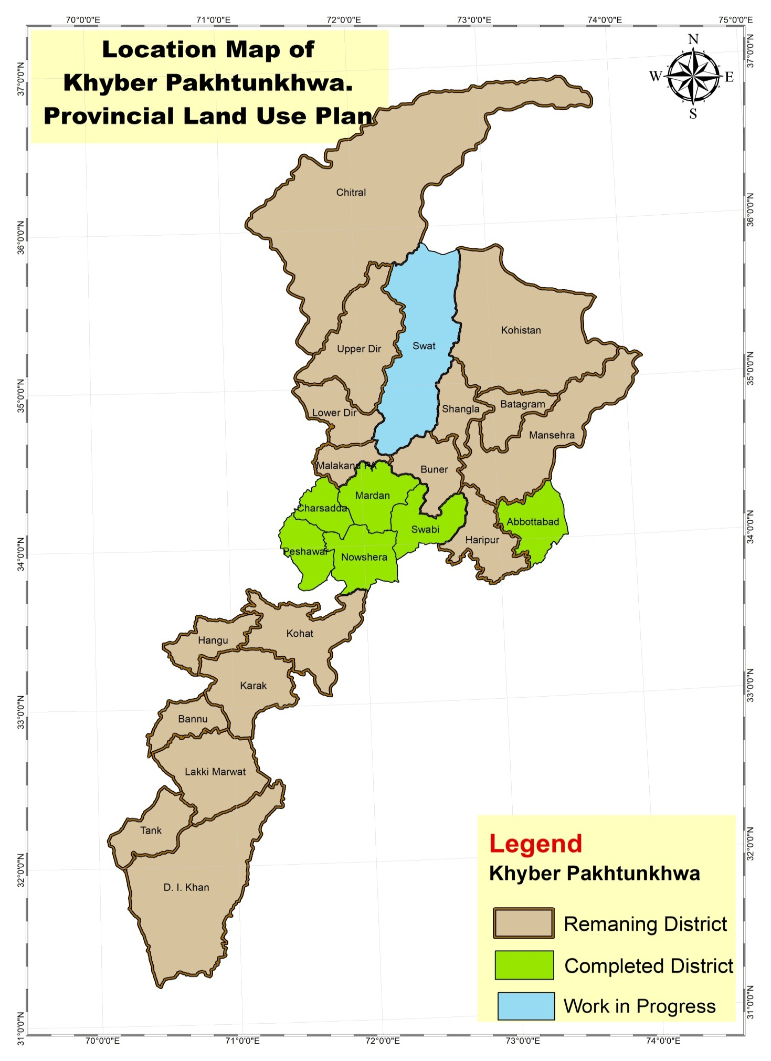

Item-wise comparison of approved cost with revised estimated cost (Rs in million)
S# | Items | Approved Cost | Revised estimated cost | Difference
1 | Staff Salaries | 66.100 | 188.214 | 122.114
2 | Operating Expenses (Communication) | 0.784 | 1.814 | 1.030
3 | Utilities | 5.660 | 3.654 | -2.006
4 | Occupancy Cost (05% annual increase) | 8.649 | 17.937 | 9.288
5 | Travel & Transport | 12.635 | 15.333 | 2.698
6 | General | 5.806 | 8.133 | 2.327
7 | Purchase of Cars | 15.290 | 11.771 | -3.519
8 | Machinery & Equipment | 8.471 | 8.928 | 0.457
9 | Repair & Maintenance | 4.150 | 7.904 | 3.754
10 | Furniture & Fixture | 1.498 | 1.811 | 0.313
11 | Medical | 1.000 | 0.900 | -0.100
12 | Honorarium | 0.200 | 0.400 | 0.200
13 | Entertainment & Gifts | 0.895 | 0.863 | -0.032
14 | Registration for vehicles | 0.141 | 0.171 | 0.030
15 | Consultancy Services (General) | 145.193 | 156.610 | 11.417
16 | Payments to four academic experts one each from NIUIP, NUST, UET Peshawar and DRUP University of Peshawar @ Rs 50,000/- per report. | 0.000 | 4.000 | 4.000
Total |  | 276.470 | 428.444 | 151.972

ESTIMATED CONSULTANCY SERVICES COST FOR DISTRICT LAND USE PLAN FOR 05 DIVISIONS OF KHYBER PAKHTUNKHWA EXCLUDING MERGED DISTRICTS
Based on market analysis, however the actual cost will be based on the financial Proposal submitted by the consultants at the time of RFPs
Division Names | Estimated Consultancy Services Cost (Rs Million) | Area (Sq.km) | Population | Density
Malakand Division | 30 | 29478.7 | 7,514,694 | 254.92
Hazara Division | 30 | 17163.2 | 5,325,121 | 310.26
Kohat Division | 20 | 7010.4 | 2,218,971 | 316.53
Bannu Division | 20 | 4362 | 2,044,074 | 468.61
DI Khan Division | 25 | 9048.3 | 2,019,017 | 223.14
Total | 125 | 67062.6 | 19,121,877

PC-1 FORM
 | Name of the Project |  |  | Provincial Land Use Plan, Urban Policy & Planning Unit (UPU), Planning &Development Department (P&DD), Government of Khyber Pakhtunkhwa
 | Location |  |  | Khyber Pakhtunkhwa
 | Authority Responsible for  - Sponsoring |  |  | Government of Khyber Pakhtunkhwa
 | - Execution |  |  | Provincial Land Use Plan, UPU, P&DD
 | - Operation & maintenance |  |  | LGE & RDD
 | - Concerned Federal Ministry |  |  | Planning Commission
 | Plan Provision |  |  | The scheme has been included in the ADP 2020-21 vide ADP No. 80059 with estimated cost Rs. 276.47 Million.  Allocation for FY 2020-21 is Rs. 20.00 Million.
 | Project Objectives and its relationship with Sectorial Objectives |  |  | - To promote efficient utilization, acquisition & disposition of land.  - To initiate a process for evidence-based land use planning in the province.  - To provide broad guidelines to the nation building departments, agencies for undertaking multi-sector, multi-year integrated and coherent development program for each district of the province.  - To document and classify land of each district of the province and properly allocate land for future development needs.  - To direct, harmonize and influence discussions and activities of the private and public sectors  - To reconcile land use conflicts/proposals between and among individuals, private and government entities  - To preserve areas of ecological, aesthetic, historical and cultural significance and to ensure local food security and sustainable development  (TORs attached as Annexure-A)
 | The Project
 | - Description of the Project |  |  |  | The Provincial Land Use Plan is envisaged as a policy document for an integrated, coordinated and systematic planning and even spread of development activities, employments to the rural and sub-urban population close to home and reduce pressure on mega cities. It aims at establishing hierarchy of settlements and developments of Satellite, Intermediate, Secondary and Industrial Towns as focal points of future to cater the rural areas and small towns. Meanwhile, the Plan will aim at optimizing exploitation of human and physical resources, maximizing provincial income, increase in overall activity and balanced distribution of infrastructure and services and increased per capita Income. It will also provide guidance to the nation building departments agencies including District Governments/TMAs for undertaking integrated and coherent development programs through holistic planning approach.  The project also aims to document and classify the land of each district on the bases of current and proposed utilization of the land taking into account agricultural land, residential areas, barren lands, forest, grasslands, water courses, land being utilized for communication networks etc.  More importantly the project aims to conserve the prime agriculture land of the province from non-agriculture uses; encroachment in order to ensure local food security and sustainable development of the areas.  According to Section 4, Sub-Section 2 (xv) of the NWFP Housing Authority Act 2005, the NWFP Housing Authority (PHA) is required to formulate a Provincial Land Use Plan/Policy of the province. Therefore, Project Management Unit (PMU) under the Housing Department in PHA was established on 1st April, 2010. This unit initiated the process of formulation of a Provincial Land Use Plan/ policy of the province in the year 2010.  Project Management Unit was shifted to UPPU in 2013 under the direction of the Honorable Chief Minister of Khyber Pakhtunkhwa on grounds that scope of the project is beyond Housing only (Annexure-B). In order to make the formulation and subsequent implementation of the plan by involving all concerned departments, P&DD was considered more appropriate location to house this project. Upon shifting of the project to P&DD, the name of the Project Management Unit of Land Use Plan was changed to Provincial Land Use Plan  (Annexure-C).
 | - History |  |  |  | The Provincial Land Use Plan (PLUP) is composed of staff qualified in Spatial Planning and Geographic Information System (GIS).  The purpose of the project is to prepare the district Land Use Plans for every district of Khyber Pakhtunkhwa. Currently in Khyber Pakhtunkhwa, development is going on in a haphazard way which leads to jeopardize utilization of the land and its resources. Currently the province has a very high rate of population growth associated with rapid changes in land use creating unfavorable conditions for natural resources of the province which is not only affecting the provincial economy but also gradually deteriorating living standards of the people of the region. The proposed District Land Use Plan will serve as a major planning document by allocation of land for future development initiatives. This will help to fulfill human needs in a more effective manner and also ensure protection of the natural environment.  The Land Use Plan will bring a paradigm shift in the planning system of the province and will provide a tool for rational and evidence based planning system in the province. Rational Development Plan requires a comprehensive and systematic Land Use Plan which is a pre-requisite for sustainable development. The allocation of land for various human needs is imperative for urban, regional and provincial level development activities. The District Land Use Plan will help to better manage the already scare land resource and earmarked land for various activities for next twenty years.  District Land Use Plans will be prepared for all 28 districts of Khyber Pakhtunkhwa. As per approved work plan, distribution of work was made in three phases as per following details:
Target Districts | Work done (%)
- Peshawar | 100%
- Mardan | -do-
- Swabi | -do-
- Nowshera | -do-
- Charsadda | -do-
- Abbottabad | -do-

 | - Justification of the Project | In Khyber Pakhtunkhwa, the Master Plans/Structure Plans of cities and towns were prepared in isolation of their hinterland, a piecemeal and isolated effort. Under the devolution plan the local governments have to prepare district development plans for their respective districts which are not possible without the availability of proper in-depth district/regional land use map showing various land use both actual and proposed. The current Government taking cognizance of the situation, has decided to carry out development of all areas of the province by adopting an integrated and holistic planning approach.  The provincial cabinet in its meeting date 26/10/2017 decided to constitute a committee under the Chairmanship of ACS P&D to submit a comprehensive plan for regulating Land use planning, urbanization and mushroom growth of Housing schemes on cultivable land. In the wake of this decision, role of PLUP has been increased many folds. By end of 2019 PLUP was able to finalize the land use plans of six districts (Abbottabad, Peshawar, Mardan, Nowshera, Charsadda and Swabi) and handed-over these plans to LGE and RDD for approval from the competent forum. However, land use plans of all the remaining districts of the province are required to be completed on emergent bases. PLUP will prepare Landuse Plans of 21 districts in the next 3 years. By the end of the proposed extension, the Provincial Government will have land use plans of the Province. PLUP Consultancy Procurement Plan (Annexure-E).  At the end of the Project, a comprehensive land use plan of the whole of Khyber Pakhtunkhwa province will be available. Proper Land Use and resource management of the province will ensure the appropriate utilization of land and its resources and appropriate allocation of developmental budget which will ultimately benefiting the masses at a larger scale.  The uncontrolled invasion over the agriculture land as well as the rural-urban migration would be minimized resulting economic benefit to the province. Properly planned towns & villages will be developed. The ongoing ruination of precious agricultural lands will come to an end. Based upon recommendations of these plans, equitable distribution of resources would be possible to ensure.  The Province of Khyber Pakhtunkhwa is facing issues in sustainable development including the absence of a proper Land Use Plan or a legitimate policy document to provide guidance to the nations building departments/agencies for future development. If steps were not taken to solve the issue immediately, it may transform into a disastrous situation for the people of the province.  Over and above the other related issues, the conversion of prime agriculture land into housing and infrastructure bearing lands is leading the province to food insecurity. Due to rapid population growth and unavailability of employment opportunities in the rural areas, people are migrating from rural to urban areas creating severe stress on the civic facilities in urban centers. Further, as a result of unplanned development it is difficult for the local municipalities to provide municipal services to these areas.  The guided land use distribution will result in creation of better living environment with proper sanitation, safe drinking water supply and other facilities. Forestation will make the environment clean and healthy reducing the chances of epidemic/calamities and other natural disasters.  The original PC-1 was approved in 2010 and was extended/revised at different times keeping in view the importance of the Project. The scope of the project cannot be achieved in time as the administrative control was shifted from Housing Department to P&D Department and then to the Urban Policy and Planning Unit. Initially the task was outsourced to private consultants but later it was decided that the project will be completed by the PLUP staff. The concept of Land Use Plan was quite new in Khyber Pakhtunkhwa Province and there was lack of expertise and experience in this field. All these factors caused delay in the completion of the Project.  The district land use plan of Peshawar, Charsadda, Nowshera, Swabi, Mardan & Abbottabad successfully completed and handover to LGE&RDD for further approval from the competent forum and implementation. The work on districts Swat is in progress (in-house). The PLUP will complete the remaining 22 districts through consultants in 3 years duration.
 | - Technical Parameters | The PLUP will provide a proper mechanism for future development and will strengthen the district / local government institutions responsible for construction, maintenance, operations and financing of municipal infrastructure and services.  Establishment of Geographic Information System (GIS) and a detail database at district /provincial level will have the capacity to produce up-to-date maps of various land uses for rational decision making. These maps can be over laid, updated or generate at any desired scale and will provide a comprehensive tool to monitor the status of each area marked for various uses. The land use policy and rules will be developed at the end.
 | Cost Estimates
 | Date of Estimation of project Cost |  | July, 2020  Estimated Cost of the project for next 3 Years (July 01, 2020 to 30th June, 2023) is Rs 245.409 Million (Summary of cost estimate at (Annexure-F).
 | Basis of determining the capital |  | The Cost is based on the previous work and market surveys.
 | Justification for revision of PC-1 |  | - By end of 2019 PLUP was able to finalize the land use plans of six districts (Abbottabad, Peshawar, Mardan, Nowshera, Charsadda and Swabi) and handed-over these plans to LGE & RDD for approval from the competent forum.  - Work has been initiated on the District Land Use Plan of Swat and will be completed in-house by June 2021.  - By the end of current extension of the PC – I the Provincial Government will have Land Use Plans of the remining 22 districts including all divisional headquarter districts (Peshawar, Abbottabad, Swat, Kohat, Bannu and DI Khan).  - The Federal Government has also advised all the provincial governments to prepare Provincial Land Use Plans of their respective provinces on priority basis (Annexure-D),  - The LGE&RDD is in the process of finalizing the Physical Planning Act/Law for the formation of Land Use (Planning & Management) Authority the province of Khyber Pakhtunkhwa by the direction of Honorable Chief Minister Khyber Pakhtunkhwa and the District Land Use Plan is an important component of this law. It is also worth mentioning that control over the land use is a high priority area of the present Provincial Government. The land use plans of 6 districts (Peshawar, Mardan, Charsadda, Nowshera, Swabi and Abbottabad) are already completed and the LGE & RD Department have initiated the process for its approval. To avoid further delay in completion of the project, it is extremely necessary to revise PC-1 of the project and expedite process for development of land use plans for all remaining districts of the province.
 | Year-wise estimates of operating  Expenditure |  | Year Wise estimate of operating expenditure of Provincial Land Use Plan (PLUP) for the next 3 years is placed at (Annexure-G)
 | Annual Operating & Maintenance cost after completion of the Project |  | As per approved procedure.
 | Demand & Supply Analysis |  | Injudicious location and allocation of land had caused severe effects on the life of people of both urban and rural areas.  The Province is generally confronted with growing environmental issues like urbanization, population explosion, non-judicious exploitation of natural resources, air pollution, surface and sub-surface water exploitation and solid waste generation. These environmental issues threaten the development process both in social and economic terms. The extended stay of Afghan refugees and the Temporality displaced people (TDPs) of different regions of FATA to the settled areas has further aggravated the problem by putting immense pressure on the local economy, infrastructure and ecology.  The GIS and land use plan will provide baseline for inclusion in draft legislation by different institutions in the province as required by the government.  The project will help to identify and strengthen the government policies/ programs in urban sector.  It will control and regulate the physical growth of the villages, town and cities in accordance with proposed strategies to preserve the environment and resources.
 | Financial Plan and Mode of financing |  | The project is included in the Government of Khyber Pakhtunkhwa Annual Development Plan ADP No. 2151(80059) with ADP cost of Rs. 276.47 Million. Allocation for the financial year (FY-2020-21) is 20.000million.
 | Project Benefits & Analysis
 | Financial |  | Proper Land Use and resource management of the province will ensure the optimum utilization of Land and its resources and will provide a rational decision-making tool to financial managers for allocation of resources for development activities in the province.
 | - Social Benefits with Indicators |  | The ultimate beneficiaries of the project will be the people living in both urban and rural areas. Through land use planning people will be able to have better understanding of their land and environment and will be able to efficiently utilize the land and its resources.  Potential areas will be identified for development of new resource based small and medium town with optimum infrastructure that will reduce the migration of people from rural areas to urban areas and rural population will have access to employment at their door step. Further, rural areas of the province will not deprive of their skilled human resource.
 | - Employment Generation  (Direct & Indirect) |  | Direct:  The Provincial Land Use Plan shall be providing employment opportunity to 32 Nos of staff with provision of 08 No of Internees.  Indirect:  Currently the province of Khyber Pakhtunkhwa is facing actuate shortage of trained technical professionals in the fields of urban planning, regional planning, rural planning and development, Geographic information System resource management. The current project will provide an opportunity to local professional to get hands on training on all aspects of planning and development.  The development of resource based industrial towns will boost the local economy and will provide extensive job opportunities for people of the province.  Further, as a result of the policy and institutional reforms, there will be significant number of additional job opportunities for professionals in both public as well as private sector.
 | Environmental Impact |  | Land use plan will help in preventing loss of environmental resources such as fertile agriculture land, pristine, rivers and natural resources and loss caused by unplanned development.  Proper sanitation, drinking water supply, forestation and the controlled use of agricultural land will make the environment clean and healthy.
 | Impact of delays on project cost and viability |  | Impact of delay will cause the depletion of agriculture land, uncontrolled growth of human settlements, deforestation, misuse of developmental budget and mismanagement and unequal distribution of resources.
 | Schedule |  | Starting date: July 01, 2020  Completion date: June 30, 2023
 | Management structures and manpower requirements including specialized skills during execution and operational phases |  | The Provincial Land Use Plan shall be a professional special entity working as an attached Unit of the Planning & Development Department under Urban Policy Unit. The project will have professional staff specialized in the field of urban and regional planning and GIS. The project will be headed by a Project Manager, reporting to Executive Director UPPU. Detail of PLUP Staff salaries estimates is given at (Annexure-H) and comparative statement of existing sanctioned posts and proposed posts (Annexure-I).
 | Additional projects / decisions required to maximize socio economic benefits from the proposed project |  | After completion of the districts Land Use Plans, the Completed plans will be handed over to the Local Government, Election and Rural Development Department (LGE & RDD) for approval from the competent forum and subsequent implementation.

Certified that the Project proposal has been prepared on the basis of instructions provided by the Planning Commission for the preparation of PC -1 for Urban Development Sector.

Prepared By:
Mr. Maqsood Ahmed Jan
Project Manager
PLUP, UPPU P & DD

Mr. Adnan Salim Khan
Urban Planner
Urban Policy & Planning Unit, UPPU

Checked By:
Zubair Asghar Qurashi
Executive Director
Urban Policy & Planning Unit, UPPU

Approved By:
_________________________________________________________
Name, Designation

Annexure-A
TERM OF REFERENCES (TOR) FOR THE PREPARATION OF THE DISTRICT LAND USE PLAN OF 21 DISTRICTS OF KHYBER PAKHTUNKHWA

Divisions:

- Malakand Division
  - Malakand
  - Dir (Upper)
  - Dir (Lower)
  - Chitral (Upper)
  - Chitral (Lower)
  - Buner
  - Shangla

- Hazara Division
  - Mansehra
  - Haripur
  - Batgram
  - Kohistan (Lower)
  - Kohistan (Upper)
  - Kolai-Palas Kohistan
  - Tor Ghar

- Kohat Division
  - Kohat
  - Hangu
  - Karak

- Bannu Division
  - Bannu
  - Lakki Marwat

- DI Khan Division.
  - D.I.Khan
  - Tank

- District Land Use Plan for (Peshawar, Mardan, Nowshera, Charsadda, Swabi and Abbottabad district) has been completed and forwarded to LGE&RDD for implementation and work in progress on Land Use Plan of District Swat.
INTRODUCTION

The basic needs of food, water, fuel, clothing and shelter must be met from the land, which is in limited supply. The increase in population puts pressure on the available resources. The available Land must be used in such a way to meet the new demands as a result of increase in population. Due to more housing schemes the available land for agriculture and farming is decreasing day by day.

The Master Plans of cities/towns were prepared in isolation of their hinterland, as piecemeal. The Government taking cognizance of the situation, has decided to carry out development of all areas of the province by adopting an integrated, holistic and rational approach. Proper Land Use and resource management of the province will ensure the appropriate utilization of Land and developmental budget, benefit to the end user.

The uncontrolled Urban sprawl over the agriculture land is putting great pressure on the available resources of the Province and as a result of these resources shall be equally distributed among the population of the province. Planned towns & villages will be developed and in the result of these planning resources shall be equally distributed among the population of the province. The guided land use distribution will also result in healthy living environment, better human resource utilization. Proper sanitation, drinking water supply and forestation will make the environment clean and healthy. It will also minimize the chances of epidemic and other man mad disasters and will contribute in upgrading the living standards of the area.

To develop an integrated land use plan for the province of KP the Urban Policy Unit of P&D Department organized consultative conferences for the development of Terms of Reference for the District Land Use Plan in May 29th 2014 with various stakeholders including district administration, government officials, policy planners, academia and civil society organizations. Provincial land use plan is a planning and policy document for integrated, coordinated, evidence based and systematic planning. This successful completion of Land Use Plans will increase developmental activities, generate employments for the urban and rural areas. It aims at establishing hierarchy of settlements and developments of satellite, intermediate, Secondary and existing towns/settlements as focal points for future development. This will help in increasing the life standards of the people and optimum utilization of the natural resources.

The current TOR consist of two sections, section one deals with the preparation of the district land use base map and section two includes district studies/research reports and the preparation of the district land use plan which are further described below.

PURPOSE
The population of Khyber Pakhtunkhwa is rapidly increasing and it has been estimated that the population dependent on the land for food, fuel and employment will double within the next 25 to 30 years. Even in areas where land is still plentiful, many people have inadequate access to land or to the benefits from its uses. Due to scarcity of land, the degradation of farmland, deforestation and loss of water resources are clear signs that our natural important resources are in danger of being wasted/loss.
Land-use planning is the systematic assessment of land and water potential, alternatives for land use and economic and social conditions in order to select and adopt the best land-use options. Its purpose is to select and put into practice those land uses that will best meet the needs of the people while safeguarding resources for the future. The driving force in planning is to cater for the new emerging demands/needs of the population and to ensure improved management of the available natural resources.

All kinds of rural and urban land use involves: the allocation of land for agriculture sector, forestry, wildlife conservation, tourism, housing and industries. Land use planning provides guidance in cases of conflict between rural land users for urban and rural expansion.

The basic purpose of the provincial land use plan is to:

• To identify the need for changes in existing land use, or action to prevent some unplanned change.

• To provide guidelines and create a strong political will and ability to put the plan into effect.

RATIONALE:
The purpose of the project is to prepare Land Use Plans for all the 28 districts of the Khyber Pakhtunkhwa Province. Currently in the province of KP development is going in haphazard way which leads to jeopardize utilization of the land and its resources. Due to high population growth and rapid change in the Land use pattern the province is facing unfavorable conditions, adversely affecting the local economy and deteriorating living standards of the area. Land use plan will serve as a planning document for the allocation of land for the future development to fulfill the human needs and protection of the prime agriculture land and environment in each district. In the past, no efforts have been made to prepare Land Use Plan for the province of Khyber Pakhtunkhwa and mostly planning is done on hypothetical data and assumptions. As a result, our developmental projects seldom succeed to produce the required result and alleviation of poverty and provision of basic municipal services. The proposed project will provide a tool for rational and evidence base planning system in the province. In the absence of land use plan the rational development plan making is not possible. Land use plan is essential element for achieving the notation of sustainable development. The plan will document all potential resources of the province and ensure allocation of land for various human needs. It will also provide a proper base line for urban, regional and provincial level development planning. Land Use Plans will be made for the Remaining 22 districts in the revised PC1. Out of 22 districts, work is in progress on Land Use Plan of district Swat in house.

Benefits of the Project:
The Land Use Plan project will help to adopt measures for sustainable development, optimize exploitation of land and physical resources, enhancing provincial income, increase overall employment opportunity, income generating activity and balanced distribution of infrastructure and services in the districts. Some of the benefits of the project are describe below:

1. Land use Plan project will be a tool to provide guidance to Provincial and District Governments and TMAs for undertaking integrated and coherent development activities. Through this project the provincial government as well as local government institutions would be able to initiate different developmental projects in a planned, integrated and holistic way. The district Land Use Plans will be used by all organizations/departments involved in:
- Resource Planning
- Economic Planning
- District Planning and Development Authorities
- District/Local Governments.
- Urban Planning
- Training Institutes involved in Planning and Development.

2. The Plan will also provide guidelines for proper development of rural areas. In past plans were mostly restricted to urban areas only. The Land Use Plan will have envisaged the plans for rural development, by protecting and developing prime agriculture land, dairy production, identification for the need of social infrastructure in rural areas, identification of sites for model villages, agro based industry that will provide be direct benefits to farmers and local communities.

3. The proposed Plan will initiate evidence-based planning system in the province and will provide a tool for rational development planning and decision making. The district Land Use Plan can be used to develop plans down up to UC/settlement level.

4. The Plan will identify key local economic drivers and potentials to strengthen the economic capabilities of the district. The Land Use Plan will provide a base for initiation of projects at district level that will help to enhance local economy and as a result it will improve provincial/national economy.

5. The land use plan will ensure proper utilization of the land in the district through rational allocation of land for various human needs in the district.

6. As the plan would be based on participatory and rational approach, the implementation on the plan would be easier. The Team leader will suggest an appropriate legal and institutional framework for implementation, monitoring and review mechanism for the District Land Use Plan.

7. The project will help to identify and strengthen the government policies and development programs in the district.

8. Reliable, sufficient and up to date data will be readily available for planning, monitoring and decision making.

9. The Land Use Plan will help in improving the environment indicators of the concerned districts after protecting it from the imminent hazards.

OBJECTIVES OF THE DISTRICT LAND USE PLAN

- To promote efficient utilization, acquisition & disposition of land.
- To initiate a process for evidence-based land use planning in the province.
- To provide broad guidelines to the nation building departments, agencies for undertaking multi-sector, multi-layer integrated and coherent development program for each district of the province.
- To document and classify land of each district of the province and properly allocate land for future development needs.
- To direct, harmonize and influence discussions and activities of the private and public sectors
- To reconcile land use conflicts/proposals between and among individuals, private and government entities
- To preserve areas of ecological, aesthetic, historical and cultural significance and ensure local food security and sustainable development

SECTION ONE:
PREPARATION OF THE DISTRICT LAND USE BASE MAP

INTRODUCTION

This section of the TOR includes the preparation of the land use Base Map, using satellite imageries and other tabular data. The project will prepare a Land Use base map, showing in detail existing land uses / land cover conditions of the district. The District Land Use Plan will be based on district studies/research reports and existing land use/ land cover. In absence of accurate Land Use / land cover maps, effective development plans cannot be prepared. The outcome of this section of the TOR will show the existing condition of the land and will provide vision to the decision/policy makers and relevant stakeholders for future sustainable development initiatives at provincial, district and down up to tehsil/ TMA / UC & neighborhood level.

The purpose of the land use base map is;

- To record the existing land use/land covers on map and produce spatial and attribute data in Geographic Information System (GIS).
- Based on existing land use/land cover stakeholder consultation meetings will be conducted at all level for the preparation, allocation and implementation of the proposed land use plan for future keeping in view the existing laws, standards, rules and regulations (for successful implementation of the Land Use Plan and to ensure continuity of the process where required new laws, bylaws, rules and regulations will also be formulated).

BASEMAP

- The Project will use the SOP sheets of RF 1:50,000 for digitization of the base map.
- The land Use Plan data will be digitized @1:2000 scale on satellite imageries.
- All the data/information will be made available on GIS format such as SHP, GDB and MDB.
- Groundtruthing will be carried out for the verification of the base map.
- The data regarding the District/Tehsil/TMAs boundaries shall be acquired from Survey of Pakistan.
- The data regarding Union councils/VC & NC /Wards/ neighborhood will be taken from Population Census organization/ LGE&RDD.
- Data relating to Road, Railways, forestry, agriculture, irrigation, industry and local government etc will be collected from concerned departments.
- Data regarding GT-sheets of major’s cities/divisional/district/tehsil HQ/rural settlements shall be taken from Survey of Pakistan.
- Data regarding the population will be collected from Population Census organization and Pakistan Bureau of Statistics (BOS).
- Data regarding the classification of Soil and its capability will be obtained from Soil survey of Pakistan (SSOP) and will be used for allocation of land for future uses.

The Base map will consist of following layers:

All layers and the features of the base map are divided into different layers and are given below:

S. No | Land Use Categories | District level | Tehsil/TMA/Union/Village Council Level
 | Scale | RF 1:50,000 | RF 1: 2000
1. | Boundaries | • International  - National  - Provincial  - Districts | • Tehsil  • TMA  • UC/VC/NC
2. | Human Settlement | • Residential  • Commercial/whole sale  • Public Services and Semi Public Services  • Industrial | Residential  • Planned and Un Planned Area  • Sprawl  • Spontaneous Growth  Height of Building  (Single Story, double or Multi Story)  • Population Density Commercial  • Retail  • Whole Sale  • Ware Houses  Public & Semi Public  • Civic Services e.g. Health, Education, Public Utilities, Banks, Post Offices, Union Councils, Municipal Committee Offices, Parking Area, Masjid, Church, Police Stations, Parks Play Ground, Museums  Industrial  • Industrial Estates  • Individual Industry  • Small Scale and Large Scale Industry  • Ware Houses  • Type of Industry
3. | Services | - Health services (Private / Public)  - Education (Private / Public)  - Public Buildings  - Parks  - Religious  - Private Services (Banks, Private Firms/Offices, NGOs etc.)  - Opportunities Areas  - Tourism and historical  - building | • Health services (Private / Public)  • Education (Private / Public)  • Public Buildings  • Parks  • Religious  • Private Services (Banks, Private Firms/Offices, NGOs etc.)  • Opportunities Areas  • Tourism and historical building
4. | Transport | • Metaled Road  • G.T. Road  • Un Metaled Track  • Railway Lines  - Airports  - Bridges | • Metaled Road • G.T. Road  • Un Metaled Track • Railway Lines  • Airport  • Bridges
5. | Land (Agriculture Land | • Contour Lines with 50 meters’ interval Showing the following  • Cultivated Land  • Irrigated and Un-Irrigated Land  • Cultivable Waste  • Orchard Horticulture Area  • Farm Houses  • Feeding Operation of Animals | - Contours same as District Level  • Cultivated Area  • Irrigated and  • Un-Irrigated Area  • Un Cultivated and Cultivated Waste  • Open Land / Barren Land  • Graveyard  • Orchards  • Farm Houses / Poultry • Cattle Dairy
6. | Soil and Geology) | • Type of Soil  - Bare Land / Expose Rock  - Strip Mines, Quarries and  Gravels / Sand Muds / Pits  • Natural hazard maps and  fault lines  • Water logging and salinity | • Barren Land • Quarries  • Gravels
7. | Forest & Range Land | • Type of Land  • Forest, Deciduous, Evergreen, Mixed Forest  • Range Land and pastures | • Forest Area • Green Belt  • Grazing Land and Range Land
8. | Water Bodies | • Rivers  - Stream  - Lakes  • Reservoirs • Canals  • Wet Lands  • Flood risk areas | • River  • Streams • Lake  • Reservoirs • Drainage  • Sewerage Line • Canal  • Wet Land • Pitch  • Deep Land  • Abundant Quarries

SECTION 2:
DISTRICT STUDIES / RESEARCH REPORTS AND DISTRICT LAND USE PLAN

INTRODUCTION:
This section of the TOR deals with the district study reports and preparation of the land use plan. For the preparation of the land use plan, the project will undertake detail research studies based both on primary and secondary data sources. The Land Use Plan will be formulated based on the evidence collected from studies reports of the land by the concerned districts. This section will be consisted of the following chapters;

CHAPTER 1: THEORETICAL BACKGROUND, LEGAL & INSTITUTIONAL FRAMEWORK AND METHODOLOGY.
- Introduction to land use planning, outcomes and lesson learned from Phase 1 of the project.
- Review of Existing Planning System, including evolution of Urban and Regional Planning in Khyber Pakhtunkhwa.
- Review of development plans (Land Use Plan, master plan, Structural Plans and local plans) and their outcome.
- Planning methodology and approach; use of evidence for future planning through stakeholder participation, data sources (primary and secondary), data collection, processing, and analysis.
- Assessment of the current planning procedures, working mechanism, formulation of annual development plans and their implementations aligned with the land use plan by respective line department and agencies including planning and development.
- The existing Local Planning Institution and their impacts on different sectors in the districts.
- Study of existing laws, by laws, building control, codes and standards, practiced in Khyber Pakhtunkhwa for urban and rural areas in the district.
- Introduction to the Provincial Land Use Plan (PLUP), its importance in planned developmental activities and the expected impact are socio-economic life of the Province.
- The available Legal Framework in the district for the implementation of Land Use Plans with roles, responsibilities and short comings.

CHAPTER 2: PHYSICAL ENVIRONMENT STUDY.

Physiography and Geology
- Locational map of the District – with main physical features.
- Geological map of the district in GIS digital vector format (SHP).
- Relief map (DEM/DTM) with resolution 30 meters.
- Seismographic conditions, expected epicenters, intensity/direction of waves/ major fault lines.
- Demarcation of fault lines.

Climate
  - Range and monthly distribution of temperature – historical perspective.
  - Monthly precipitation distribution pattern - historical perspective, annual rainfall data of the last fifty years.
  - Monthly distribution of humidity.
  - Prevailing wind direction around the year.
  - Monthly wind direction.

Hydrology and Water Resource
- Surface water resources and distribution networks, dams, rivers, canals and drainage system.
- Ground sub soil water. (aquifer level)
- Soil and land capability map based on soil survey of Pakistan standards.
- Sediment load of river and its effects.
- Water quality study (surface and ground).
- Identification of ground water recharges locations.
- Review of completed/ongoing projects/plans
- Constraints and Recommendations (what, how, where, when, who, and why). Through district level institutional heads, political leaders, NGOs, and community notables.

Environment
- Detailed study of main sources of air and water pollution and its impact on environment.
- Identification of industrial pollutant areas.
- Identification sensitive areas.
- Review of existing laws & policies and Future plans
- Constraints and Recommendations.

Forest
- Distribution of forest land and type since 1947.
- Deforestation and afforestation in the district.
- Comparison with other districts, provinces and international level.
- Past and present forest produce – economic effect on district’s/local economy.
- Impact of deforestation on environment.
- Existing polices, plans and Future direction (what, how when, who, where and why).
- Constraints and Recommendations.

CHAPTER 3: POPULATION AND HUMAN SETTLEMENT.

Study of Population distribution, density, and growth variation, in and out migration of district: / tehsil / TMA UCs (Urban & Rural) from post- partition census periods (1951, 1961, 1972, 1981, 1998, 2017) Present and plan period 20 years by projection).

Population composition and characteristics
- Identification of the age group by sex including special group.
- Infants (1month-4 years)
- Primary/school going age (5-9 years)
- Middle (10-14years)
- high (15-19 years)
- higher secondary university going (19-24 years)
- Young adults (25-39 years)
- Mature adults (40-59 years)
- Senior citizens (60+ years)
- House hold size, literacy and educational attainment. (through sample survey of MICS standard)
- Human resource Employment/ occupation. (through sample survey of MICS standard)
- Constraints and Recommendations

CHAPTER 4: URBANIZATION AND HIERARCHY OF HUMAN SETTLEMENT

Human settlement by size, type, rural /urban, rank-size (primary, secondary, territory)

- Urbanization trend in historical prospective (shape files through change detection analysis)
- Population density of the settlements.
- Human settlement by size, type: urban / rural, rank size, function and classification and rapidly growing human settlements.
- Study of urban regeneration and urban sprawl. (shp files through change detection analysis)
- Identification of areas which would be urbanized in next 20 years.
- Future population projection of settlement (identified by 1998/2017 census) by different models 20 years ahead.
- Development of guidelines for declaration of urban settlement with stake holder participation.
- Future proposes decentralization, new towns and development corridors identification.
- Guidelines for identification of major developing corridors and their associated issues.
- Distribution of infrastructure and facilities in every settlement of the district.
- Facilities such as sewerage, water supply, play grounds, boundary wall, within the settlement.
- Identification of the major links between the districts upward and downward.
- Findings and recommendations.
- Review of the existing and new towns in public and private sector.
- Future plans of the physical planning. (to be taken from the future land use proposal)

CHAPTER5: FUELS, MINERALS AND ENERGY

Fuels and minerals
- Existing and potential fuels and minerals resources in the district.
- Economic Impact assessment of fuels and minerals development in the District.
- Existing practices for extraction of mines, fuels and mineral and their impact on environment. (Secondary source such as EPA and academic institution).
- Review of existing laws, policies, and regulations.
- Future plan (what, how, why, when, who, and where,).
- Constraints and Recommendations.

Energy and power development
- Identification of existing, proposed and potential energy sources (renewable and non-renewable):
- Hydro
- Solar
- Wind
- Thermal/coal/oil/gas.
- Existing demand/generation and shortfall in the district.
- Review of National/ provincial policy regarding the energy and power.
- Existing/ongoing/future plans (what, how, why, when, who, and where,).
- Constraints and Recommendations.

CHAPTER 6: COMMUNICATION

Road Network
- Plotting of Detail road network in the district on map.
- Identification of major transport corridors.
- Traffic volume on major transport corridors.
- Origin – Destination surveys. (at all entry and exist point of the district one-week duration)
- Annual Development Plans, planned and in progress.
i. On-going projects.
ii. New Projects.
iii. Future Plans.
iv. Capital outlay involved.

- National Highway Authority:
i. On-going projects.
ii. New Projects.
iii. Future plans (what, where, how, when, who, and why).
iv. Capital outlay.
- Constraints and recommendations.

Rail Network
- Mapping and Identification of Rail network in the district with Right of Way Detail.
- Railway stations and Status of the railway network section in the district.
- Constraints and recommendations.
- Future plans (what, where, how, when, who, and why).

Air Network
- Mapping and study of the Existing airports in the district and its catchment area.
- Load on airport.
- Origin and destination survey of the airport.
- Constraints and recommendations
- Future plan (what, how, why, when, who, and where,).

  - Telecommunication, Postal Services & Telegraphs
- Mapping of telecommunication services in the province/Districts.
- Level of services and their coverage.
- Constraints and Recommendations
- Requirement of new postal services in the district.
- Future plans (what, how, why, when, who, and where,).

CHAPTER 7: SOCIAL AMENITIES: HEALTH, EDUCATION RECREATION, AND SECURITY

Education
- Literacy ratio by age and sex group district wise. (Household survey comparison with census.
- Existing distribution of the education institution (schools, colleges, universities) (private and government) including special education institutions.
- Enrollment and dropout rate of the students in district.
- Primary school
- Middle school
- High school
- Colleges
- Technical education colleges
- University
- Need of new education institution (schools, colleges, universities) and their site identification.
- Teacher-student ratio in the district primary, secondary, higher, intermediate, and higher level.
- Major Constraints and challenges in education system in the districts
- Recommendation
- Future plans regarding the education services in the district. (what, how, why, when, who, and where,).

Health Facilities
- Existing health facilities and availabilities of trained manpower, beds
- W.H.O (world health organization) standards of health and coverage standards regarding the health, and their comparison with the existing health situation in the district.
- Population to doctor ratio.
- Number of beds available in the hospital.
- Need of new health facilities.
- Major disease in last 2 years.
- Current status of health facility [ functional, non-functional if non-functional their reasons]
- Review of existing health policy regarding the establishment of health facility.
- Constraints and recommendations.
- Future plans (what, how, why, when, who, and where,).

Recreational Facilities
- Prominent sports, facilities, historical and religious places (stadiums, sport courts, grounds, golf courses etc.) Entertainment (Zoos, Safari Parks, hill resorts, museums, main libraries and alike).

- Sports
    - Type of Sports facility available.
    - Review of existing sport facility policy for establishment of sport facility
    - Standards for allocation of new grounds/ stadium.
    - Identification of new location for sport facilities.
    - Constraints and recommendations.
    - Future Plans (what, how, why, when, who, and where).
- Entertainment.
- Hotels (category wise).
- Hill resorts.
- Effect of hotels and hill resort on current infrastructure.
- Constraints and recommendations.
- Future Plans (what, how, why, when, who, and where).

- Historical and religious Places.
- Details of historical places (Forts, Mosques, temples, Gurdawaras, Tombs etc).
- Conversation and Rehabilitation Plans of the government.
  - Existing.
  - Future
  - Constraints.

- Libraries, Museum, Zoos and Open Spaces, Parks and Playground
- Details of libraries, zoos, and major open spaces, parks and playground.
- Need of new parks and playgrounds their standards and locations.
- Future plan (what, how, why, when, who, and where).

Security
- Entry and exit points of the district.
- Number of Police stations, security check post, their current status and coverage (map, shp files and documentation)
- Population to security personal ratio and their capacity.
- Location and allocation criteria of the new security stations.
- Constraints and recommendations.
- Future plans (what, how, why, when, who, and where).

Grave yards
  - Existing and proposed graveyards
  - Capacity of current graveyards and issues such as squatting etc.
  - Constraints and Recommendations

CHAPTER 8: HOUSING.
    - Household size/No. of persons per dwelling unit in Projective perspective.
1951, 1972, 1981, 1998, 2017 and present Plan Period (20 years)
Existing Housing Stock
(i) katcha
(ii) Semi pucca
iii) pucca
    - Occupancy Rates- Historical perspective from housing census
1981, 1998, Present, Projected figure (20years)
    - Existing Housing Scheme Public and Private Sector.
    - Housing Shortage/backlog current and plan period (20 years).
    - Affordability inputs of the public.
    - Housing Density.
    - Ownership pattern of house.
    - Appropriate location for new housing schemes.
    - Assessment of national/provincial policy regarding housing and its implementation.
    - Constraints and recommendations.
    - Future plan (what, how, why, when, who, and where)

Chapter 9: AGRICULTURE AND LIVESTOCK.

Agriculture Sector
Total area of the district and its uses
- Cultivated
  - Barani Rain fed.
  - Irrigated.
- Uncultivated waste.
  - Cultivated waste not available for cultivation
- Forest area
- Range Land as given in Land Use Plan
- Eroded areas
- Cultivable waste
- Production profile of the district including main crops. And cropping pattern (existing and future)
- Water Management issues and type of irrigation.
- Agriculture Employment.
- Impact of urbanization and settlement growth on agriculture. (on land, production, employment)
- Review of existing laws/policies. (provincial and federal both)
- Constraints and Recommendations.

Livestock Sector
- Detail documentation of available livestock.
- Assessment of poultry and fisheries centers.
- Economic potential of livestock.
- Documentation of animal husbandry, training, institutes, veterinary hospitals, available facilities and their level of services.
- Review of existing regulatory framework.
- Plans Existing / ongoing. New / in process. Future.
- Constraints and recommendations

Water Logging & Salinity
  - Map indicating water logged and saline sodic areas.
  - Classification of water logged and saline areas by degree.
  - Measures taken by Govt: to reclaim area by SCARP Projects.
  - Existing Plans. Constraints, Future Plans.
  - Constraints and Recommendations.
  - Future plans (what, how, why, when, who, and where,).

Chapter 10 INDUSTRY
- Map indicating by industry by (size and type) heavy, medium and light (manufacturing) industrial zones/small industrial estates, and individual industry.
- Industrial growth pattern – historical perspective.
- Industrial Employments.
- Employment distribution by type.
- Industrial Reforms.
- Map indicating Tax Free Zone.
- Existing & future industrial plans (what, how, why, when, who, and where).
- Review of existing laws/policies.
- Constraints/disparities and recommendations.

CHAPTER 11: NATURAL HAZARDS

Floods
- Map indicating areas liable to floods with acreage.
- Classification of areas liable to flooding by period, rate of incidents and degree of flooding last 100 years.
- Short term and long term plans.
- Flood Management.
- Constraints and recommendations.
- Future plans (what, how, why, when, who, and where,).
  - Earthquakes
  - Landslides

Chapter 12 TRADE AND COMMERCE
- Distribution of Commerce and Trade Centers.
    - International
    - National (Supported by a Map)
    - Regional District
    - Sub Regional District
- Services area of Commerce & Trade Centers.
    - Details analysis of all types of commercial activities in the district (data/information to collect through field service).
    - Distribution of Dry ports and Export Processing Zones.
    - Details of export / import of various goods / commodities.
    - Service area.
    - Location aspects.
    - Foreign Exchange Component.
- Impact of trade and Commerce on economy of the KPK in particular and country in general comparison with other Provinces.
    - Work Force.
    - Skilled
    - Semi-Skilled
    - Unskilled
    - Managerial.
- Constraints and recommendations
- Future plan (what, how, why, when, who, and where,).

CHAPTER 13: DRINKING WATER SUPPLY, SEWERAGE AND STORM WATER

DRAINAGE
  - Source(s) of drinking water supply.
  - Quality/quantity of drinking water at source and user per WHO/local standards.
  - Future and current water demand per settlement in the district.
  - Existing coverage of the water supply/gaps in demand.
  - Existing situation of the sanitation/drainage system (katcha, pacca, open and covered etc.).
  - Waste water quality.
  - Available/proposed waste water treatment plant and their feasible locations.
  - Constraints and recommendations
  - Future plans (what, how, why, when, who, and where).

Chapter 14: SOLID WASTE MANAGEMENT
- Existing condition of Solid waste management in the settlement.
- Identification of Solid Waste disposal sites.
- Review of Rules/Policies dealing with Solid Waste Management
- Current and Projected Solid Waste Generation in the settlement/district.
- Existing, proposed collection, transportation and disposal system.
- Proposed solid waste landfill /disposal sites.
- Geographical analysis through GIS (A Decision Support System) proposed and existing.
- Constraints and recommendations.
- Future plans (what, how, why, when, who, and where).

Chapter 15: DISTRICT ECONOMY
  - District /regional potential for economic development
  - Key economic Drivers. (primary and secondary both)
  - Current and Projected Employment generation.
  - Future strategies, constraints, and recommendation.
  - Future plan (what, how, why, when, who, and where,).
  - Constraints and Recommendations.

METHODOLOGY FOR THE PREPARATION OF LAND USE PLAN
Following methodology shall be adopted by the project for the completion of the task.

Approach
The essential philosophy of the district / regional development plan is to provide broad framework for future growth and development which will give rise to good so socio eco cultural and physical environment, based on the principle of social justice and equity, help to reduce gape between the developed and less develop area of the district. The plan neither is precise blue print nor is it intended it to be a restricted zoning plan which specifies how each parcel of the land should be used. Intension of the plan is to improve the quality of life and environment and to make the area safe, secure, healthy, comfortable, conveniently live able with all sort of model infrastructure amenities, services and provision of job opportunities by exploiting local resources. The Plans will identify potential projects/sources for short, medium and long term investment in different sectors for boosting economic activities, creating jobs, industrialization and overall development. Further, it will be flexible enough to adapt to the new emerging socio-economic, environmental requirements. For better implementation the Plans will be needed to be implemented with the active cooperation and help of all stakeholders.

Data collection
Apart from secondary data, Primary data will be collected through different surveys conducted by the consultant(s) @ 1% of the population of the concerned district. This exercise will enhance the final Land Use Plans and will go along with an improving the socio-economic condition of the people of the concerned area. The combination of quantitative and qualitative data collected through surveys will have a positive impact on the Land Use Plan prepared on its basis which ultimately has a greater impact on improving on the service delivery. For optimum positive impact, the involvement of Civil Society, NGOs and Line departments in the formulation and implementation stages will lead to a long lasting positive impact on the lives of people.

Data sources
- Data will be collected as per the requirement of TORs formulated for the project.
- All maps would be in vector editable format (SHP etc.).
- Settlement identification would be taken from the available data as per the most recent conducted National Census/delimitation done by LGE &RDD@ 1% of the population of the concerned district.
- Primary surveys will be done through different available survey formats
- After collecting different data from various line departments, Focus group discussion will be held with the local community for obtaining their opinion.
- All primary data will be compared with the available data with the concerned departments/organizations for identifying the variation occurred.
- Sources of all the data will be properly cited for ready references for ensuring the authenticity of the reports.
- No important department concerned with public service delivery will be left out during the process of Primary data collection.

Data analysis
- The Project will use appropriate type of computer software’s (GIS, excel, SPSS any other) for data analysis purposes.
- Score cards should be prepared for every district showing the data in numeric forms of every chapter.
- The data will be analyzed through Functional Matrix.
- The best data analysis approaches presently used shall be applied for comparison and analyzing the collected primary and secondary data.

Data presentation
- All the data collected, analyzed, finalized and utilized shall be presented in the form of District Studies Reports, Base Maps and District land Use Plans can be utilized for future planning
- District study report should include all the studies undertaken by the project through both primary and secondary sources.
- All mapping should be done on the software (GIS, ERDAS IMAGINE and others) and SHP files should be provided.
- Hard and soft copies of the data collected shall be the property of Provincial Land Use Plan and can be utilized for future planning in the government departments.

Time frame

- The project activities shall be completed within the duration of the Project.

Deliverables
- Work plan for the deliverables
- Inception Report
- Secondary data collection
- Mechanism/outline for the collection of Primary data
- Focus Group Discussion with the concerned community
- Existing Land Cover map/report
- Base Map
- Studies Report
- Development of legal and institutional framework
- Review of the Plan
- Review by the Technical Evaluating Committee
- District Land Use Plan

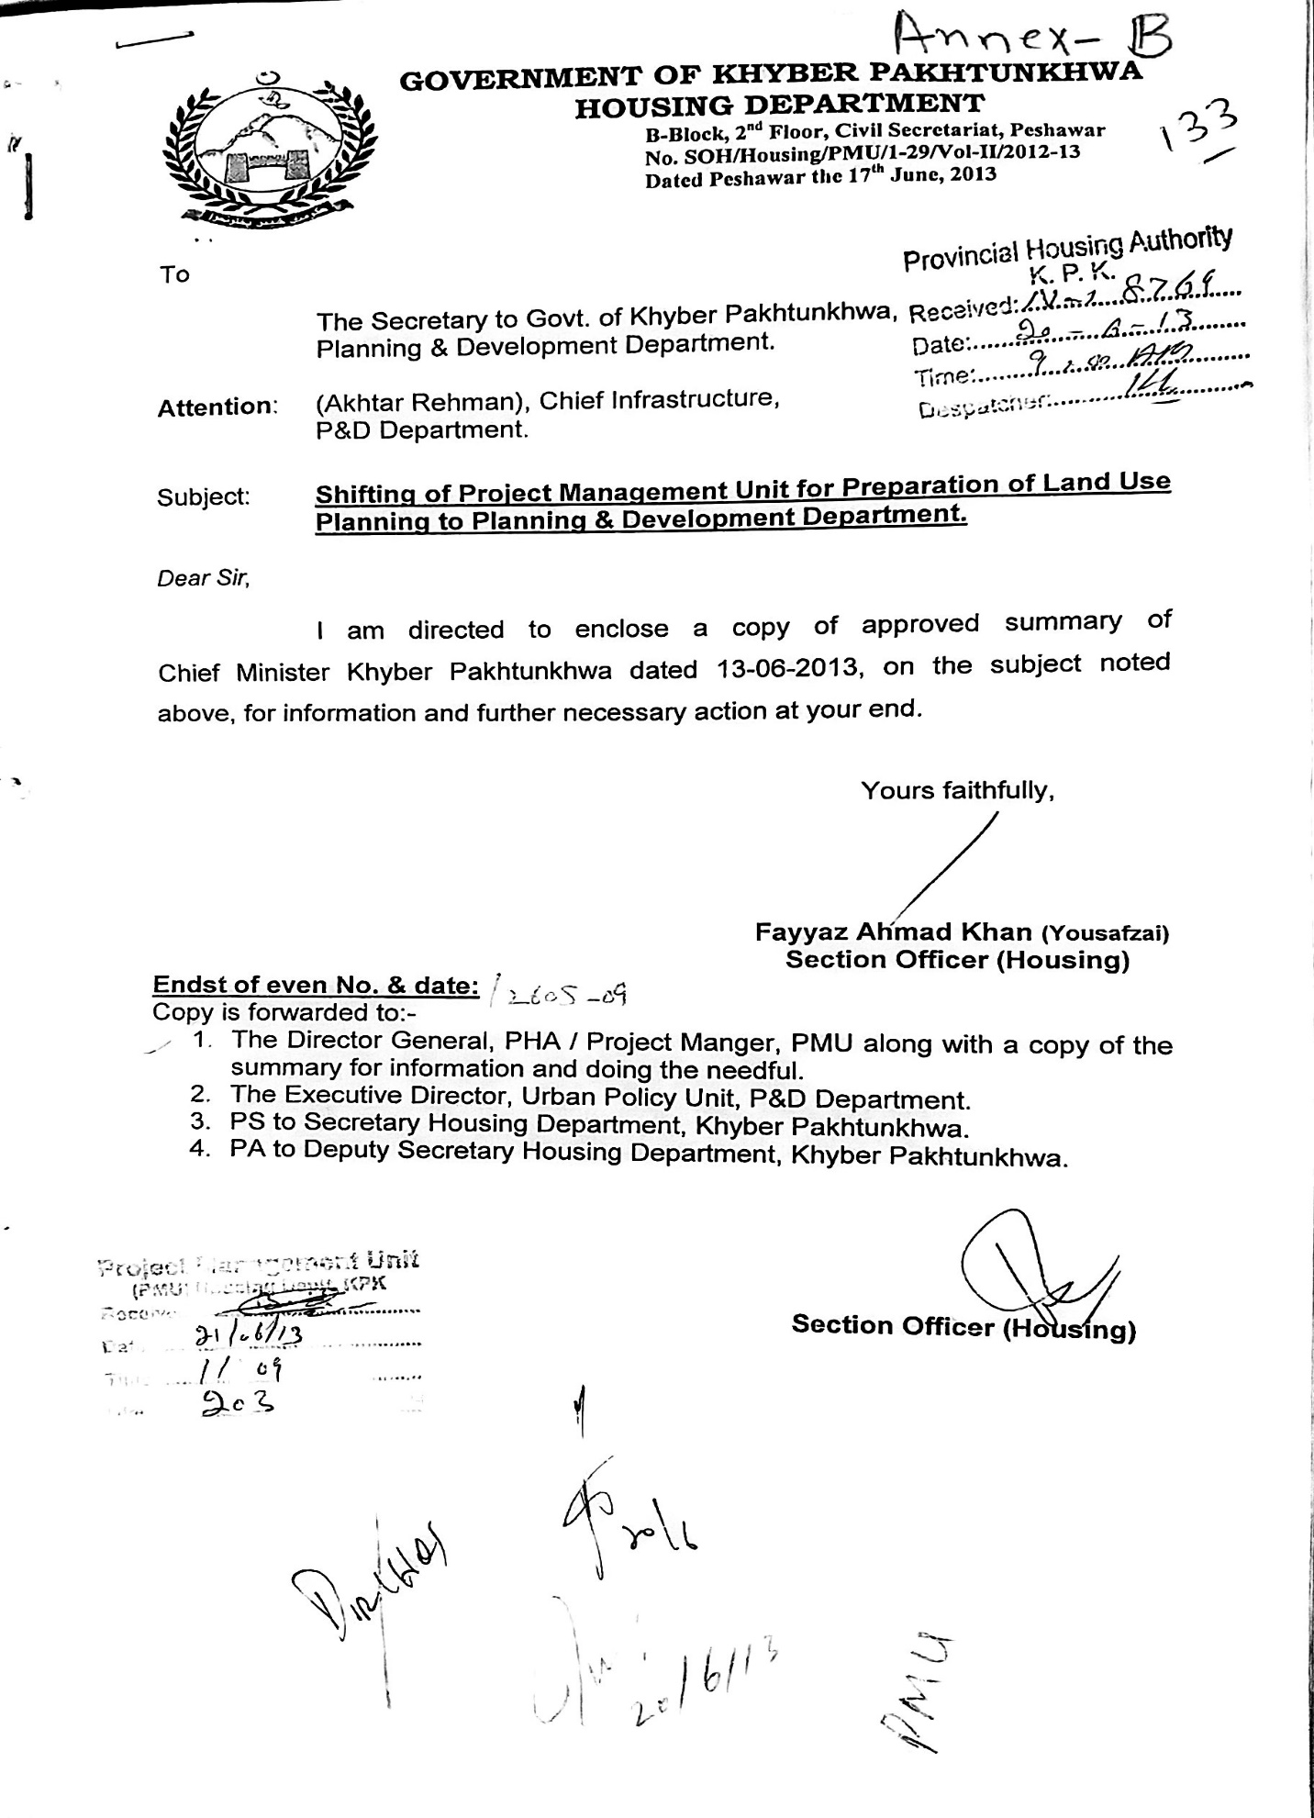
Annexure-B

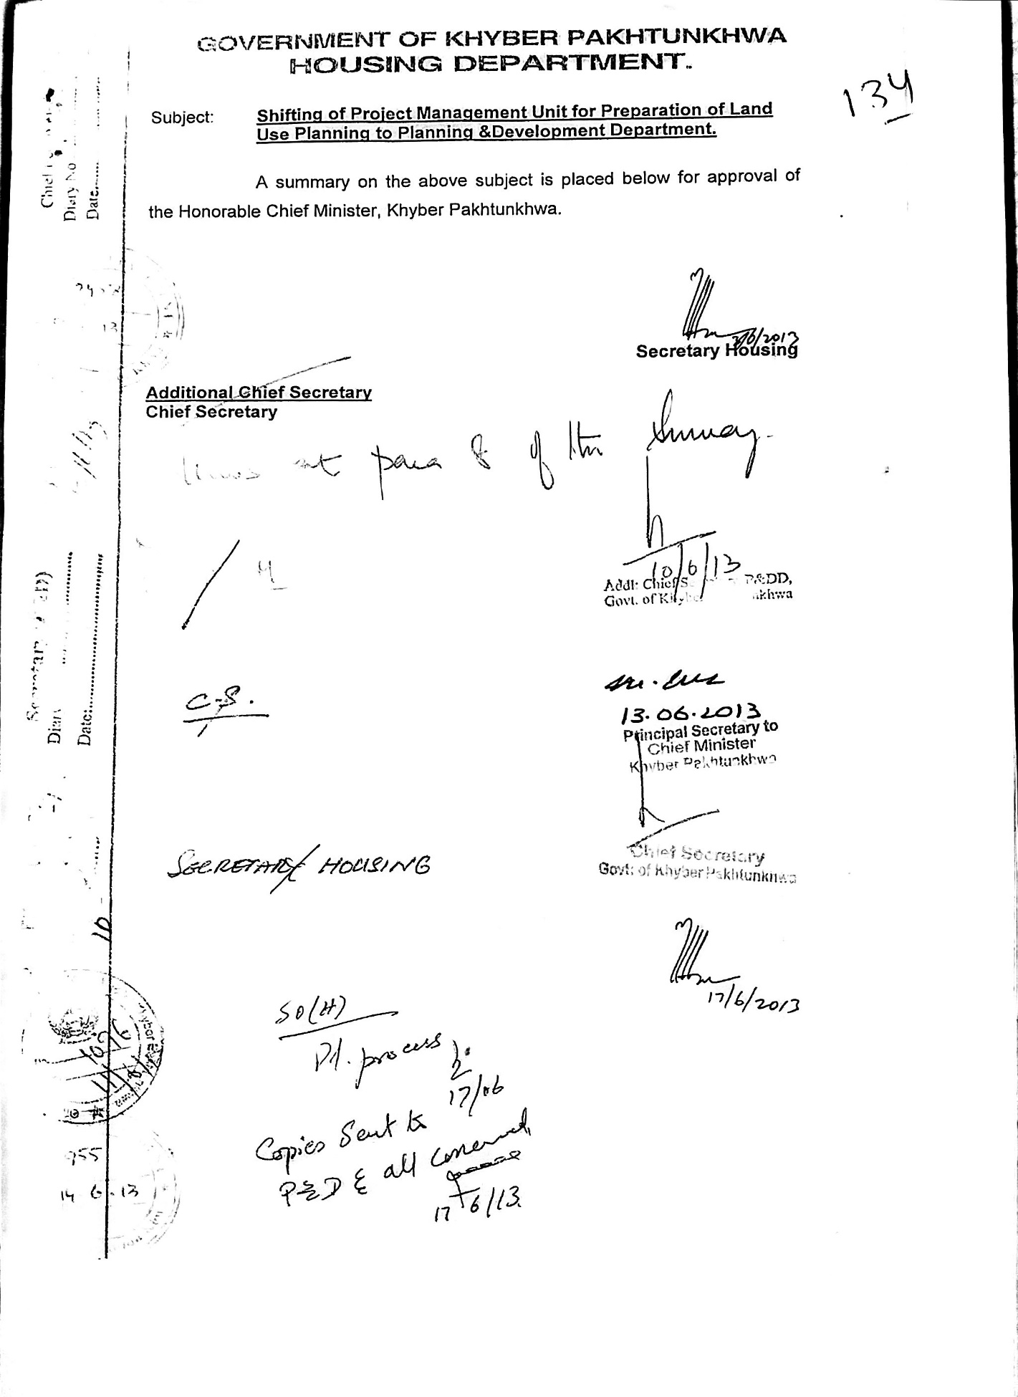

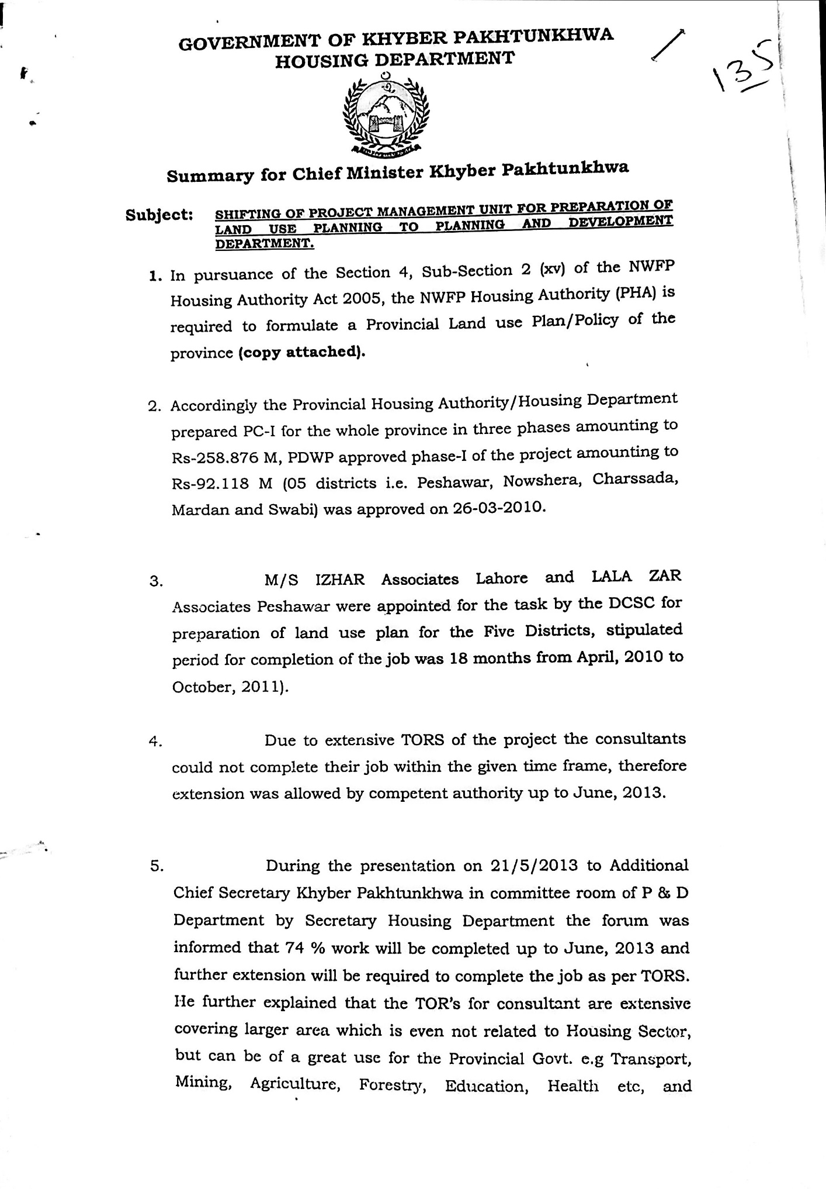

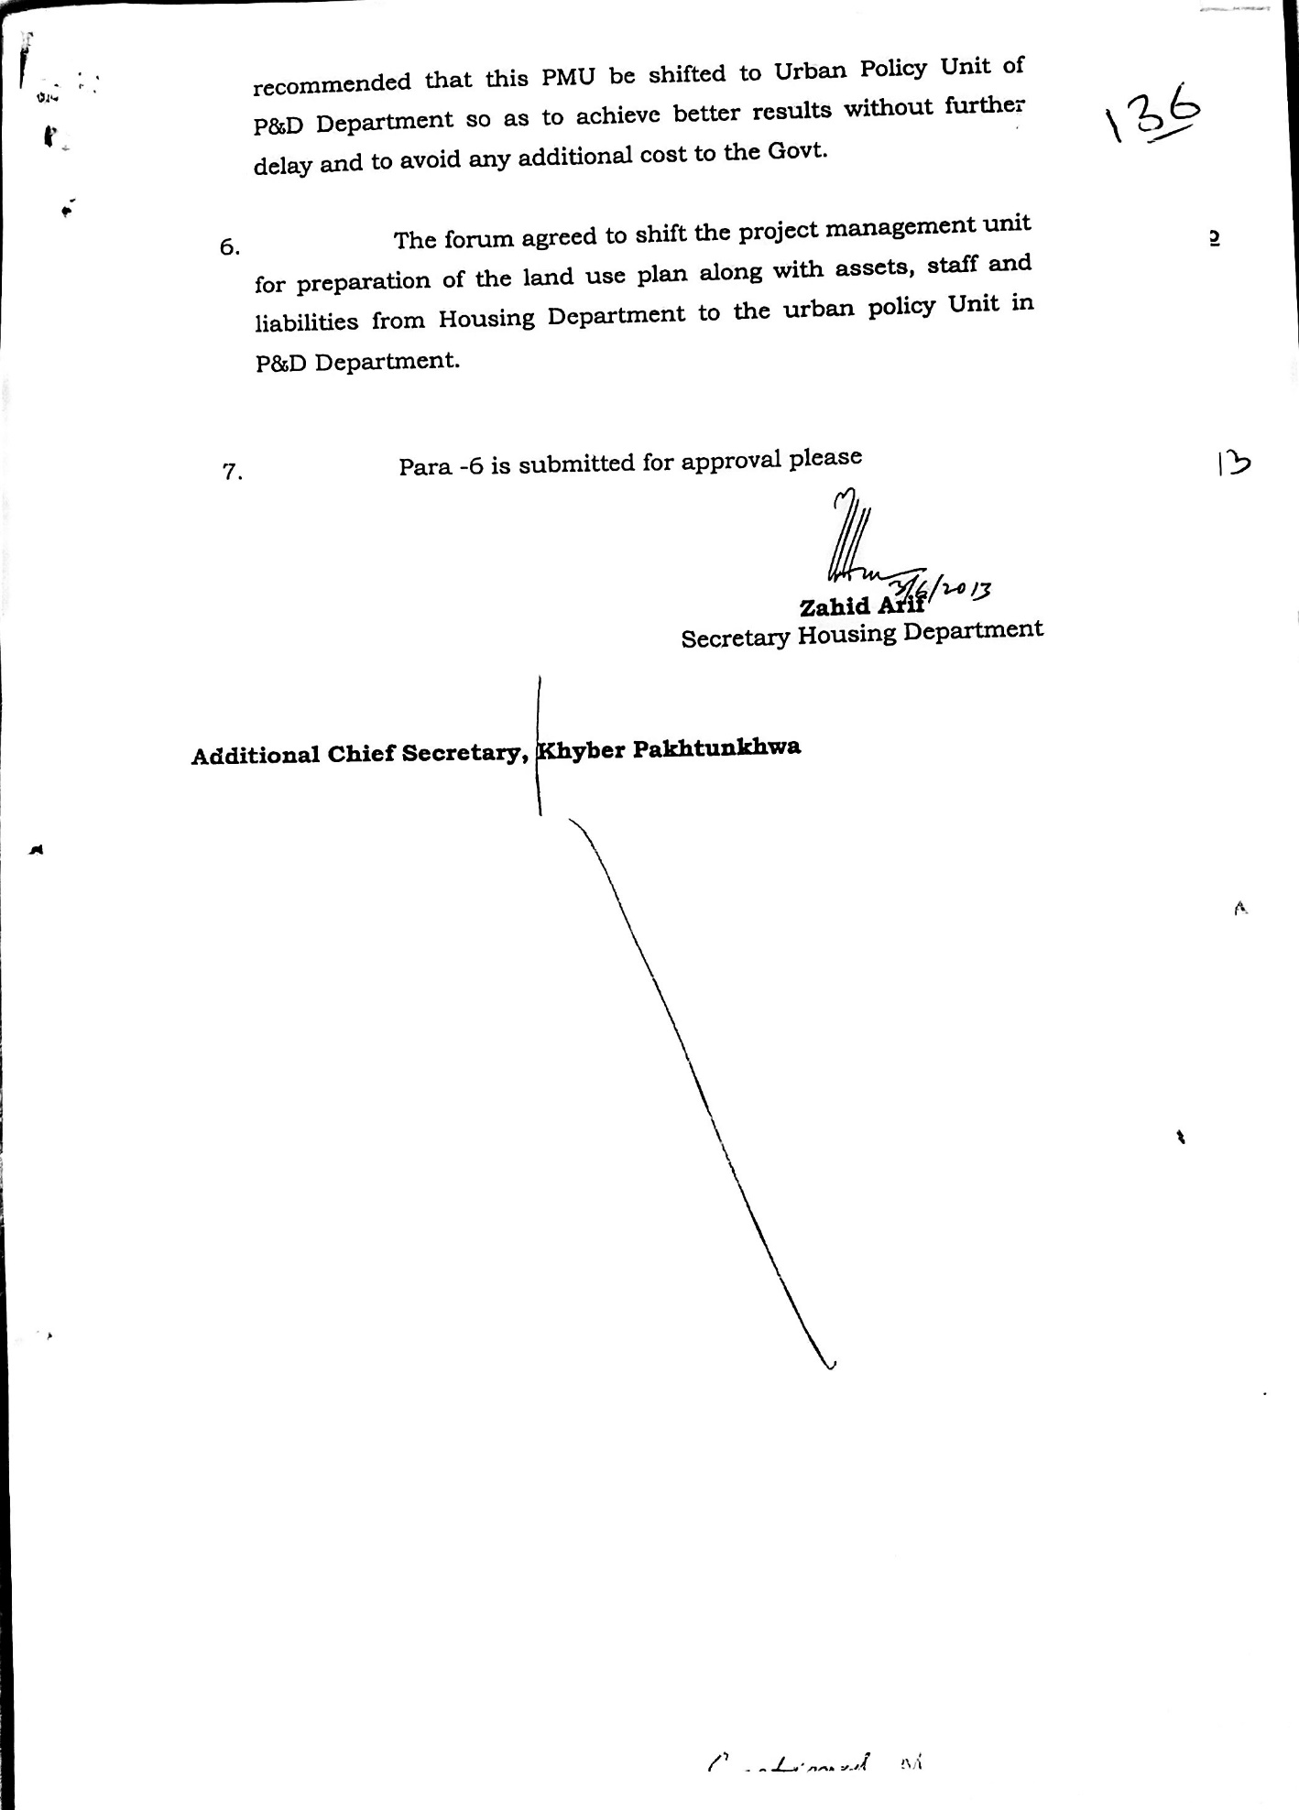

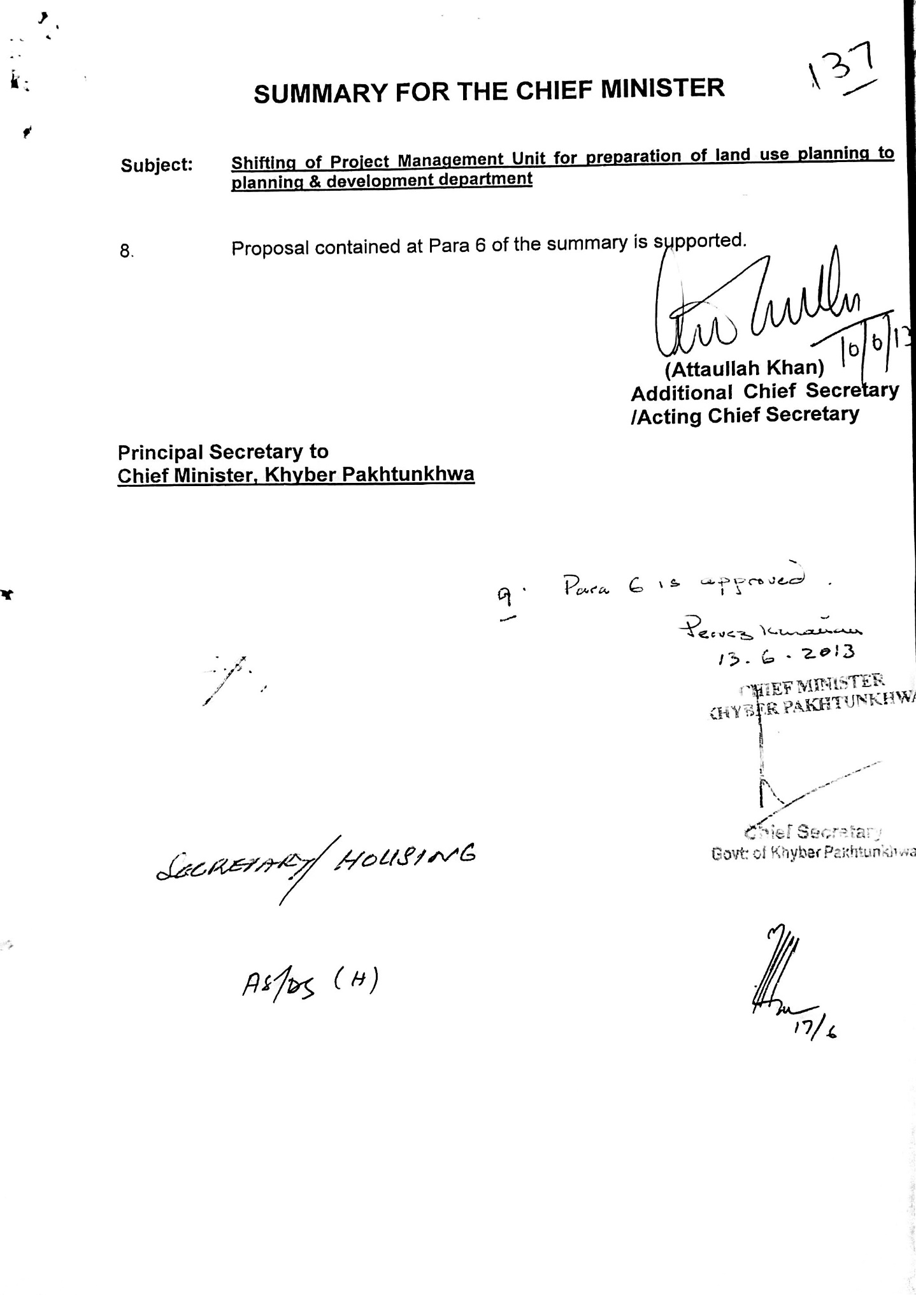

Annexure-C
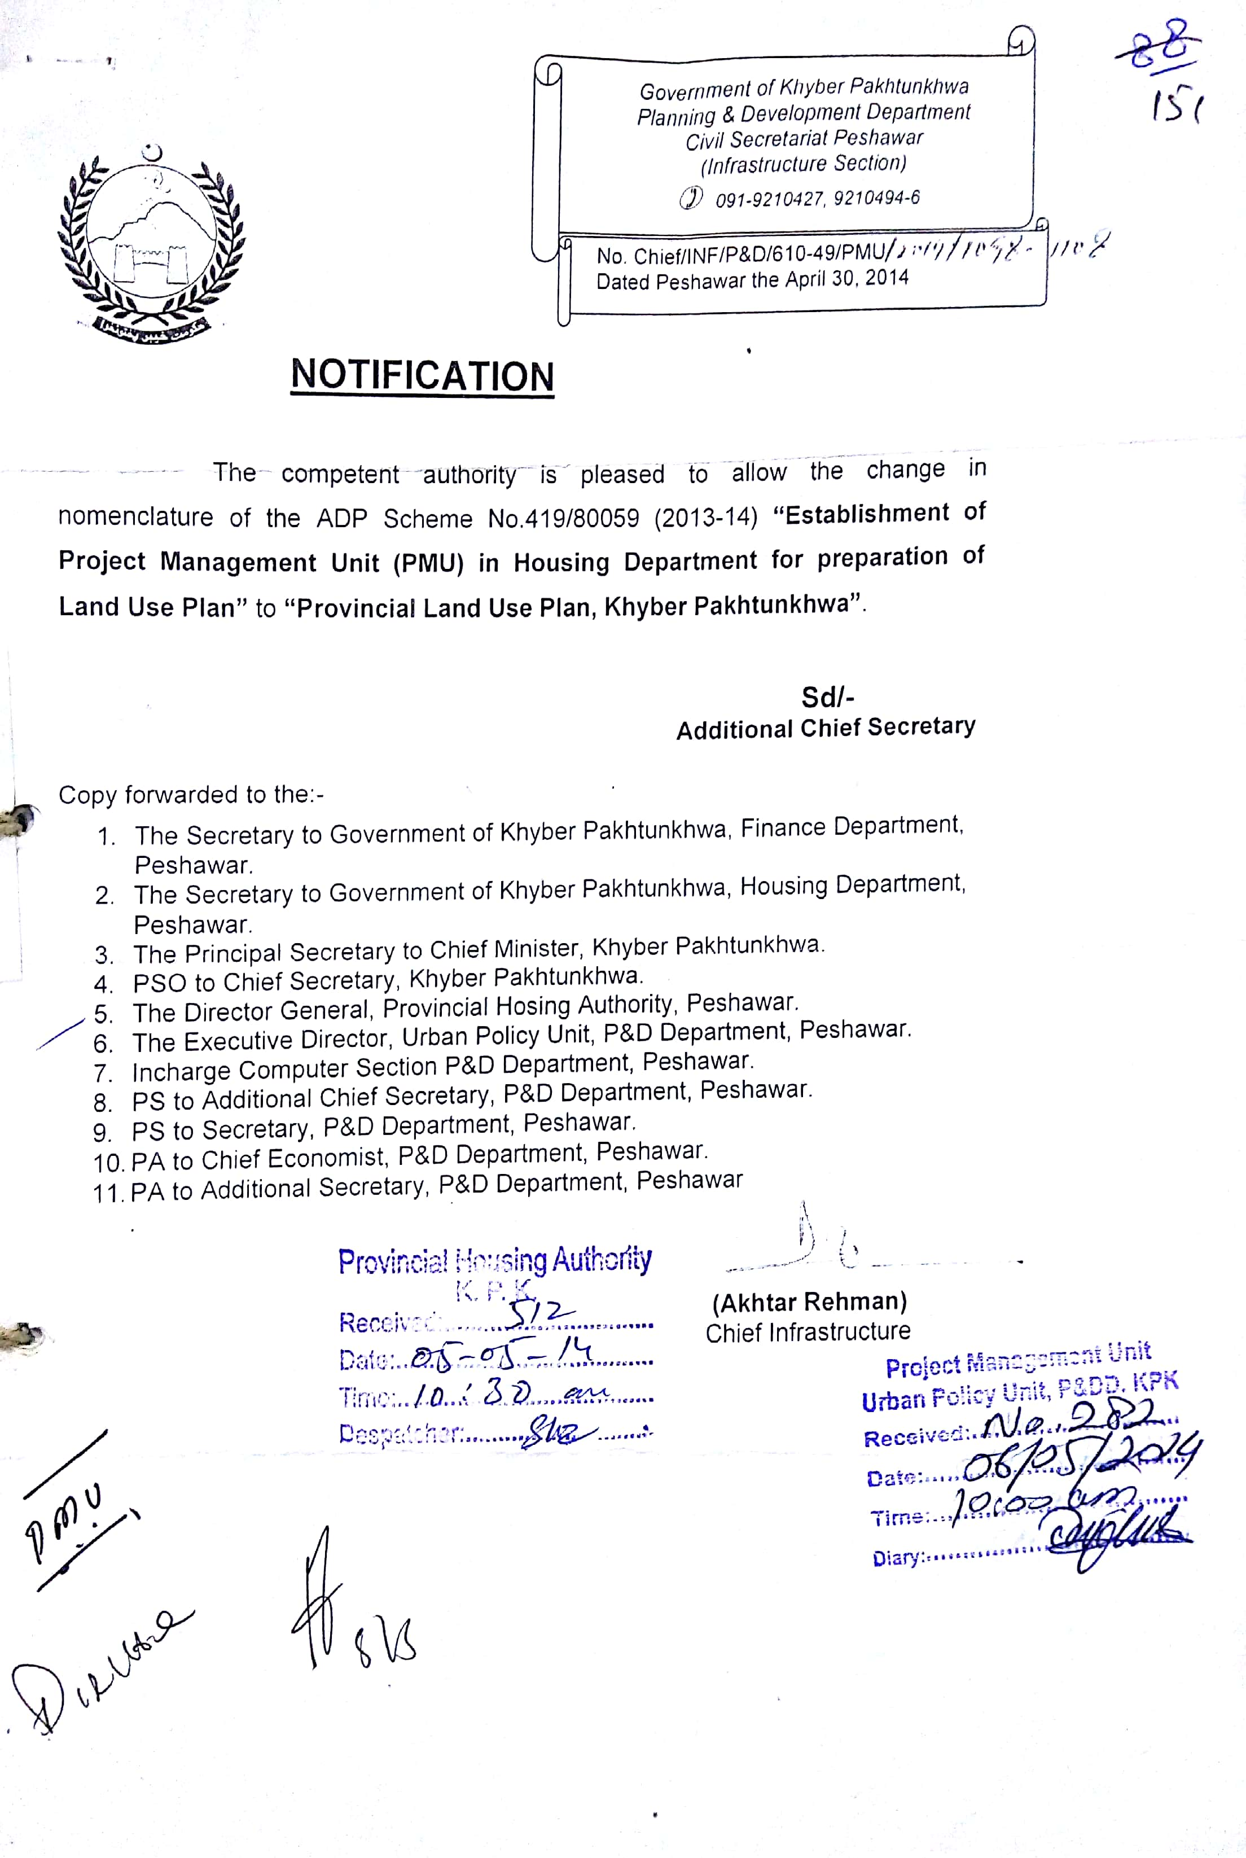
Annexure-D
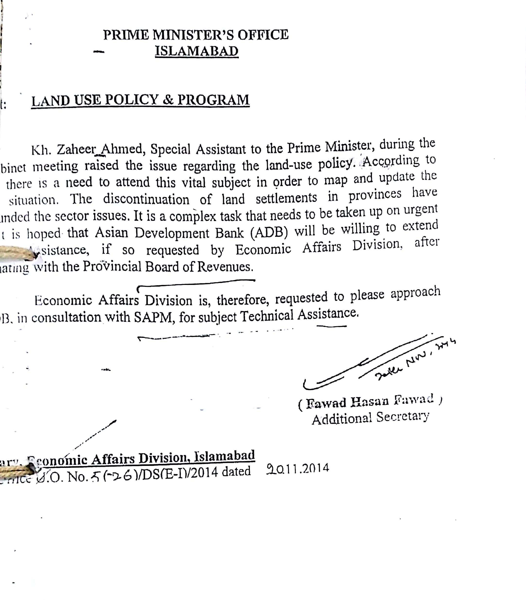
Annexure-E
ANNUAL PROCUREMENT PLAN FOR FINICAL YEAR 2020-21
(Under section 22 KPPRA act, 2012 Rule 30 of procurement rule, 2014)
Preparation of Division Wise District Land Use Plan of Khyber Pakhtunkhwa
Name of Procurement Agency: Provincial Land Use Plan (Urban Policy & Planning Unit, P & D Department)
1 | 2 | 3 | 4 | 5 | 6 | 7 | 8
S # | Name of procurement (Description) | Estimated Cost | Procurement Method | Advertisement | Tentative Date of Award of Contract | Tentative completion Period | Remarks (if Any)
1. | Preparation of District Land Use Plan of Malakand Division | 30 Million | Quality & Cost based selection (QCBS) | 30 days after proposed revision of the PC-1 | 90 Days after the advertisement | 18 months
2 | Preparation of District Land Use Plan of Kohat Division | 20 Million | Quality & Cost based selection (QCBS) | 30 days after proposed revision of the PC-1 | 90 Days after the advertisement | 18 months
3 | Preparation of District Land Use Plan of Bannu Division | 20 Million | Quality & Cost based selection (QCBS) | 30 days after proposed revision of the PC-1 | 90 Days after the advertisement | 18 months
4 | Preparation of District Land Use Plan of DI Khan Division | 25 Million | Quality & Cost based selection (QCBS) | 30 days after proposed revision of the PC-1 | 90 Days after the advertisement | 18 months
5 | Preparation of District Land Use Plan of Hazara Division | 30 Million | Quality & Cost based selection (QCBS) | 30 days after proposed revision of the PC-1 | 90 Days after the advertisement | 18 months

Project Manager PLUP Assistant Manager Finance (PLUP) Procurement Manager (UPPU)

Executive Director (UPPU)

Annexure-F
 |  |  | SUMMARY OF COST ESTIMATES FOR
 |  |  | PROVINCIAL LAND USE PLAN (PLUP)
 | S. No. | Description |  | Expenses to date | FY-2020-21 | FY-2021-22 | FY 2022-23 | Grand Total (Rs.) | Grand Total (Rs in Million)
 |  | Staff Salaries |  | 108,432,758 | 24,643,400 | 27,094,200 | 28,044,000 | 79,781,600 | 79.782
 |  | Operating Expenses (Communication) |  | 697,594 | 372,000 | 372,000 | 372,000 | 1,116,000 | 1.116
 |  | Utilities |  | 918,330 | 912,000 | 912,000 | 912,000 | 2,736,000 | 2.736
 |  | Occupancy Cost (05% annual increase) |  | 7,136,695 | 3,600,000 | 3,600,000 | 3,600,000 | 10,800,000 | 10.800
 |  | Travel & Transport |  | 7,332,911 | 2,652,000 | 2,652,000 | 2,652,000 | 7,956,000 | 7.956
 |  | General |  | 3,564,592 | 1,660,000 | 1,604,000 | 1,304,000 | 4,568,000 | 4.568
 |  | Purchase / Registration of Vehicles |  | 11,541,341 | 160,000 | - | - | 160,000 | 0.160
 |  | Machinery & Equipment |  | 6,678,450 | 2,090,000 | - | - | 2,090,000 | 2.090
 |  | Repair & Maintenance |  | 2,818,493 | 1,767,468 | 1,767,468 | 1,767,468 | 5,302,404 | 5.302
 |  | Furniture & Fixture |  | 1,311,478 | 500,000 | - | - | 500,000 | 0.500
 |  | Medical |  | - | 300,000 | 300,000 | 300,000 | 900,000 | 0.900
 |  | Honorarium |  | 400,000 | - | - | - | - | 0.000
 |  | Entertainment & Gifts |  | 362,847 | 156,000 | 172,000 | 172,002 | 500,002 | 0.500
 |  | Registration for vehicles |  | 230,079 | - | - | - | - | 0.000
 |  | Consultancy Services (General) |  | 31,609,683 | 20,000,000 | 60,000,000 | 45,000,000 | 125,000,000 | 125.000
 |  | Payments to four academic experts one each from NIUIP, NUST, UET Peshawar and DRUP University of Peshawar @ Rs 50,000/- per report. |  | - | 1,000,000 | 1,500,000 | 1,500,000 | 4,000,000 | 4.000
 | Total |  |  | 183,035,251 | 59,812,868 | 99,973,668 | 85,623,470 | 245,410,006 | 245.410

Annexure-G
Operating Expenditure for Provincial Land Use Plan (PLUP) in (Rs)
Operating Expenditure | Per Month / Unit | FY 2020-21 | FY 2021-22 | FY 2022-23 | Grand Total (Rs.) | Grand Total (Rs in Million)
Communication
Postage | 1,000 | 12,000 | 12,000 | 12,000 | 36,000 | 0.036
Telephone + Fax + Internet | 30,000 | 360,000 | 360,000 | 360,000 | 1,080,000 | 1.080
Total |  | 372,000 | 372,000 | 372,000 | 1,116,000 | 1.116
Utilities
Gas Charges | 10,000 | 120,000 | 120,000 | 120,000 | 360,000 | 0.360
Water Charges | 1,000 | 12,000 | 12,000 | 12,000 | 36,000 | 0.036
Electricity Charges | 65,000 | 780,000 | 780,000 | 780,000 | 2,340,000 | 2.340
Total |  | 912,000 | 912,000 | 912,000 | 2,736,000 | 2.736
Occupancy Costs
Rent for office Building (05% annual increase | 300,000 | 3,600,000 | 3,600,000 | 3,600,000 | 10,800,000 | 10.800
Total |  | 3,600,000 | 3,600,000 | 3,600,000 | 10,800,000 | 10.800
Travel & Transportation
Traveling Allowance (TA/DA) | 120,000 | 1,440,000 | 1,440,000 | 1,440,000 | 4,320,000 | 4.320
P.O.L Charges | 100,000 | 1,200,000 | 1,200,000 | 1,200,000 | 3,600,000 | 3.600
Conveyance Charges | 1,000 | 12,000 | 12,000 | 12,000 | 36,000 | 0.036
Total |  | 2,652,000 | 2,652,000 | 2,652,000 | 7,956,000 | 7.956

General
Stationery | 27,000 | 352,000 | 324,000 | 324,000 | 1,000,000 | 1.000
News Papers/Books/Technical Magazines. | 3,000 | 36,000 | 36,000 | 36,000 | 108,000 | 0.108
Printing & Publications | 10,000 | 120,000 | 120,000 | 120,000 | 360,000 | 0.360
Advertising and Publicity |  | 300,000 | 300,000 | 0 | 600,000 | 0.600
Workshops & Seminar |  | 500,000 | 500,000 | 500,000 | 1,500,000 | 1.500
Others/Misc | 27,000 | 352,000 | 324,000 | 324,000 | 1,000,000 | 1.000
Total |  | 1,660,000 | 1,604,000 | 1,304,000 | 4,568,000 | 4.568
Transport
Motorcycle Honda 125 cc (01 No) |  | 160,000 | - | - | 160,000 | 0.160
Total |  | - |  | - | 160,000 | 0.160

Operating Expenditure | Per Month / Unit | FY 2020-21 | FY 2021-22 | FY 2022-23 | Grand Total (Rs.) | Grand Total (Rs in Million)
Machinery & Equipment
Projector/ Multimedia Latest | 125,000 | 125,000 |  |  | 125,000 | 0.125
Laptop (Latest) (04 No) | 133,750 | 535,000 |  |  | 535,000 | 0.535
Furniture | 500,000 | 500,000 |  |  | 500,000 | 0.500
PCs Computer (Latest) (2 Nos) | 180,000 | 360,000 |  |  | 360,000 | 0.360
EX. HDD 02TB (05 Nos) | 20,000 | 100,000 |  |  | 100,000 | 0.100
Printers (03 Nos) | 60,000 | 180,000 |  |  | 180,000 | 0.180
Color Printer | 100,000 | 100,000 |  |  | 100,000 | 0.100
Photocopier Latest | 400,000 | 400,000 |  |  | 400,000 | 0.400
Water Dispenser (1 Nos) | 30,000 | 30,000 |  |  | 30,000 | 0.030
01 No Split ACs | 120,000 | 120,000 |  |  | 120,000 | 0.120
Digital Camera | 100,000 | 100,000 |  |  | 100,000 | 0.100
Web Server | 40,000 | 40,000 |  |  | 40,000 | 0.040
Total |  | 2,590,000 |  | 0 | 2,590,000 | 2.590
Honorarium |  | - | - | - | - | -
Medical |  | 300,000 | 300,000 | 300,000 | 900,000 | 0.900
Total |  | 300,000 | 300,000 | 300,000 | 900,000 | 0.900
Entertainment & Gifts

Entertainment & Gifts | 13,000 | 156,000 | 172,000 | 172,002 | 500,002 | 0.500
Total |  | 156,000 | 172,000 | 172,002 | 500,002 | 0.500

Repairs & Maintenance | Per Month / Unit | FY 2020-21 | FY 2021-22 | FY 2022-23 | Grand Total (Rs.) | Grand Total (Rs in Million)
Repair of Transport
Transport Repair | 90,000 | 1,080,000 | 1,080,000 | 1,080,000 | 3,240,000 | 3.240
Machinery & Equipment Repair
Machinery & Equipment | 56,289 | 675,468 | 675,468 | 675,468 | 2,026,404 | 2.026
Furniture & Fixture
Furniture & Fixture | 1,000 | 12,000 | 12,000 | 12,000 | 36,000 | 0.036
Total |  | 1,767,468 | 1,767,468 | 1,767,468 | 5,302,404 | 5.302
Grand Total |  | 11,419,468 | 11,379,468 | 11,079,470 | 36,628,406 | 36.628

Annexure- H
Staff Salaries Estimates, Provincial Land Use Plan (PLUP) in (Rs)
Name of Posts | Vacant Posts | Filled Posts | Single Employee Pay | Total Pay of staff Per Month | FY 2020-21 | FY 2021-22 | FY 2022-23 | Grand Total (Rs.) | Grand Total (Rs in Million)
Project Manager BS-19 | 1 |  | 175,000 | 175,000 | 1,050,000 | 2,205,000 | 2,310,000 | 5,565,000 | 5.565
Deputy Manager (SP) BS-18 | 1 |  | 125,000 | 125,000 | 750,000 | 1,575,000 | 1,650,000 | 3,975,000 | 3.975
Deputy Manager (GIS/Geo) BS-18 |  | 1 | 181,250 | 181,250 | 2,250,000 | 2,325,000 | 2,400,000 | 6,975,000 | 6.975
Assistant Manager (SP) BS-17 | 2 |  | 90,000 | 180,000 | 1,080,000 | 2,268,000 | 2,376,000 | 5,724,000 | 5.724
Assistant Manager (Admn) BS-17 |  | 1 | 112,500 | 112,500 | 1,404,000 | 1,458,000 | 1,512,000 | 4,374,000 | 4.374
Assistant Manager (Fin) BS-17 |  | 1 | 121,500 | 121,500 | 1,512,000 | 1,566,000 | 1,620,000 | 4,698,000 | 4.698
Map Cartographer BS-16 |  | 1 | 84,000 | 84,000 | 1,044,000 | 1,080,000 | 1,116,000 | 3,240,000 | 3.240
Data Specialist BS-16 |  | 1 | 84,000 | 84,000 | 1,044,000 | 1,080,000 | 1,116,000 | 3,240,000 | 3.240
Accountant BS-16 | 1 |  | 60,000 | 60,000 | 360,000 | 756,000 | 792,000 | 1,908,000 | 1.908
Assistant/Document Compiler BS-16 |  | 1 | 84,000 | 84,000 | 1,044,000 | 1,080,000 | 1,116,000 | 3,240,000 | 3.240
Statistical Investigator BS-16 |  | 2 | 84,000 | 168,000 | 2,088,000 | 2,160,000 | 2,232,000 | 6,480,000 | 6.480
Personnel Assistant BS-16 |  | 1 | 84,000 | 84,000 | 1,044,000 | 1,080,000 | 1,116,000 | 3,240,000 | 3.240
Computer Operator BS-12 | 1 |  | 30,000 | 30,000 | 360,000 | 378,000 | 396,000 | 1,134,000 | 1.134
Junior Clerks (Diary/Dispatch/ Typing) BS-11 |  | 2 | 42,000 | 84,000 | 1,044,000 | 1,080,000 | 1,116,000 | 3,240,000 | 3.240
Accounts Clerk BS-14 |  | 1 | 50,000 | 50,000 | 624,000 | 648,000 | 672,000 | 1,944,000 | 1.944
Dak-Runner BS-5 |  | 1 | 29,000 | 29,000 | 360,000 | 372,000 | 384,000 | 1,116,000 | 1.116
Drivers BS-6 |  | 2 | 29,000 | 58,000 | 720,000 | 744,000 | 768,000 | 2,232,000 | 2.232
Drivers BS-6 | 2 |  | 20,000 | 40,000 | 480,000 | 504,000 | 528,000 | 1,512,000 | 1.512
Office Boy BS-4 | 1 |  | 16,000 | 16,000 | 192,000 | 204,000 | 216,000 | 612,000 | 0.612
Office Boy BS-4 |  | 5 | 22,400 | 112,000 | 1,392,000 | 1,440,000 | 1,488,000 | 4,320,000 | 4.320
Security Guard BS-4 | 2 |  | 16,000 | 32,000 | 384,000 | 403,200 | 422,400 | 1,209,600 | 1.210
Sanitary Worker BS-3 |  | 1 | 22,400 | 22,400 | 278,400 | 288,000 | 297,600 | 864,000 | 0.864
Contingent Paid Staff (Liabilities) | LS |  |  | 1,739,000 | 1,739,000 |  |  | 1,739,000 | 1.739
Interns @ Rs 25,000/- each. |  | 8 | 25,000 | 200,000 | 2,400,000 | 2,400,000 | 2,400,000 | 7,200,000 | 7.200
Total | 11 | 21 | 1,587,050 | 3,871,650 | 24,643,400 | 27,094,200 | 28,044,000 | 79,781,600 | 79.782
Note: Pay package will be as per Provincial Project Policy
Annexure-I
COMPARATIVE STATEMENT OF EXISTING SANCTIONED POSTS & PROPOSED
S.N | Name of Position | Numbers in approved PC-1 | Numbers in Proposed Revised PC-1 | Remarks/Justification
 | Project Manager BS-19 | 1 | 1 | No Change
 | Deputy Manager (Spatial Planning) BS-18 | 1 | 1 | No Change
 | Deputy Manager (GIS/Geography) BS-18 | 1 | 1 | No Change
 | Assistant Manager (GIS/IT/Networking) BS-17 | 1 | 0 | Abolished as GIS section has alternate staff to cover the desire work
 | Assistant Manager (Spatial Planning) BS-17 | 1 | 2 | 01 Post added, keeping in view the requirement of the Project
 | Assistant Manager (Admin) BS-17 | 1 | 1 | No Change
 | Assistant Manager (Finance) BS-17 | 1 | 1 | No Change
 | Assistant (Spatial Planner) BS-16 | 03 | 0 | Abolished as the scope of Project has been changed to Consultancy
 | Assistant (GIS) BS-16 | 03 | 0 | Abolished as the scope of Project has been changed to Consultancy
 | Map/Cartographer BS-16 | 2 | 1 | 1 Abolished as the scope of Project has been changed to Consultancy
 | Data Specialist BS-16 | 1 | 1 | No Change
- o | Accountant BS-16 | 1 | 1 | No Change
 | Assistant/Document Compiler BS-16 | 1 | 1 | No Change
 | Statistical Investigator BS-16 | 3 | 2 | 1 Abolished as the scope of Project has been changed to Consultancy
 | Personnel Assistant BS-16 | 1 | 1 | No Change
 | Computer Operator BS-12 | 1 | 1 | No Change
 | Accounts Clerk BS-14 | 1 | 1 | No Change
 | Junior Clerks (Diary/Dispatch/ Typing) BS-11 | 2 | 2 | No Change
 | Dak-Runner BS-5 | 1 | 1 | No Change
 | Drivers BS-6 | 06 | 04 | 02 Posts abolished
 | Office Boy BS-4 | 6 | 6 | No Change
 | Security Guards BS-4 | 2 | 2 | No Change
 | Sanitary Worker BS-2 | 1 | 1 | No Change
Total Posts |  | 42 | 32

Note: Duty station of the Project Staff will be determined as per project requirements.

