PSDP Share Rs. 897.582million
ADP Share Rs.1420.703 million
Farmers’ Share Rs.420.000 million
Total Cost Rs. 2738.285 million

Government of Khyber Pakhtunkhwa

PC-I





National Program for Enhancing Command Area of Small and Mini Dams in Barani Areas of Pakistan
(Khyber Pakhtunkhwa Component)
DIRECTORATE GENERAL
ON FARM WATER MANAGEMENT, AGRICULTURE EXTENSION,
AGRICULTURAL ENGINEERING,

AGRICULTURE, LIVESTOCK & COOPERATION DEPARTMENT
PESHAWAR

April, 2019
CONTENTS

No. | Section | Page
Abbreviations_________________________________________________ ii
- Project Name _ 01
- Location _ 01
- Authorities Responsible _ 01
  - Sponsoring _ 01
  - Execution _ 01
  - O&M _ 01
- Plan Provision _ 02
- Project Objectives & its relationship with sector objectives _ 03
  - Objectives _ 03
  - Relationship with sector objectives _ 03
- Description, Justification & Technical Parameter _ 03
- Capital Cost Estimates _ 13
- Annual operation & maintenance cost after completion of the project _ 18
- Demand & Supply analysis _ 18
- Financial Plan & Mode of Financing _ 18
- Project benefits & analysis _ 18
  - Employment generation 18
  - Impact on environment 18
  - Impact of delays on project cost and viability 19
  - Internal Return Ratio & Cost Benefit Ratio 19
- Implementation schedule _ 19
- Management Structure & Manpower Requirements _ 21
  - Management structure _ 21
  - Manpower requirements 22
  - Federal Steering Committee______________________________________ _22
  - Federal Coordination Committee____________________________________22
  - Provincial Steering Committee 22
  - Provincial Implementation Committee (PIC)___________________________ 23
- Additional projects/decisions required to maximize socio-economic benefits 23
- Certificate __ 25Annexures _26-40
ABBREVIATIONS

ACS : Additional Chief Secretary
AD : Assistant Director
ADB : Asian Development Bank
AG : Accountant General
AWP : Annual Work Plan
bgs : Bags
CCA : Culturable Command Area
Cusecs : Cubic FeetPer Second
DG : Director General
DO : District Officer
DRAC : District Rate Assessment Committee
EDO : Executive District Officer
GDP : Gross Domestic Product
GI : Galvanized Iron
GIS & RS : Geographical Information System & Remote Sensing
GoP : Government of Pakistan
HRD : Human Resource Development
IRR : Internal Return Ratio
Kg : Kilogram
KPK ; Khyber Pakhtunkhwa
LPS : Liters Per Second
m : Meter
m³ : Cubic Meter
MAF : Million Acre Feet
M&E : Monitoring & Evaluation
M&P : Monitoring & Planning
Nos : Numbers
NPIWCs : National Program for Improvement of Watercourses
OFWM : On Farm Water Management
O&M : Operation & Maintenance
PC : Provincial Coordinator
PCC : Portland Cement Concrete
PCPS : Precast Parabolic Segment
PD : Project Director
PLL : Precision Land Leveling
PSC : Project Steering Committee
PVC : Polyvinyl Chloride
SWC : Soil and Water Conservation
SDC : Swiss Development Corporation
SE : Sub Engineer
TPV : Third Party Validation
USAID : United State Agency for International Development
WC : Watercourse
WMO : Water Management Officer
WMTC : Water Management Training Center
WAPDA : Water and Power Development Authority
WST : Water Storage Tank
WUAs : Water Users Associations
Revised 2005

GOVERNMENT OF PAKISTAN
PLANNING COMMISSION
PC-1 FORM

1. PROJECT NAME: | National Program for Enhancing Command Area of Small and Mini Dams in Barani Areas of Pakistan (Khyber Pakhtunkhwa Component)
2. LOCATION: | District Bannu, Charsadda, Karak, Kohat, Haripur, Nowshera, Hangu, Peshawar, Swabi, Dir Lower and Swat of Khyber Pakhtunkhwa
3. AUTHORITIES RESPONSIBLE:
3.1Sponsoring | - Government of Pakistan through Ministry of National Food Security & Research.  - Government of Khyber Pakhtunkhwa through Agriculture, Livestock & Cooperation Department.  - Water Users’ Associations (WUAs)/Farmers
3.2 Execution | Directorate General OFWM Khyber Pakhtunkhwa through its District offices & WUAs/Farmers, Directorate of Agricultural Engineering and Directorate General Agriculture Extension Khyber Pakhtunkhwa & Agriculture Research System Khyber Pakhtunkhwa.
3.3O&M | Water User’s Associations/Farmers
3.4 Concerned Federal Ministry | Ministry of National Food Security & Research
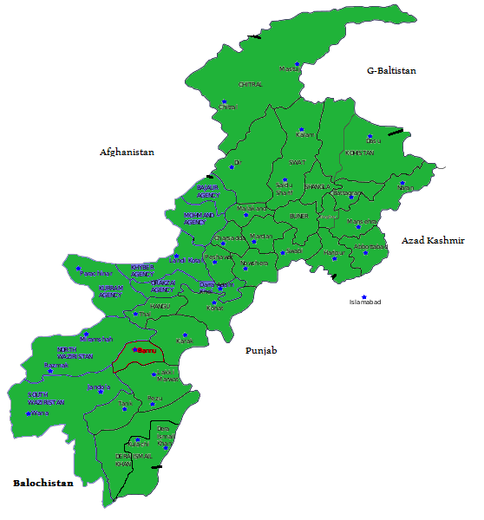
4. PLAN PROVISION

- If the project is included in the current Five-Year Plan, specify actual allocation
Project is to be considered under ADP/PSDP during 2019-20.
- If the project is not included in the current Five-Year Plan, what warrants its inclusion in the plan?
The agriculture growth, uplift of agro-economy and pro-poor interventions are priority areas on provincial as well as federal governments’ development agenda. It has always been endeavored to provide maximum financial resources for water resources management, being critical input to agriculture in arid and semi-arid zones. It has further been emphasized to focus development of farmers’ institutions, institutional re-organizations, and staff training for improvement, rehabilitation, effective management, efficient utilization, and sustainable development of water management facilities. These measures are needed to be taken at much faster pace considering Pakistan’s rapidly increasing population. In this context, the real challenge is formulation and effective implementation of a comprehensive set of measures for efficient management of scarce water resources available at the farm level. The focus of investments in water sector has been envisaged on following areas.

- Water resources augmentation
- Water conservation
- Infrastructure protection

The current water shortages and extremely slow pace of water resources development has urged and motivated the planner’s/policy makers to develop strategy for efficient utilization of available water resources. Enhancement of water productivity at field level is the best option to redress water scarcity. Improvement of conveyance efficiency at farm level by lining of watercourses can greatly help in achieving these objectives. There is a severe water shortage in the country adversely affecting the Agriculture Sector. This project would have transformational effect in improving the sustainability of irrigated agriculture in Pakistan and enduring productivity in Khyber Pakhtunkhwa province.

- If not included in the current plan, how is it now proposed to be accommodated (Inter/Intra-Sectoral adjustment in allocation of or other resources may be indicated)
Not applicable.
- If the project is proposed to be financed out of block provision for a program or PSDP/ADP, indicate in Pak-Rupees?
Not applicable.

5. PROJECT OBJECTIVES & ITS RELATIONSHIP WITH SECTOR OBJECTIVES:
5.1 Sector/ sub Sector Objectives:
The overall objectives of the project are in line with the sectoral objectives aiming to improve livelihood of the farming communities, reduce poverty and insure food security. However specific objectives of the project are:
- To develop the command area of newly constructed small and mini dams.
- Bring new area under irrigated agriculture
- To enhance farm productivity through increase water use efficiency by developing on farm water management structures.
- Improving productivity of irrigation water by efficient conveyance and its effective farm level use through adaptation of conservation agriculture practices.
- Involve Water User’s in operation and maintenance of irrigation infra-structure at tertiary level on sustainable basis.
- Alleviate poverty in rural areas through better farm returns and employment generation.

5.2 Relationship with sector objectives
The project is in line with specific objectives of National Water Policy and Provincial Implementation Plan of the agriculture sector for enhancing waterproductivity, efficient & wise use of available irrigation water with the concept of “more crops per drop” to ensure farm productivity, economic uplift of small farmers, promoting private sector involvement, and improving economy of the country as a whole. The proposed project is closely related to the following recently completed and on-going OFWM schemes, which form an important element of the integrated rural development program within the agriculture sector:

  - KP OFWM Project (World bank Assisted) (completed on 30.06.2005);
  - National Program for Improvement of Watercourses in Pakistan (Khyber Pakhtunkhwa Component) (PSDP) (completed on 30.06.2011);
  - Additional lining/Rehabilitation of Watercourses in Khyber Pakhtunkhwa (Provincial ADP) (completed on 30.06.2011);
  - Land leveling through laser technology in Khyber Pakhtunkhwa (Provincial ADP) (completed on 30.06.2011);
  - Rehabilitation /Additional Lining of Watercourses in Khyber Pakhtunkhwa (completed on 30.6.2013);
  - Provincial Program for On Farm Water Management Activities in Khyber Pakhtunkhwa (Provincial ADP) (completed on 30.06.2014);
  - Special Program for OFWM Activities in Khyber Pakhtunkhwa (Provincial ADP)(completed on 30.6.2016);
  - Improvement and Lining of Watercourses in Khyber Pakhtunkhwa (completed on 30.06.2017).

- DESCRIPTION, JUSTIFICATION & TECHNICAL PARAMETERS:
6.1 Description
Government of Khyber Pakhtunkhwa has indicated agriculture growth, uplift of agro-economy as its priority areas in its developmental agenda. Maximum financial resources have been planned for water resources management The current water shortages and extremely slow pace of water resources development has urged and motivated the planner/policy makers to develop strategy for efficient utilization of available water resources. Enhancement of water productivity at field level is the best option to redress water scarcity, Improvement of conveyance efficiency at farm level.

Inadequate water availability is a major irrigation constraint limiting the expansion of the agriculture productivity and meeting the growing food and fiber demands of the country. A recent study indicates an available supply of water of little more than 1,000 m³ per person, putting Pakistan in the category of a high stress country and with the potential for disastrous results, Demand for irrigation water is increases daily.

On the basis of the current water shortage and rapidly competing future demands, the foreseen situation would be unsustainable for agriculture. Horizontal as well as vertical expansion of agriculture is urgently needed to grow the economy. It is important to consider possible strategies for increasing water productivity through efficient management of the scarce water resources. A comprehensive approach is needed to provide a complete package of OFWM interventions to convert rain fed areas into irrigated, minimize water losses at all levels and improve water productivity through ensuring its adequacy, equity and reliability at the farm level.

In Khyber Pakhtunkhwa, various dams have been constructed by the government to provide irrigation water to small agriculture lands but the command area development activities in most of the dams has not been carried out. Under OFWM component, the development of 47817acres command area following 17 small dams (Annex “A” at Page No 31) in Bannu, Charsadda, Karak, Kohat, Haripur, Nowshera, Hangu, Swabi and Peshawar District of Khyber Pakhtunkhwa will be carried out:

1 | Barganattu Dam, Bannu | 10 | ZamirGul Dam, Kohat
2 | Palai Dam, Charsadda | 11 | Chatri Dam , Haripur
3 | Ghole Banda Dam,Karak | 12 | Khair Bara, Haripur
4 | Sharki Dam, Karak | 13 | JabbaKhattak, Nowshera
5 | Chnaghoz Dam, Karak | 14 | Jalozai Dam, Nowshera
6 | Mardankhel Dam, Karak | 15 | Naryab Dam , Hangu
7 | Gandially Dam, Kohat | 16 | Aza Khel Dam, Peshawar
8 | Kandar Dam, Kohat | 17 | Kundal Dam, Swabi
9 | Darmalak Dam, Kohat

Besides the above mentioned small Dams, command area development of 11363 acres’ areas of Balambat Flow Irrigation Scheme Dir Irrigation Division at Timargara ( Annexure “B” at page No 32-34),4037.50 acres’ area of Bagh Dehri Flow Irrigation Scheme District Swat(Annex “C”) and 8,458 acres of Nipkikhel Irrigation Channel Swat (Annex “D”) will also be carried out. So a total of 71,675.50 acres of new Irrigated land will be brought under the instant project.

A comprehensive approach will be followed up in this regard by providing a complete package of OFWM interventions to strengthen Government of Khyber Pakhtunkhwa (GoKP) ongoing efforts of upgrading the farm level water conveyance infrastructure. The farmers will also be equipped with improved irrigation techniques and technologies. Furthermore, enabling environment will be created for sustainable technology transfer at the grassroots level for optimal and efficient management of available water resources. The command area development activities will include:

- Construction and lining of 400 watercourses (open/pipe) and allied structures
- Rough Land Levelling of 34,000 acres
- Plantation of fruit plants on 2,130 acres
- Plantation of Oilseed/Pluses Crops on 5,200 acres
- Growing of Fodder/Forage/Range on 1,500 acres.
- Capacity building of 100 Professional & Non Professional Staff
- Capacity building of 2000 No’s of Farmers of Water Users Associations

The combined effect of these advancements would lead to enhance output of available land water resources. This project would have transformational effect in improving the sustainability of irrigated agriculture in Pakistan and enduring productivity in Khyber Pakhtunkhwa province.

- Interventions

- Construction of Earthen Watercourses (WCs) & Lining

The new area brought under crop through land development/reclamation, needs to be further brought under irrigated agriculture to increase its productivity. In the newly developed land, earthen watercourses, where feasible, will be constructed.

The improvement works on watercourses in small / mini dam’scommanded area would be somewhat different than the improvement of conventional canal commanded area watercourses. In the command area first earthen watercourses will be constructed in case of open channel. Lining of critical position, preferably head reach will be carried out. Distribution network will be provided preferably through pipe (where feasible). In case, if any earthen channel existed in the command area may be replaced with lining though pipe watercourses or open channel watercourses keeping in view thefeasibility of site.

The farmers of project area depend upon very scarce water mainly available through storage of water in the small dams. The only way of utilizing this water for irrigation purposes, will be conveyed to the fields through pipes or open channel flow for irrigation during the crop growing period, especially in critical growth stages. The project will be executed on participatory approach through active participation of the farming community where beneficiaries will be involved right from the feasibility till completion of the scheme. The beneficiaries will also be involved in the total scheme cost as per in vogue OFWM practice.

Watercourse improvement/ lining generally include, inter alia, following components.

- Conveying the water to the fields situated at higher elevations through RCC, GI and PVC pipes.
- Supplying water to the fields of lower or equal elevation through open channels or through pipe depends on the feasibility & available discharge at the source.
- Connecting different fields having depressions in between through RCC or PVC, GI pipes.
- Using checks and turnouts at water distribution points.
- Installation of culverts at road crossing etc

Watercourse lining offers great opportunity for improving farm level water availability. Different impact evaluation studies have been carried out by various agencies under previous OFWM projects. The findings of these assessments have indicated significant benefits accruing from watercourse lining like:

- Reduction in water losses : 33%
- Improvement in delivery efficiency : 39%
- Increase in cropping intensity : 20%
- Overall increase in crop yield : 24%

The government will provide 100% cost of construction materials while the farmers will be contributing skilled & un-skilled labor costs for improvement of the watercourses. These arrangements are well understood and adopted by the farming community of the

province. It is, therefore, planned that the same i.e. 75:25 would be adopted under proposed project.

- Rough Land Levelling

Increasing water shortages have compelled all the concerned for developing strategies to make efficient utilization of this scarcely available resource. Rough land levelling is the best option for improving water productivity through minimizing water application losses. It is, accordingly, planned under this component; Agricultural Engineering Department will develop/level land. Reclamation of land can bring revolution in the economy of the province. The instant project has been designed to develop/level the command area of Small Dams and mentioned Irrigation Schemes.
Concept of Cost Sharing:
The department has planned to develop culturable waste/uneven agricultural land in the command area. The proposed land development activity will be accomplished in collaboration with the individual farmers on cost sharing basis. If the departmental machinery could not be spared for leveling/development of land, it shall be carried out through private earthmoving machinery under close supervision of concerned Agricultural Engineer/Assistant Agricultural Engineer (DDO). After satisfactory completion of work, Government Share @ 80% cost of land development work (Rs.40000/acre) as calculated by On Farm Water Management Department Khyber Pakhtunkhwa and approved by PDWP forum in its meeting held on 22/04/2019 will be paid to the individual beneficiary in shape of cross cheque through Accountant General Khyber Pakhtunkhwa/District Account Officer.
Implementation Mechanism For Rough Land Levelling:
The project will be executed as per procedure proposed here-under:
- The Scheme will be advertised in leading newspapers indicating the laid-down criteria of the scheme.
- The concerned Agricultural Engineer/Assistant Agricultural Engineer will collect applications from land owners interested in the development/leveling of their land.
- The farmer /farmers interested in availing the project facility will apply on printed application form (to be provided by the department) supported by the following documents:
- Fard and Aks-e-shajra- of the land, duly attested by the revenue authorities/ Tehsildar concerned/Certificate from Revenue Department showing therein the size of land in possession of applicant (individual or group with attorney in favour of anyone of them)
- Certificate from the Revenue/Irrigation Department that the land of the farmer/farmers falls in the command area of the aforementioned Small dams and Irrigation Schemes.
- Surety/undertaking from the farmer/farmers (Attested by Oath Commissioner) that the land developed /leveled shall not be used for purpose other than agriculture for 10 years minimum.
- Departmental technical committee comprising of Agricultural/Assistant Agricultural Engineer and Unit Supervisor of the concerned sub-office will scrutinize the applications and land ownership documents duly verified by district revenue department on the basis of criteria and physical inspection of site for availing the facility.
- The site feasibility report will then be prepared by the technical committee including GPS Coordinates and minimum three pictures of the site to be developed/leveled.
- Agricultural Engineer/Assistant Agricultural Engineer of the concerned sub-office will furnish all the verified applications along with the relevant documents received at his end of the individual sites to the Director Agricultural Engineering Khyber Pakhtunkhwa. (not exceeding 20 acres of land in each case). Director Agricultural Engineering will scrutinize the documents and accord final approval to the deserving beneficiaries keeping in view the very objectives of the project.
- On the receipt of approval, farmer shall then arrange for deployment of earth moving machinery. If the departmental machinery could not be spared for leveling/development of land, it shall be carried out through private earthmoving machinery under close supervision of concerned Agricultural Engineer/Assistant Agricultural Engineer (DDO) and on the approval of Director Agricultural Engineering Khyber Pakhtunkhwa Tarnab, Peshawar. After completion of work, the Departmental Technical Committee and consultant will confirm satisfactory completion of land leveling work. Government Share @ 80% (Rs.40000/acre) cost of land development work as calculated by On Farm Water Management Department Khyber Pakhtunkhwa and approved by the PDWP Forum in its meeting held on 22/04/2019 will be paid to the individual beneficiary in shape of cross cheque through Accountant General Khyber Pakhtunkhwa/District Account Officer only after provision of verification/satisfaction report by consultant regarding successful completion of land leveling work.
- Provision of Fruit Trees /Oil Seed/ Pulses/ Fodder
Khyber Pakhtunkhwa has diverse agro-climatic conditions ranging from snow melting mountains in the North to sizzling hot summer in the extreme South. Therefore, it is very suitable for growing various fruits, vegetables and crops over an extended period thus favoring availability of fresh fruits and vegetables to consumers over a long period of time. Horticulture is an important branch of agriculture specially fruits. Because of higher
returns per unit area, fruits have great scope for growers, market men, and exporters. Directorate General Agriculture Extension Khyber Pakhtunkhwa along with Agriculture Research System Khyber Pakhtunkhwa will carryout the activities in collaboration with OFWM department for which an MoU will be signed. In Khyber Pakhtunkhwa area under fruit orchards is 36900 hectare producing 0.344 million tons’ fruit. However, the potential of the industry in KP is underutilized because of deficiencies inherited in the supply of germplasm and its subsequent orchard management in the area (Kharif and Rabbi Fruits detail 2016-17). Total of 2130 acres of land will be cultivated with different fruit orchards compatible with the local environmental conditions in the instant Project area. The farmers of the Project area will also be trained in orchard management & latest technology to get more per acre yield. Edible oil is one of the important commodities of everyday use. Pakistan has been constantly and chronically deficient in production and it is very difficult to meet the edible oil requirement of ever increasing population of Pakistan. About 88% of the domestic requirements are met through import of US$ 4.5 billion (Agric. Statistics 2017-18) and its import increased at the rate of 12.5% annually which is huge threat to our economy. However, efforts have been made to increase its local production. The oilseed crops have prime importance and an integral part of cropping system in Pakistan. The oilseed crops include rapeseed-mustard, canola, sunflower, soybean, groundnut, sesame, linseed and safflower. Total area under oilseed crop with total production is 14051 hectare & 7464 MT, respectively (Crop Reporting Services 2016-17). Furthermore 5200 acres of plots will be laid out on farmer field in the project area to promote / introduce new hybrid of oilseed crops and dissemination of latest production technology which can also decrease dependency on import of edible oil. Fodder crops are grown on 134210 hectares with total production 2167299 MT. Major fodder crops growing in Khyber Pakhtunkhwa e.g. Alfalfa, Lucerne, sorghum, berseem, oat, millet, guar, cowpea, shafthal. Lack of nutritious fodder crop is major reason for low milk production in the province. Demo plots on 1500 acres regarding new and improved fodder varieties and hybrids having high content of protein percentage, will also be introduced in the project area.

C-1 Eligibility Criteria

Fruit trees, oilseed/Pulses & fodder crops will be cultivated at various locations in the command area of the instant project. Following procedure will be followed:

- Preference will be given to farmers having own agriculture land.
- Preference will be given to farmers having registration with MFSCs.
- Farmers willing to cultivate oilseed /fodder crops and laying out of fruit orchards.
- In case of more applicants, the names will be finalized through open draw.
- Survey for suitability of the applicant will be carried out keeping in view the assigned targets by concerned district field staff.
- The plots will be not more than two acres.
- Site will be selected based on criteria given below:
- CNIC of the applicant.
- Proof of owner ship of the applicant.
- Security of the orchards to be planted by the owner.
- Ensure the availability of water.
- Ensure availability of labours for plantation.

- Training & Capacity Building
This project will provide specialized training to 30 professionals/sub professional of OFWM to enhance their technical capabilities. Short courses on advance water management practices (HEIS & PLL), quality of construction material, scheme survey design and cost estimation, project management, project planning, monitoring and evaluation, etc. In addition to this, exchange visits will be arranged to different demonstration sites in the country. This project will provide specialized training to 30 Nos professionals/sub professional (Table-3) of OFWM to enhance their technical capabilities. For this purpose, an amount of Rs. 2.000 million has been allocated in the PC-I (Table-4).

Moreover, the farmers of command area need to be trained on various parameters of irrigation agronomy to shift from conventional to precise irrigation i.e. crop water requirements/ optimal use of irrigation water, monitoring of soil moisture content, operation and maintenance of the system, etc. Trained staff of OFWM at district level as well Water Management Training Centre (WMTC) D.I.Khan will provide the necessary training to the farmers. This should be complemented by one-day training courses preferably on or near demonstration farms or leading farmers’ fields. The trainings will be organized on the field school approach. Hands-on training will be provided on specific issues to 800 farmers (Two Numbers of Farmers per Watercourses) for this purpose an amount of Rs. 2.000 million has been year-marked (Table-4).

- Implementation Mechanism
The proposed procedure for the Interventions under the proposed project will be as follows.

  - A comprehensive publicity campaign will be launched to create awareness amongst the farming community about benefits of intervention, facilities available under the proposed project, and procedure for availing government support.
  - The applications will be invited from participating farmers in the districts.
  - The OFWM staff will mobilize WUA and stakeholders for active participation in improvement works.
  - The OFWM field staff will conduct engineering surveys of the command area and prepare the design and cost estimates of planned/required civil works in consultation with WUA.
  - An account will be opened in a Commercial Bank with the authorization of District Director/District Officer (OFWM) to be operated jointly by Chairman & Treasurer of WUA.
  - An output-based agreement will be signed by District Director/District Officer (OFWM) with WUA wherein, roles and responsibilities of both the parties will be defined.
  - The case will then be submitted to the Field Engineer of TPV consultant by District Director/District Officer (OFWM) for design verification.
  - Scheme Costing Rs. 1.00 million will be sanctioned at district level while the case will be submitted to Project Director for issuance of Technical Sanction in respect of schemes costing more than Rs. 1.00 million.
  - The OFWM staff will provide technical assistance to WUA by making frequent visits at sites and ensure that works are being carried out as per prescribed standards/ specifications.
  - The TPV consultants will arrange spot checking as per their ToRs during execution stage for quality assurance, recommending transfer of funds to WUAs, and certification of completed works.
  - Prior to recommending the final payment, the TPV consultants will submit certified FCR and Takmeli (handing/taking) to Project Directorate for updating the database.

- Construction material

In case of watercourses improvement/rehabilitation/lining, precast parabolic segments (PCPS), precast rectangular segments (PCRS), bricks masonry, Portland Cement Concrete (PCC), stone pitching, pipe (GI, PVC, etc) or any other feasible material decided jointly by the WUA & project staff would be used.

- Scheme Design & Cost Estimates
Acute water shortage and trend towards growing higher value crops has motivated farmers in other countries for judicious use of available water. Over the years, considerable advancements have taken place all over the world in computer assisted design tools, better simulations, & analysis techniques to achieve the most reliable & optimum design.
Technical staff of the project will prepare the scheme design on the basis of scheme survey as well as the feasibility report keeping in view the farmers demand. Already published OFWM field manuals would be used for preparation of a scheme design.
The cost estimates of the schemes would be prepared by the technical staff on the basis of assessed material rates in close consultation with the beneficiaries, for calculation of material quantities; already published OFWM Manuals would be followed. However, any item not included in the OFWM Manual, specifications and rate would be analyzed and assessed by a committee constituted for this purpose. The cost estimates of schemes have been made on the basis of existing market rates. Average cost estimates for improvement of different type of watercourses are placed at Annexure E, F ,G, H & I.

- Scheme Approval
The scheme files duly completed in all respects will be submitted to the Project Directorate of the instant Project by the concerned DD/DO OFWM for approval & sanction. The scheme file shall be supported by:
- Farmer application
- Pre flow measurement
- Feasibility study
- Take coordinates of the scheme with Global Positioning System (GPS);
- WUA formation application on prescribed format.
- WUA registration document.
- Bank account opening.
- Sign Term of Partnership (ToP) with a legal status between the project & the respective WUA clearly defining responsibilities of both the parties;
- Complete scheme survey identifying the required works duly signed by the concerned Sub Engineer & WMO.
- Complete design of the scheme (main +all branches) duly signed by the respective (DD/DO/ WMO).
- Rate assessment duly approved by the DRAC

- Cost estimate of the scheme duly signed by the respective SE, WMO/ DO/DD.
The scheme file after approval/sanction by Project Director will be returned to the respective district office for implementation.

F. Execution Arrangements
The proposed project will be implemented through existing Administrative set up at Provincial as well as District level.

F.1 Project Implementation Unit (PIU)-I

The Director General (OFWM), Khyber Pakhtunkhwa will act as an overall incharge of the instant project whereas the Project Director ofProject Implementation Unit (PIU)will implement the proposed project. He will be responsible to supervise, manage, and monitor the proposed activities from provincial headquarters mainly through existing setup. The activities of component will be mainly carried out through the OFWM staff in the districts and water users association (WUA), with technical assistance &supervision of OFWM staff and TPV consultant.
There are adequate staff available at Provincial as well as in the districts to implement activities envisaged under the proposed project. It is further indicated that there are considerable number of trained OFWM personnel in the surplus pool of the provincial government. Their services can be requisitioned for supplementing the existing filed force, if needed. The organizational setup of PIU-1is given in the following organogram.

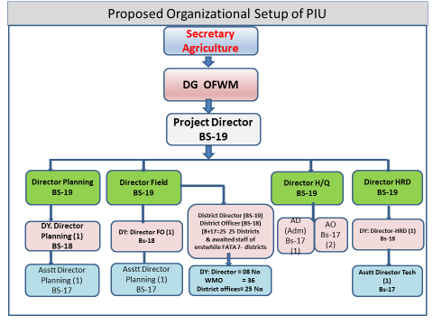

Project Implementation Unit (PIU)-II
The proposed project activity (Rough Land Levelling) will be implemented through existing set up of Agricultural Engineering Department at Provincial level. Director Agricultural Engineering Department Khyber Pakhtunkhwa will act as overall in-charge of the Agriculture Engineering Component. One of the BS-18 Officer of the Department will be nominated as AE Component Deputy In-charge. He will be responsible to supervise, manage, and monitor the proposed activities from Provincial Headquarter through existing set-up of Directorate and Sub-Offices. He will report the monthly physical and financial progress to the Project Director on regular basis.
The project activities in the sub-offices will be implemented by Agricultural Engineer/Assistant Agricultural Engineer (Incharge DDO) through their exiting human resources and project staff. He will be responsible for supervision, coordination and internal monitoring of all the activities in the concerned sub-office.

F.2 District Offices

The project activities (Watercourses Earthen & Lining) in the districts will be implemented by District Director/District Officer (OFWM) mainly through their exiting human resources. The requisite incremental resources will be provided from the project funds for the purpose. The District Director/District Officer (OFWM) would be responsible for supervision, coordination and internal monitoring of all activities in the concerned district. Organogram of district level OFWM setup is given below:

F.3 District Rate Committee (DRC)

The DRC comprising the following officers will be constituted to decide the rates of construction materials for improvement of watercourses and other OFWM civil works:

- District Director/District Officer, OFWM Chairman
- Representative of Provincial Works Department (at district level) Member
- Field Engineer (TPV Consultants) Member
- Deputy Director/WMO OFWM Member/Secretary

The DRC will have the following mandate:

- Periodically review rates of various construction materials.
- Fix price band for different materials for clusters on geographical basis in accordance with the specifications prescribed in OFWM Field Manuals.

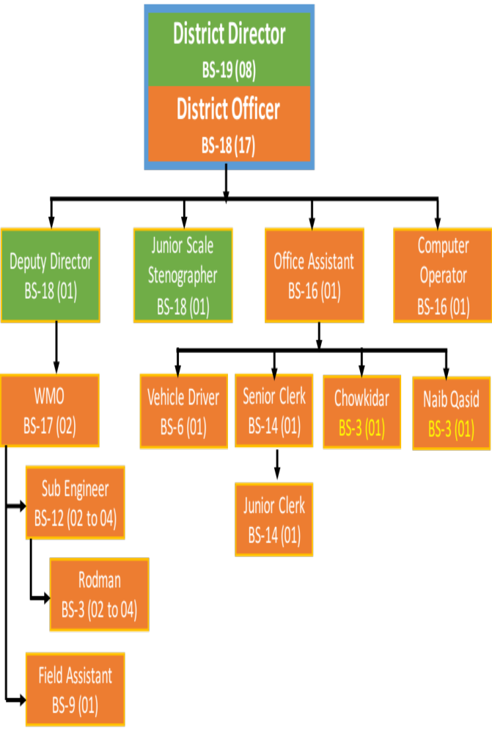

G.Monitoring & Evaluation

G.1 Provincial Program Monitoring Unit (PPMU)
Monitoring act as catalyst for effective implementation & completion of any project. The Program Monitoring Unit staff proposed in the project titled “National Program for Improvement of Water Courses in Pakistan Phase-II (KP component) “will also monitored the activities related to this instant project as per TORs recorded in the above mentioned project.

G.2 Scheme Validation
All the schemes executed under this project will be verified/validated for quality and quantity by the third party validation (TPV) consultants. TPV Consultants would be engaged by the Federal Government as per in vogue procedures of the Federal Government. Detailed ToRs of the consultants will be prepared and documented in the Umbrella PC-I at Federal level.

G.3 Monitoring and Evaluation Consultancy
Monitoring and Evaluation (M&E) consulting services would be required for impact assessment of various project interventions as well as to evaluate degree of achievement of Project Development Objective. The other objective of this consultancy would to assist project management as well as to regularly keep track of performance of envisaged interventions and take course correction measures, if needed. Detailed ToRs will be prepared and documented in the Umbrella PC-I at Federal level.

G.4 Provision of building, transport & equipment

Existing facility (building, transport & equipment) of the On Farm Water Management at district as well as provincial level would be utilized under the instant project. In order to implement this project within the stipulated time and achieve its objectives, provision has been made to procure 01 No of Van for Water Management Training Centre and 2 No’s vehicles for field offices under this project. For this purpose, an amount of Rs. 6.800 million has been allocated (Table-6).

In order to supplement the existing infrastructure, provision has also been made for POL, Repair& maintenance of the existing OFWM transport/equipment/machinery in this project for which an amount of Rs. 23.930 million has been allocated in this PC-I (Table-7).

H. Justification

Pakistan’s population has reached 180 million and expected to reach 221 million by 2025. This demands urgent steps to increase the agricultural production to ensure food security in the country. The irrigated sector is so intimately interwoven with almost all other sectors that it acts as engine of growth for the rest of the country. However, the performance of the agriculture sector in terms of water use and capacity as well as quality has remained very low for the last few decades. More importantly, the crop water productivity has been lowest than its potential because of ineffective and inefficient utilization of agricultural resources, particularly water. Water is the determining factor for agriculture development which, however, has to be managed sustainably.

Water is the most critical and precious input for crop production in arid and semiarid areas. Growing physical scarcity of freshwater resources, snowballing uncertainties associated with ongoing climate change in economically accessible water, growing population, and increasing competition for water amongst various sectors has threatened sustainability of agriculture. The situation has further aggravated due to low crop water productivity causing persistent food insecurity besides environmental degradation.
Irrigated agriculture is the lifeline of Pakistan’s economy. The sector is so intimately interwoven with almost all other major sectors that it acts as engine of growth for rest of the economy. However, the performance of agriculture sector in terms of water use and capacity as well as quality has remained very low for the last few decades.

Since independence, the amount of cultivated land has increased by more than one-third. This expansion is largely the result of improvements in the irrigation system that makes water available to additional fields. Substantial amount of farmland has been lost due to urbanization & menace of water logging, but losses are more than compensated for by addition of new land under plough.

The scanty rainfall over most of months makes about 80% of cropping dependent on irrigation. Fewer than 4 million hectares of land, largely in northern Punjab and Khyber Pakhtunkhwa, are totally dependent on rainfall. An additional 2.0 million hectares of land are under non irrigated cropping, such as plantings on floodplains as the water recedes. Non-irrigated farming generally gives low yields, and although the technology exists to boost production substantially, it is expensive to use undulated lands.

All this emphasizes the need to invest in water conservation and improvement in water use efficiency. It requires a shift in agricultural policies to encourage water conservation, crop diversification and productivity enhancement.

I. Technical Parameters
Thetechnical parameters as well as support would be according to the approved/published OFWM field manuals with slight changes subject to the site conditions. Following specifications would generally be followed for execution of a scheme under the instant project:
- Rectangular brick section with 23 cm thick side walls, 10 cm concrete bed (1:2:4) with 1:4 mortar (brick masonry & plaster);
- Rectangular PCCsection with 23 cm thick walls&10 cm concrete bed (1:2:4);
- Trapezoidal PCC withlining (1:2:4);
- Precast Parabolic Segment (1:1:2) lining;
- PVC, GI, RCC, CI pipe and Butyl rubber are cost competitive materials for low flows (15 LPS or less);
- Any other type of lining alternative acceptable to the farmers and technically feasible on the site subject to approval of specified committee;

- Input and output Technical Parameters
Input | Output
400 numbers of watercourses would be lined/ improved, total material cost would be bear by the project/Government as a subsidy to the farming community. | 71,675 acres of new valuable agriculture land will be brought under cultivation.
34,000 acres of Rough Land Leveling would be carried out during the instant project, 80% of cost of land development / Level work would be borne by the project/Government as a subsidy to the farming community. | 71,675 acres of barren land will be brought under cultivation
Fruit Orchard on 2130 acres of area would be establish at farmers’ fields free of cost. | Fruit orchard laid out on 2130 acres and 10000 farmers trained in improved technology.
Oil Seed crops on 5200 acres of area would be establishes at farmers’ fields free of cost. | Oil Seed crops on 5200 acres cultivated & 25000 farmers trained in oil seed production technology.
Fodder crops on 1500 acres of area would be established at farmers’ fields free of cost. | 1500 acres of different fodder crops cultivated & 7000 farmers trained in improved fodder production technology.

7. CAPITAL COST ESTIMATES
- Date of estimation of project Cost: March, 2019
- Basis of determining the capital cost: Prevailing market rates

- Year-wise estimation of physical activities:

Table-1 Year-wise targets of physical works
S. No. | Activities/Interventions | Unit | Physical Targets
S. No. | Activities/Interventions | Unit | 2019-20 | 2020-21 | 2021-22 | 2022-23 | 2023-24 | Total
1 | Construction of earthen watercourses | Nos | 100 | 100 | 100 | 100 | 0 | 400
2 | Lining of watercourses & allied structures | Nos | 50 | 100 | 100 | 100 | 50 | 400
3 | Rough Land Levelling | Acres | 5000 | 5000 | 8000 | 8000 | 8000 | 34000
4 | Fruit orchards. | Acres | 130 | 500 | 500 | 500 | 500 | 2130
5 | Oil Seed Crops | Acres | 200 | 1250 | 1250 | 1250 | 1250 | 5200
6 | Fodder crops | Acres | 0 | 400 | 400 | 400 | 300 | 1500

Table-2 Year-wise Funds Allocation for physical works

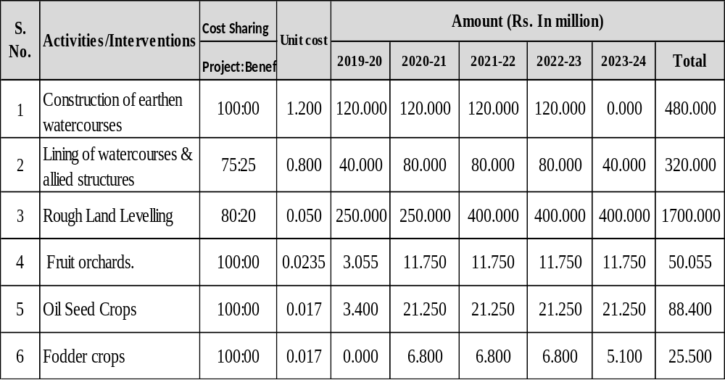

Table-3 Phasing of Physical Targets for Training / Capacity Building

S. No. | Activities/Interventions | Unit | Physical Targets
S. No. | Activities/Interventions | Unit | 2019-20 | 2020-21 | 2021-22 | 2022-23 | 2023-24 | Total
1 | Capacity Building Professionals/Sub Professionals | Nos | 15 | 15 | 0 | 0 | 0 | 30
2 | Farmer’s Training @2Nos per Watercourse | Nos | 160 | 160 | 160 | 160 | 160 | 800

Table-4 Phasing of Funds for Training / Capacity Building

S. No | Activities/Interventions | Cost Sharing | Unit cost | Amount (Rs. In million)
S. No | Activities/Interventions | Project:Benef | Unit cost | 2019-20 | 2020-21 | 2021-22 | 2022-23 | 2023-24 | Total
1 | Capacity Building Professionals/Sub Professionals | 100:00 | Lump Sum | 1.000 | 1.000 | 0.000 | 0.000 | 0.000 | 2.000
2 | Farmer’s Training @2Nos per Watercourse | 100:00 | Lump Sum | 0.400 | 0.400 | 0.400 | 0.400 | 0.400 | 2.000

Table-5 Establishment costs

S. No | Establishment | Cost Sharing | No of Posts | Fix Salary per month | Amount (Rs. In million)
S. No | Establishment | Project:Benef | No of Posts | Fix Salary per month | 2019-20 | 2020-21 | 2021-22 | 2022-23 | 2023-24 | Total
1 | Internees | 100:00:00 | 22 | 0.030 | 7.920 | 7.920 | 7.920 | 7.920 | 7.920 | 39.600

Table-6 Phasing of Transport, Equipment, Furniture, etc.

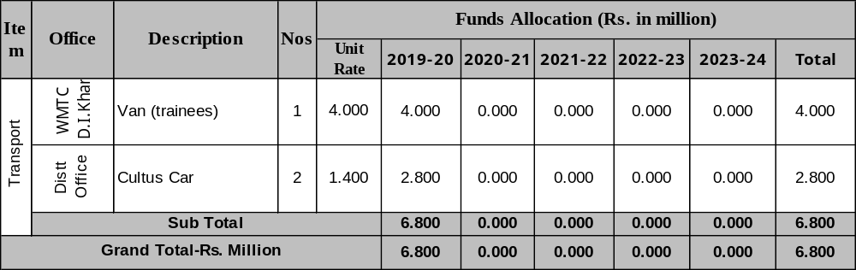
Table-7 Phasing of Operational Cost

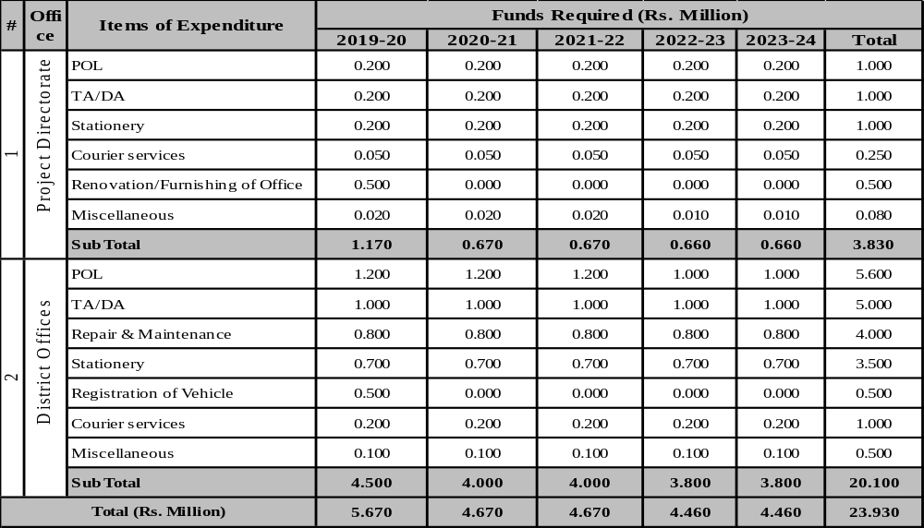

Table-8 Phasing of Project Cost
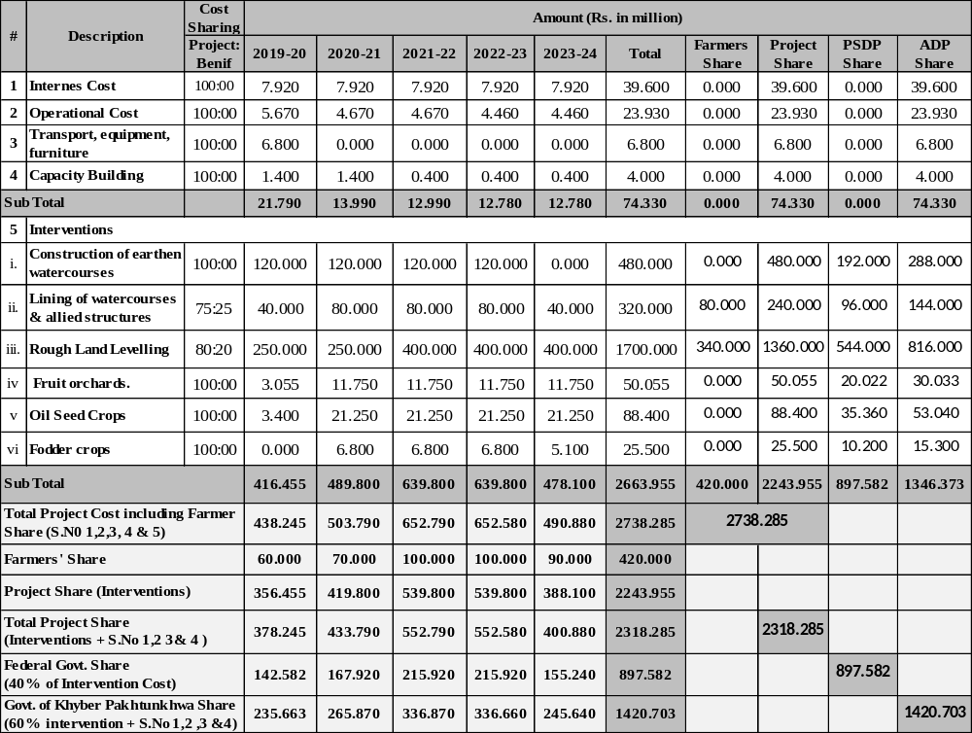
Table-9 Summary Project Cost
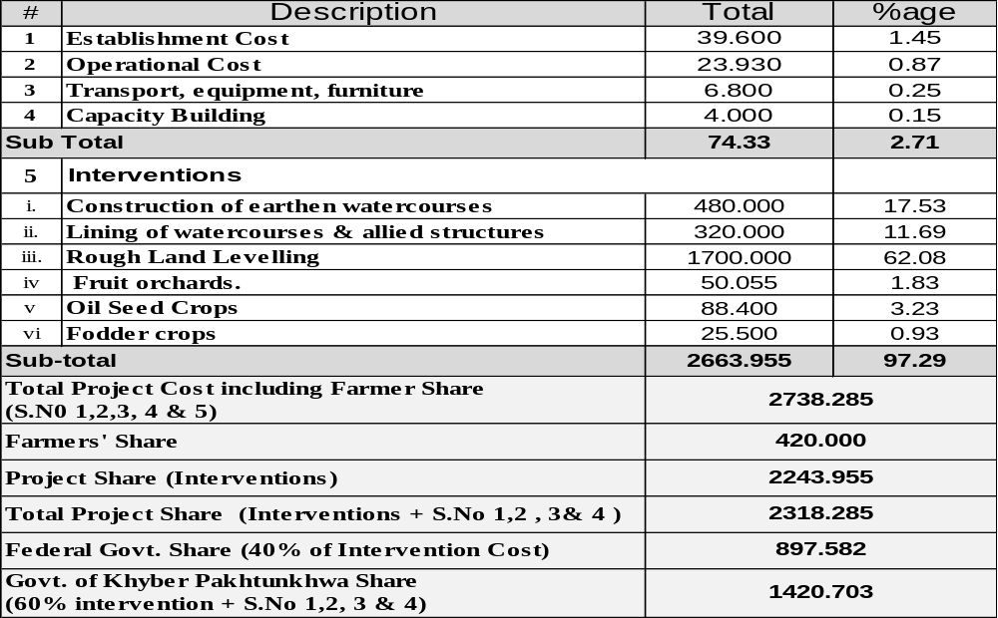

8. ANNUAL OPERATING AND MAINTENANCE COST AFTER COMPLETION OF
THE PROJECT:

The farmers (WUAs) would be responsible for the operation and maintenance of the project interventions and as such there would be no recurring expenditure for these facilities on the part of government after completion of project gestation period.

9. DEMANDS AND SUPPLY ANALYSIS:

Not applicable

10. FINANCIAL PLAN & MODE OF FINANCING:

(a) Equity:

Indicate the amount of equity to be financed from each source.

- Sponsors own sources. N.A.
- Federal government. Rs 897.582 Million (PSDP)
- Provincial government Rs. 1420.703 Million (ADP)
- DEPs/banks N.A.
- General public (Service Providers). N.A.
- Foreign equity (indicate agency). N.A.
- Beneficiaries. Rs 420.000 Million (Cash/Kind)
- Others. N.A.

(b) Debt:
Indicate the local & foreign debt, interest rate, grace period and repayment period for each loan separately.

(c). Grants along with source. N.A

(d). Weighted cost of capital. N.A

Total: Rs. 2738.285 Million

11. PROJECT BENEFITS AND ANALYSIS:
Successful completion of the proposed project would result in reduction of about 50% water losses in conveyance & application. Moreover, efficient use of available water will increase 10% crop yields. It has been estimated that about 35% labour requirements for irrigation operation will be reduced. Cropped area would be increased by about 76,000 acres, water logging & salinity would be controlled, utilization of non-water inputs will become more efficient, and use of farm machinery will be facilitated.

11.1 Employment generation (direct and indirect)
Trained & experienced staff for all positions is made available by the provincial government and district government setupin addition to their own duties with some incentive from the project. However operational cost will be borne from the Project funds. Due to project interventions, employment opportunities would be generated for skilled and unskilled labour either at scheme site or material yards. The instant project will generate about 87000 annual employment opportunities (direct/indirect) to help in poverty alleviation in the province.

11.2 Impact on environment
All the schemes are generally environment friendly as there is no involvement of heavy machinery of displacement The lining/improvement of WCs is an environment friendly project which helps in proper management/drainage of water avoiding ponding, water logging/salinity hazards. It is expected that after completion of the project, the micro climate of the area would have very positive effects.

11.3 Impact of delays on project cost and viability

Delay in implementation of the project will further exaggerate the erosion risk and heavy losses will occur in shape of loss of nutrient rich top-soil. The runoff water lost every year, if utilized, can contribute to a mammoth increase in agriculture production. The delay in implementation would mean loss of opportunity to store water for agriculture and associated uses. Furthermore, considering the inflation, greater amounts of money will be required to spend on similar activities with every delayed year. Productivity of land will be adversely affected and food security problem may arise.
Due to unstable market situation and unprecedented price hike, a delay in the project for three years will result in increased project cost and delayed benefits.

11.4 Internal Rate of Return (IRR) &Benefit-Cost Ratio (BCR)
The IRR of 31% and cost-benefit ratio of 1 :5 for the project has also been calculated which is placed at Annexure J & k at Page No 44 & 45.

12. IMPLEMENTATION SCHEDULE:
- Date of commencement : 1st July, 2019
- Date of Completion : 30th June, 2024

- Item wise / year wise implementation schedule in line chart co-related with the phasing of physical activities
Line Diagram of Project Activities
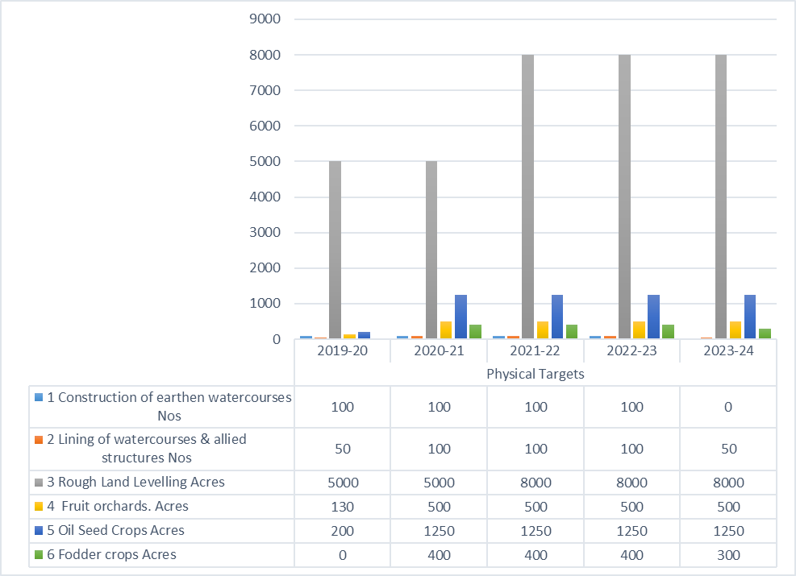

Table-6 Result Based Monitoring Indicators:
# | Input | Out put | Outcome
# | Input | Out put | Baseline indicator | Target after completion of Project | Targeted impact
1 | Construction/Lining of Watercourses of 400 Nos | Efficient distribution of irrigation water | No watercourses have been existed/Improved under the command area prior to the project. | 71,675 acres of valuable agriculture land will be brought under irrigation. | Proper irrigation at farm level will reduce conveyance losses
2 | Rough Land Levelling of 34,000 acres | Judicious / equitable use of water | No Rough Land Levelling have been carried about prior to the project | 34,000 acres of valuable agriculture land will be levelled. | Leveled field with high distribution uniformity and application efficiency
3 | Fruit Orchard on 2130 acres of area would be establish at farmers’ fields free of cost. | Fruit orchard laid out on 2130 acres and 10000 farmers trained in improved technology. | No. orchards available or activities carried out prior to the project. | Introduction of high value crops like fruit orchards in the project area. | Awareness among the farming community regarding new crops created.  Dissemination of improved production technology.  Increase the income per unit land of agriculture land
 | Oil Seed crops on 5200 acres of area would be establishes at farmers’ fields free of cost. | Oil Seed crops on 5200 acres cultivated & 25000 farmers trained in oil seed production technology. | No. orchards available or activities carried out prior to the project. | Farmers of the project area would be able to develop Oil Seed crops.
4 | Fodder crops on 1500 acres of area would be established at farmers’ fields free of cost. | 1500 acres of different fodder crops cultivated & 7000 farmers trained in improved fodder production technology. | No. orchards available or activities carried out prior to the project. | Farmers of the project area would be able to develop fodder crops.

SWOT ANALYSIS

Strengths:
  - Well established offices in the 25 districts of the province covering activities in the whole of Khyber Pakhtunkhwa.
  - Highly skilled professional and qualified field staff in the relevant technology.
  - Lesson learnt in the donor assisted completed project can be exercised properly.
  - Availability of HR institution with in the department.

Weaknesses:
- Non-existence of a proper building in some of the district;
- Low capacity of OFWM staff in latest water management techniques, especially irrigation agronomy;
- Old field vehicles, most of which have already spent their service life;
- The OFWM staff and offices not exist in erstwhile districts of FATA. However, SNE for establishment of seven offices with required staff of erstwhile districts were sent to the government;
- Inadequate capacity of Agricultural Engineering Department in terms of machinery and staff for implementing the Rough Land Leveling work under the instant project.
- Lack of proper training facilities in Water Management Training Center D.I.Khan.
Opportunities:
- Water losses control and increase cropped area;
- Adaptation of new technology for improved irrigation techniques;
- Increase in cropping intensity/ crop production;
- Adaptation of high value crops, change in profitable cropping pattern and increase in per acre yield
- Improve the social economic position of the farming community;
- Motivation of farming community for participatory approach.

Threats:
- Delay in the release of funds may cause difficulty in achieving the target in stipulated time;
- Natural calamities and weather condition & may affect smooth functioning of field activities;
- Irrigation requirement results in delay of schemes;
- As skilled and unskilled labor is to be provided by the farmers, delay in timely provision of labor may result in the overall delay of the project.

13. MANAGEMENT STRUCTURE & MANPOWER REQUIREMENTS INCLUDING SPECIALIZED SKILLS DURING EXECUTION AND OPERATIONAL PHASES

13.1 Management Structure

The Directorate General OFWM in the province is part of the Government of Khyber Pakhtunkhwa Agriculture, Livestock & Cooperation Department, headed by the Secretary. The OFWM department is headed by the Director General (BS-20) at provincial level. All the OFWM activities in the province are executed through OFWM developmental as well as current budget staff.
The Directorate General OFWM KP Office will act as a Project Directorate and the Director General will be the overall incharge of the Project. Moreover, the senior most Director of the Directorate of OFWM will be nominated as a Project Director for instant Project.The project will be implemented through existing administrative and physical infrastructure of OFWM under current budget. The Project Directorate would have following main functions:
- Develop, implement, coordinate and up-date a detailed work-plan/cash flow plancovering key activities;
- Approval/sanction of schemes;
- Prequalification and selection of suppliers and finalize the selection;
- Coordinate with all the line department/agencies in the project interest;
- Monitor physical and financial progress of the project in each district/site and prepare reports for submission to PSC & administrative department;
- Supervise training programs; arrange workshops/seminars/field days;
- Arrange project review committee (PRC) meetings on monthly/quarterly basis;
- Reconciliation of accounts and finally submission of Annual Audit Report.
- Prepare annual reports of the project and submit it to donors, administrative department t and all other line agencies;
- Facilitate donors/third party in monitoring/validation of the schemes.
13.2 Manpower Requirements

As mentioned above, the project staff would comprise existing experienced OFWM staff in the directorate as well in all district-wise staff of the province. However, 22 numbers of internees graduate 11 each of B.SC Agriculture Engineers and M.SC (hons) Agriculture would be selected for a period of 12 months, so a total of 110 numbers graduate would be benefited from the instant project.

13.3 Federal Steering Committee (FSC)

FSC would be responsible for overall policy guidance, coordination, approval of AWP/Cash Plans, Review & approve the physical targets and financial allocation, Any other policy issue and matter presented by the provincial executing agencies for consideration and approval, FWMC of NFS&R would be the secretariat of the FSC, FSC meeting to be convened annually/by annually and also as and when necessary etc. It organization set-up would be as under:
- Secretary, NFS&R Chairman
- Secretary PD&R Division Islamabad Member
- Additional Finance Secretary (Budget)Islamabad Member
- Representative of Accountant General of Pakistan Member
- Representative of Auditor General of Pakistan Member
- Additional Chief Secretaries (all provinces) Member
- Agriculture Secretaries (all provinces) Member
- Director Generals/Project Director (all provinces) Member
- Director General Federal Water Management Cell Member/Secretary

13.4 Federal Coordination Committee (FCC)

FCC would be responsible for review, coordination, support of the overall project activities in the country. Proposed revision (if needed) of AWP, periodically review the project implementation status and progress, take necessary action to overcome deficiencies, FCC meeting to be convened after every three months and also as & when necessary. It organization set-up would be as under:
- Director General FWMC Chairman
- Director Generals/Project Directors (all provinces) Member
- Director General Agriculture AJK Member
- Director Agriculture Northern Areas Member
- Representative of P&D Division Islamabad Member
- Director (Head Quarters) NPIWC Member/Secretary

13.5 Provincial Steering Committee (PSC)

A PSC shall be constituted to provide policy guide lines, approval of AWP and budget etc. The PSC would be responsible for coordination, adjustment, modification & clarification within the framework of approved PC-I. In addition, monitoring of project implementation status at least twice a year and resolution of project implementation issues at Provincial level will also be the responsibility of PSC. The PSC would comprise the following members:
- Additional Chief Secretary P&D Chairman
- Secretary Agriculture Member
- Secretary Finance Member
- Provincial Coordinator (PMU) Member
- Team Leader TPV Consultants Member
- Director General/Project Director Secretary/Member

13.6 Provincial Implementation Committee (PIC-I)

PIC would review the progress on monthly basis. All the DOs/DDs, would be the members of PIC. Its constitution would be as under:
- Director General (OFWM) Chairman
- Project Director Member
- Representative of team Leader (TPV Consultants) Member
- District Directors/District Officer (all districts) Member
- Representative of PPMU Member
- Director Field Operation Secretary/Member
13.7 Provincial Implementation Committee (PIC-II)

PIC-II would review the progress on monthly basis. All the Agricultural/Assistant Agricultural Engineers (DDOs) of the concerned sub-offices would be the members of PIC-II. Its constitution would be as under:

- Director Agricultural Engineering Chairman
- Deputy Project Director (AE Component) Member/Secretary
- Representative of team Leader (TPV Consultant) Member
- Agril: Engr/Asstt: Agricultural Engineer (concerned sub-offices) Member
- Deputy Director Planning Member
- Representative of PPMU Member

14. ADDITIONAL PROJECTS/DECISIONS REQUIRED TO MAXIMIZE SOCIO-ECONOMIC BENEFITS FROM THE PROPOSED PROJECT:

The project is proposed to be implemented in the eleven districts of Khyber Pakhtunkhwamentioned at page No 1 of this document. The interested farmers and first come first serve basis approach will be fallowed under the instant project.The farming communities will be attracted through effective mobilization through effective mass awareness campaign.

15 CERTIFICATES.
- Certified that the name, designation and phone # of the officer responsible for preparing and checking has been provided.
- Certified that the project proposal has been prepared on the basis of instructions issued by the Planning Commission for the preparation of PC-I for production sector projects.

Prepared by:
Engr. Muhammad Asif  Deputy Director Planning,  OFWM Peshawar | DR. Murad Ali Khan  Deputy Director Planning (HQ),  DGAE Peshawar | Engr. Muhammad Musa Khan  Deputy Director,  Agril: Engineering Peshawar
Checked by:

Engr. Muhammad Khurshid Afridi  Director General,  OFWM Khyber Pakhtunkhwa | Muhammad Nasim  Director General,  Agri. Ext. Khyber Pakhtunkhwa
Engr. Mahmood Jan Babar  Director,  Agril: Engineering, Khyber Pakhtunkhwa | DR. Naveed Akhtar  Director General,  AR System, Khyber Pakhtunkhwa

Counter Signed by:

_________________________________
Muhammad Israr
Secretary to Govt. of Khyber Pakhtunkhwa Agriculture, Livestock & Cooperation Department, Peshawar.
Phone # 0919210025

Cleared by PDWP: _______________________________________

Approved by CDWP: _______________________________________

Annexure A
NATIONAL PROGRAM FOR ENHANCING COMMAND AREA OF
SMALL /MINI DAMS IN BARANI AREA OF KAHYBER PAKHTUKHWA
A. KEY SALIENT FEATURES OF DAMS REQUESTED BY AGRICULTURE DEPARTMENT
S.No | Name of Dam | Location  (District) | River /  Nullay | Year of  Commen: | Year of  Completion |  | Height of  Dam  (ft) |  | CCA  (Area) | Storage  Capacity  (A.F)
1 | Kandar Dam | Kohat |  | 2002 | 2005 |  | 500 |  | 1000 | 1333
2 | Chatri Dam | Haripur | PutriNullah | 1984 | 1985 |  | 85 |  | 600 | 540
3 | Gandially Dam | District Kohat | TarroNullah | 2000 | 2003 |  | 72 |  | 3000 | 13784
4 | Aza Khel Dam | District Peshawar | AzakhelKhwar | 2003 | 2004 |  | 70 |  | 3500 | 3840
5 | Naryab Dam | District Hangu | AshkalyNullah | 2003 | 2006 |  | 105 |  | 4162 | 3120
6 | Sharki Dam | District Karak | Teri Toi | 2003 | 2006 |  | 130 |  | 3000 | 9996
7 | Changhoz Dam | District Karak | ChanghozToi | 2003 | 2006 |  | 140 |  | 3300 | 11550
8 | Barganattu Dam | District Bannu | BarganattuToi | 2007 | 2010 |  | 93 |  | 1190 | 2135
9 | Khair Bara Dam | District Haripur | Khair Bara | 2007 | 2013 |  | 90 |  | 1600 | 489
10 | JabbaKhattak Dam | District Nowshera | Jaba Tar Nullah | 2007 | 2014 |  | 44 |  | 465 | 240
11 | Palai Dam | District Charsadda | Jindi River | 2009 | 2015 |  | 104 |  | 3600 | 5000
12 | Darmalak Dam | District Kohat | Mariam ZaiToi | 2007 | 2015 |  | 92 |  | 3500 | 8033
13 | Ghole Banda Dam | District Karak | DadiAlgad | 2010 | 2015 |  | 74 |  | 1500 | 4531
14 | MardanKhel Dam | District Karak | UrmarAlgad | 2010 | 2015 |  | 130 |  | 1300 | 2383
B. KEY SALIENT FEATURES OF DAMS RECOMMENDED BY DIRECTORATE GENERAL SMALL DAMS IRRIGATION DEPARTMENT
1 | Kundal Dam | District Swabi | BadgaKhwar | 2013 |  | 2018 |  | 157.5 | 13200 | 10135
2 | ZamirGul Dam | DistirctKohat | Pala Khwar | 2013 |  | 2018 |  | 141 | 2000 | 5468
3 | Jalozai Dam | DistirctNowshera | Shah KotKhwar | 2014 |  | 2018 |  | 74 | 900 | 999

Annexure B
Details Of CCAD Of Balambat Flow Irrigation Scheme Dir Irrigation Division at Timargara
S No. | Out Let RD | Out Let Discharge Q | CCA | Tentative Lengh of Water Course
 |  | (CFS) | (Acres) | (Ft)
1 | 2+100 | 0.42 | 42.00 | 700
2 | 3+300 | 0.56 | 56.00 | 900
3 | 13+000 | 0.80 | 80.00 | 600
4 | 17+000 | 1.12 | 112.00 | 1145
5 | 34+000 | 0.05 | 5.00 | 1500
6 | 35+500 | 0.03 | 3.00 | 1400
7 | 35+700 | 0.20 | 20.00 | 1200
8 | 38+000 | 0.03 | 3.00 | 1800
9 | 38+500 | 0.38 | 37.63 | 2500
10 | 47+000 | 0.52 | 52.00 | 2300
11 | 47+800 | 0.38 | 38.00 | 1800
12 | 48+300 | 0.09 | 9.00 | 2800
13 | 51+000 | 0.15 | 15.00 | 3000
14 | 57+500 | 0.32 | 32.00 | 3500
15 | 60+000 | 0.34 | 34.00 | 2400
16 | 62+000 | 0.19 | 19.00 | 2700
17 | 67+500 | 0.36 | 36.00 | 1900
18 | 68+400 | 0.17 | 17.00 | 3150
19 | 73+600 | 0.28 | 28.38 | 2870
20 | 75+000 | 0.08 | 7.50 | 3140
21 | 76+400 | 0.28 | 28.00 | 2500
22 | 79+000 | 0.20 | 20.00 | 2680
23 | 80+400 | 0.58 | 58.00 | 3000
24 | 82+100 | 0.61 | 61.00 | 3500
25 | 83+500 | 0.10 | 10.00 | 3480
26 | 85+450 | 0.47 | 47.00 | 3670
27 | 86+700 | 1.06 | 106.00 | 3490
28 | 87+600 | 0.48 | 48.00 | 3600
29 | 88+900 | 0.34 | 34.00 | 2400
30 | 90+100 | 0.96 | 96.00 | 3180
31 | 93+800 | 0.17 | 17.00 | 2900
32 | 101+600 | 0.12 | 12.00 | 3800
33 | 103+000 | 0.09 | 9.00 | 3710
34 | 103+750 | 0.39 | 39.00 | 3650
35 | 104+900 | 0.17 | 17.00 | 3400
36 | 104+950 | 0.40 | 40.00 | 3000
37 | 105+700 | 0.42 | 42.00 | 2600
38 | 106+800 | 0.24 | 24.00 | 1800
39 | 112+000 | 0.26 | 26.00 | 1900
40 | 112+700 | 0.19 | 19.00 | 1400
41 | 13+600 | 0.14 | 14.00 | 1000
42 | 114+300 | 0.28 | 28.00 | 1300
43 | 16+300 | 0.15 | 15.00 | 1500
44 | 122+000 | 0.16 | 16.00 | 1968
45 | 130+300 | 0.15 | 15.00 | 1476
46 | 132+200 | 1.05 | 105.00 | 984
47 | 134+300 | 0.39 | 39.00 | 1181
48 | 135+800 | 0.45 | 45.00 | 1200
49 | 136+150 | 0.17 | 17.00 | 900
50 | 136+600 | 0.30 | 30.00 | 1200
51 | 137+400 | 0.11 | 11.00 | 1900
52 | 138+500 | 0.08 | 8.00 | 1100
53 | 139+000 | 0.41 | 41.00 | 3280
54 | 143+000 | 0.88 | 88.00 | 2788
55 | 144+300 | 0.57 | 57.00 | 2854
56 | 146+300 | 0.40 | 40.00 | 2886
57 | 147+000 | 0.52 | 52.00 | 2007
58 | 147+300 | 1.25 | 125.00 | 2001
59 | 147+500 | 0.47 | 47.00 | 1542
60 | 148+000 | 0.16 | 16.00 | 853
61 | 150+000 | 1.02 | 102.00 | 1509
62 | 152+500 | 0.63 | 63.00 | 1410
63 | 153+000 | 0.19 | 19.00 | 1417
64 | 153+500 | 0.72 | 72.00 | 984
65 | 155+100 | 0.24 | 24.00 | 1050
66 | 155+600 | 0.64 | 64.00 | 984
67 | 157+200 | 0.44 | 44.00 | 2296
68 | 162+000 | 0.26 | 26.00 | 1453
69 | 163+000 | 0.53 | 53.00 | 1486
70 | 163+400 | 1.50 | 150.00 | 820
71 | 164+000 | 0.56 | 56.00 | 840
72 | 165+000 | 1.36 | 136.00 | 1738
73 | 167+900 | 0.55 | 55.00 | 1164
74 | 168+000 | 0.58 | 58.00 | 1542
75 | 171+500 | 2.00 | 200.00 | 1410
76 | 172+500 | 2.17 | 217.00 | 1509
77 | 174+000 | 1.08 | 108.00 | 1132
78 | 174+500 | 0.65 | 65.00 | 1509
79 | 176+000 | 1.68 | 168.00 | 2296
80 | 176+300 | 0.13 | 13.00 | 800
81 | 177+000 | 1.85 | 185.00 | 1476
82 | 177+900 | 0.03 | 3.00 | 1500
83 | 180+000 | 3.54 | 354.00 | 1706
84 | 182+500 | 0.19 | 19.00 | 900
85 | 184+000 | 0.60 | 60.00 | 1200
86 | 187+000 | 1.48 | 148.00 | 1050
87 | 191+000 | 1.38 | 138.00 | 1181
88 | 194+500 | 1.43 | 143.00 | 1115
89 | 199+000 | 0.42 | 42.00 | 3900
90 | 200+100 | 1.10 | 110.00 | 4999
91 | 200+300 | 1.28 | 128.00 | 4100
92 | 200+500 | 2.17 | 217.00 | 3608
93 | 200+900 | 3.58 | 358.00 | 3280
94 | 201+600 | 5.23 | 523.00 | 4592
95 | 201+950 | 0.68 | 68.00 | 4600
96 | 216+000 | 7.20 | 720.00 | 4200
97 | 218+000 | 6.25 | 625.00 | 5000
98 | 222+000 | 6.01 | 601.00 | 2900
99 | 223+300 | 0.26 | 26.00 | 3400
100 | 224+000 | 3.00 | 300.00 | 3500
101 | 226+300 | 0.43 | 43.00 | 4100
102 | 228+000 | 1.55 | 155.00 | 2600
103 | 230+000 | 1.19 | 119.00 | 2500
104 | 231+000 | 4.86 | 486.00 | 3900
105 | 232+500 | 1.65 | 165.00 | 4200
106 | 234+000 | 0.90 | 90.00 | 4300
107 | 235+500 | 0.59 | 59.00 | 4600
108 | 237+000 | 1.12 | 112.00 | 4523
109 | 238+500 | 0.49 | 49.00 | 4500
110 | 240+000 | 1.14 | 114.00 | 4900
111 | 241+400 | 0.69 | 69.00 | 4500
112 | 242+800 | 0.76 | 76.00 | 4100
113 | 243+300 | 0.81 | 81.00 | 3600
114 | 244+500 | 2.50 | 250.00 | 3700
115 | 245+000 | 0.90 | 90.00 | 4600
116 | 246+400 | 1.91 | 191.00 | 4650
117 | 246+900 | 1.64 | 164.00 | 5000
118 | 247+300 | 1.46 | 146.00 | 5600
119 | 247+500 | 0.91 | 91.00 | 4500
120 | 248+000 | 1.44 | 144.00 | 4900
 |  |  | 11363.00 | 305711.6

Annexure C
DETAILS OF CCAD OF BAGH DHERI FLOW IRRIGATION SCHEME DISTRICT SWAT
S No | Outlet RD | Outlet Discharge q | CCA | Tentative length of Water Course | Command Area requiring Land Levelling
 |  | (cfs) | (Acres) | (ft) | (Acres)
1 | 10+500/L | 1.10 | 137.50 | 11000 | 8.25
2 | 19+100/L | 1.17 | 146.25 | 10000 | 9.50
3 | 24+050/L | 2.02 | 252.50 | 12000 | 20.00
4 | 30+050/L | 2.02 | 252.50 | 12000 | 15.00
5 | 33+600/L | 2.41 | 301.25 | 12500 | 12.00
6 | 39+800/L | 2.28 | 285.00 | 12500 | 18.00
7 | 42+050/L | 0.55 | 68.75 | 8000 | 5.00
8 | 45+300/L | 2.28 | 285.00 | 12500 | 18.00
9 | 46+800/L | 1.90 | 237.50 | 10000 | 14.50
10 | 49+050/L | 0.60 | 75.00 | 8000 | 4.50
11 | 54+300/L | 1.15 | 143.75 | 10000 | 9.50
12 | 58+300/L | 1.33 | 166.25 | 10000 | 10.00
13 | 59+050/L | 1.78 | 222.50 | 11500 | 14.50
14 | 62+050/L | 2.43 | 303.75 | 12000 | 18.50
15 | 69+050/L | 0.25 | 31.25 | 4000 | 2.00
16 | 72+000/L | 1.62 | 202.50 | 9500 | 12.00
17 | 73+000/L | 2.15 | 268.75 | 12000 | 16.00
18 | 74+122/L | 2.63 | 328.75 | 12500 | 19.50
19 | 74+122/R | 2.63 | 328.75 | 12500 | 22.00
 |  |  | 4037.50 | 202500 | 248.75

Annexure D
NIPKIKHEL IRRIGATION CHANNEL SWAT
S No | Outlet RD | Outlet Discharge “q “ | CCA | Tentative length of Water Course | Remarks
 |  | (cfs) | (Acres) | (ft)
1 | 3+500/L | 33.00 | 2500.00 | 30000 | Civil Rights
2 | 5+512/L | 0.25 | 6.00 | 3500
3 | 14+805/L | 0.59 | 35.00 | 8000
4 | 16+364/L | 0.91 | 70.00 | 8000
5 | 18+000/L | 0.72 | 55.00 | 6000
6 | 19+193/L | 0.57 | 44.00 | 6000
7 | 20+575/L | 0.32 | 25.00 | 5000
8 | 22+850/L | 0.25 | 16.00 | 6000
9 | 24+210/L | 1.33 | 102.00 | 9500
10 | 24+616/L | 0.28 | 22.00 | 5000
11 | 25+442/L | 0.28 | 22.00 | 5000
12 | 26+688/L | 1.82 | 139.00 | 10000
13 | 27+687/L | 0.34 | 26.00 | 6000
14 | 29+275/L | 0.76 | 58.00 | 7500
15 | 30+044/L | 0.25 | 6.00 | 3000
16 | 31+140/L | 0.70 | 55.00 | 6500
17 | 31+824/L | 0.25 | 5.00 | 3000
18 | 33+742/L | 0.81 | 62.00 | 8000
19 | 34+140/L | 1.71 | 131.00 | 10000
20 | 35+850/L | 0.27 | 21.00 | 4000
21 | 38+344/L | 1.69 | 129.00 | 9500
22 | 40+346/L | 0.22 | 17.00 | 6000
23 | 40+722/L | 0.73 | 56.00 | 6000
24 | 41+222/L | 0.25 | 13.00 | 4000
25 | 42+127/L | 0.47 | 36.00 | 6000
26 | 42+845/L | 0.25 | 15.00 | 5000
27 | 43+780/L | 0.8 | 61.00 | 6500
28 | 44+860/L | 0.25 | 14.00 | 4500
29 | 46+100/L | 0.25 | 8.00 | 5000
30 | 47+500/L | 0.94 | 72.00 | 6500
31 | 52+400/L | 0.32 | 25.00 | 6000
32 | 53+200/L | 0.76 | 58.00 | 6500
33 | 54+300/L | 0.23 | 18.00 | 5000
34 | 56+150/L | 1.33 | 102.00 | 8500
35 | 58+000/L | 0.9 | 69.00 | 8000
36 | 62+000/L | 0.28 | 22.00 | 6500
37 | 63+000/L | 0.38 | 29.00 | 6500
38 | 64+500/L | 0.43 | 33.00 | 7000
39 | 66+000/L | 0.25 | 10.00 | 4000
40 | 67+000/L | 5.41 | 413.00 | 12000
41 | 68+000/L | 0.55 | 42.00 | 8000
42 | 70+000/L | 1.11 | 85.00 | 8500
43 | 70+500/L | 1.33 | 102.00 | 9000
44 | 71+000/L | 0.45 | 35.00 | 6500
45 | 77+000/L | 1.2 | 92.00 | 8500
46 | 80+500/L | 0.78 | 60.00 | 8000
47 | 82+000/L | 0.78 | 60.00 | 8000
48 | 85+000/L | 5.24 | 400.00 | 12000
49 | 86+000/L | 1.12 | 86.00 | 8500
50 | 88+600/L | 0.65 | 50.00 | 6500
51 | 89+500/L | 0.39 | 30.00 | 6000
52 | 91+400/L | 0.24 | 19.00 | 5000
53 | 93+000/L | 1.44 | 110.00 | 8500
54 | 94+000/L | 0.4 | 31.00 | 6500
55 | 96+000/L | 4.5 | 343.00 | 12000
56 | 97+100/L | 0.25 | 19.00 | 5000
57 | 98+500/L | 5.48 | 418.00 | 12000
58 | 100+000/L | 2.44 | 186.00 | 9500
59 | 103+000/L | 0.59 | 45.00 | 5500
60 | 104+000/L | 0.31 | 24.00 | 5000
61 | 105+400/L | 2.55 | 195.00 | 9500
62 | 106+700/L | 0.64 | 49.00 | 9000
63 | 110+000/L | 3.71 | 283.00 | 9500
64 | 112+650/L | 0.64 | 49.00 | 6500
65 | 115+000/L | 0.51 | 39.00 | 5000
66 | 116+000/L | 2.74 | 209.00 | 9500
67 | 116+500/L | 2.8 | 214.00 | 9000
68 | 117+500/L | 2.75 | 210.00 | 9000
69 | 118+000/L | 0.25 | 18.00 | 5000
70 | 121+400/L | 0.25 | 18.00 | 5000
71 | 125+000/L | 0.69 | 53.00 | 8000
72 | 126+300/L | 1.37 | 105.00 | 8000
73 | 127+000/TF | 2.34 | 179.00 | 12500
 |  |  | 8458.00 | 543000
Annexure E
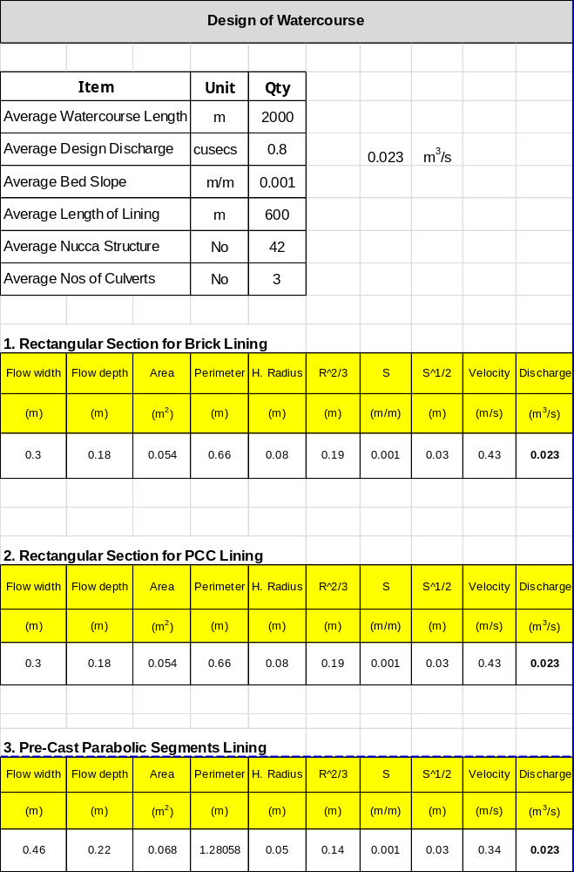
Annexure F

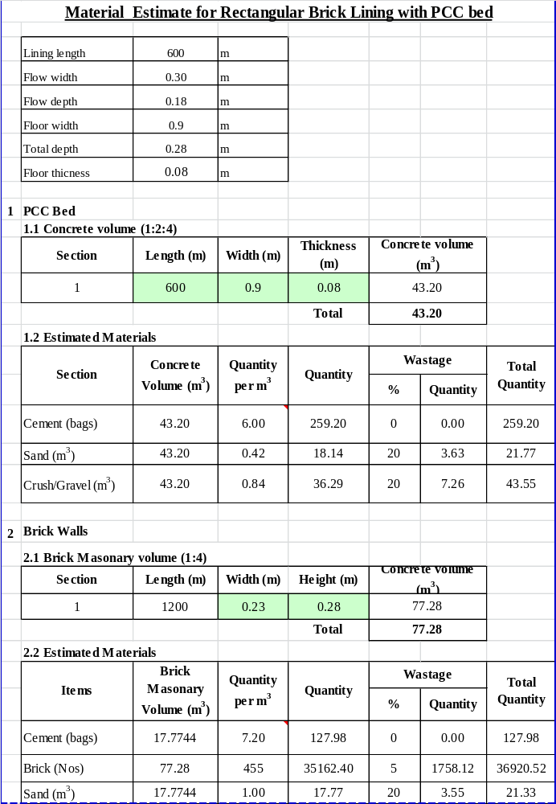

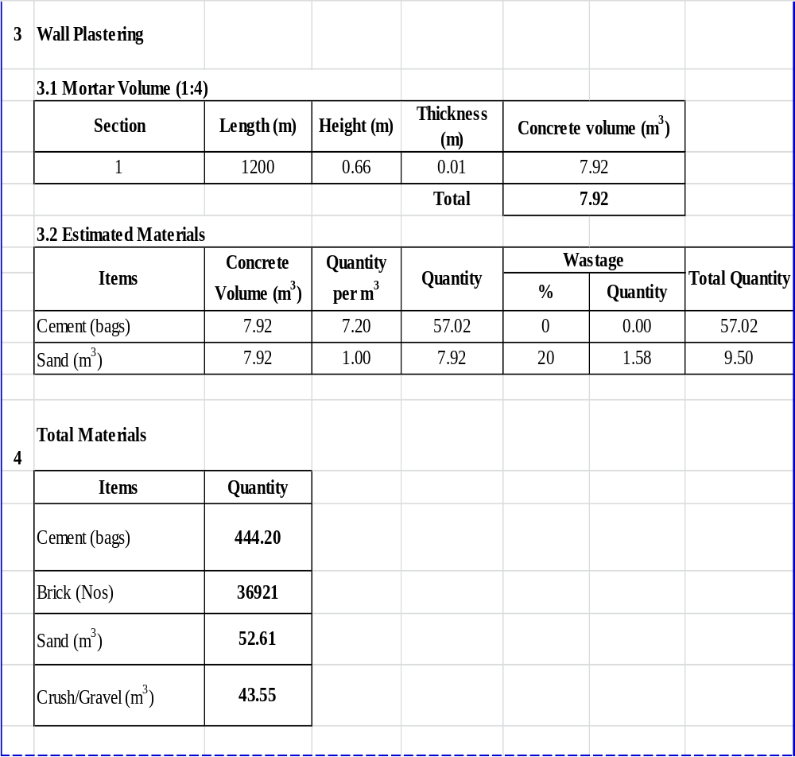

Annexure G

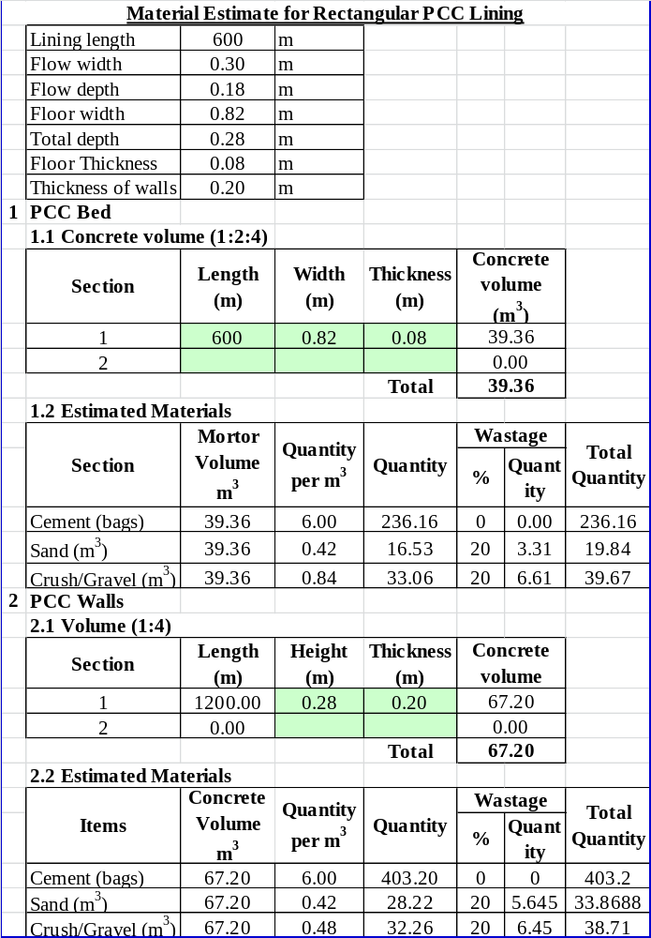

Annexure H
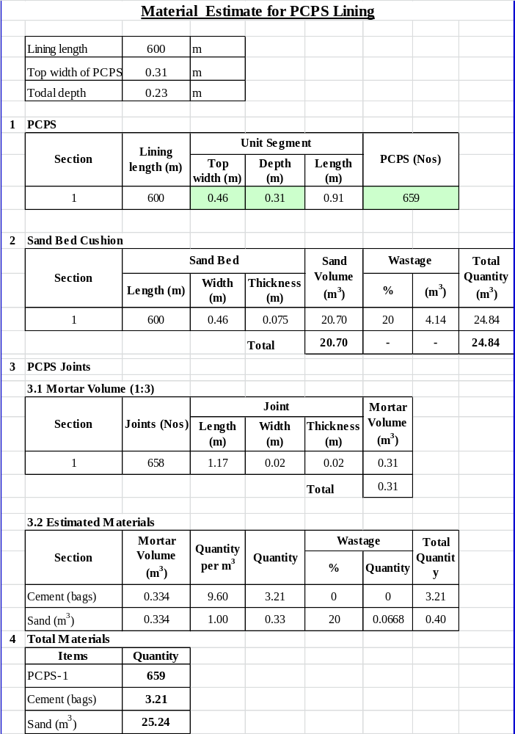

Annexure –I

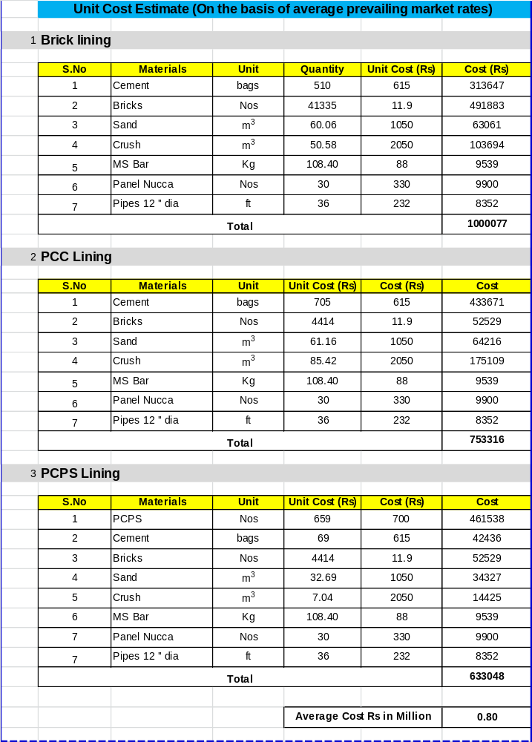

Annexure –J

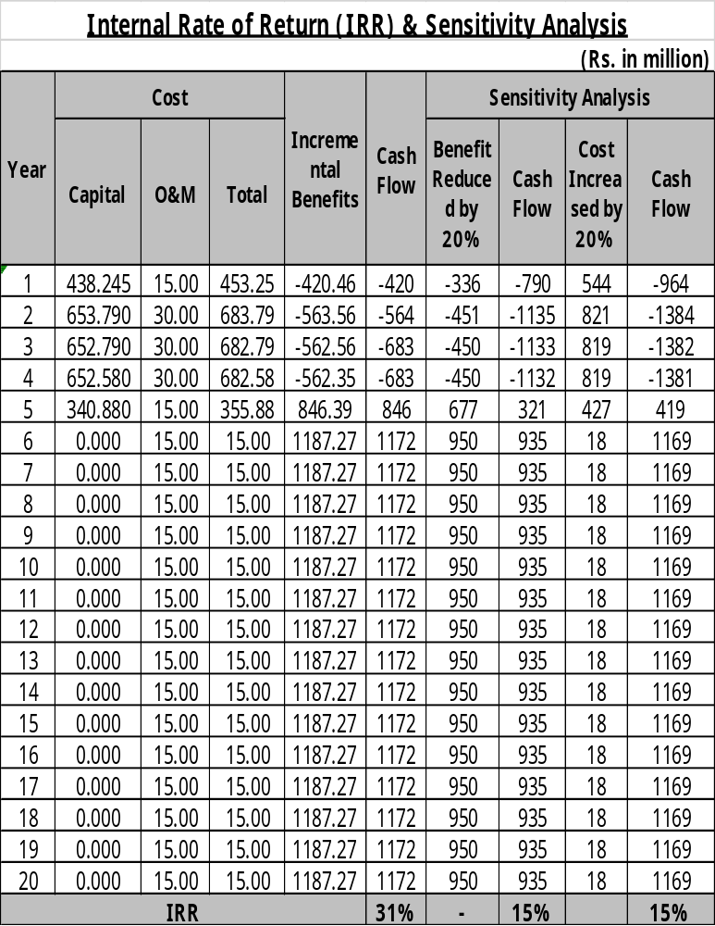

Annexure-K


