PC- I

Development of Onion and Tomato Pocket areas in Bajaur & Mohmand Districts

Merged Areas ADP (2019-20) # 35/190337
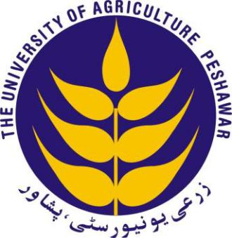

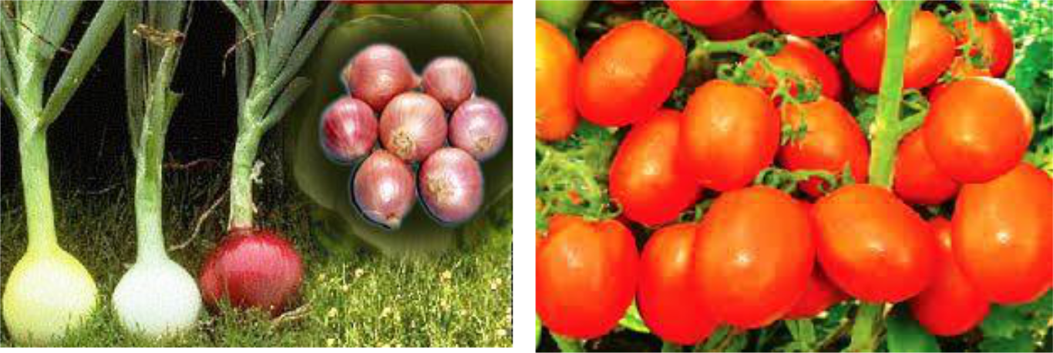

The University of Agriculture, Peshawar – Pakistan

October, 2019

1

GOVERNMENT OF PAKISTAN
PLANNING COMMISSION
PC-I FORM
(SOCIAL SECTORS)

- Name of the Project:Development of Onion and Tomato Pocket areas in Bajaur & Mohmand Districts

2. Location: The University of Agriculture, Peshawar
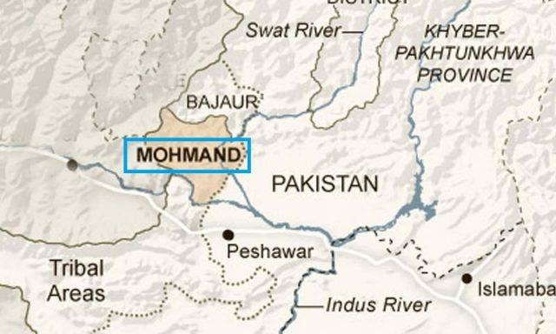

Map of the Project Area (District Bajaur & Mohmand, Khyber Pakhtunkhwa)

3. Authority responsible for:

i.

Sponsoring:

Agriculture, Livestock, Fisheries & Cooperatives Department, Government of Khyber Pakhtunkhwa

ii.

Execution:

The University of Agriculture, Peshawar

- Operation and Maintenance:The University of Agriculture, Peshawar

iv. Concerned Federal Ministry: Not Applicable (NA)

- Project objectives and its relationship with Sectoral objectives

The Sustainable Development Goals of the United Nations emphasizes to investing in the agricultural sector which can address not only hunger and malnutrition but also other challenges including poverty; water and energy use; climate change; and unsustainable production and consumption (SD Goal No.2). The goal also calls to end hunger, achieve food security and improved nutrition and promote sustainable agriculture. As we know the economy of Khyber Pakhtunkhwa is agrarian in nature where 80 percent of the total population is rural, with agriculture as their major source of livelihoods. The Agriculture Policy - A Ten Year Perspective (2015-25) clearly mentions that agriculture is the main livelihood for its people. Keeping these sectoral guidelines in view, there is a need to develop agriculture sector in a way that on one hand it can provide quality food resources while on the other enhance the socio economic condition of the farming community. Newly Merged Areas (NMAs) of Khyber Pakhtunkhwa being faced with unrest for a long time are in the dire need of providing support to its people specially the farming community to develop agriculture sector in line with UN SDGs and Agriculture Policy of the province. This will enable them to develop in tandem with other parts of the country.

The instant project is, therefore, proposed to promote the pocket area approach in Onion and Tomato production being major income generating crops in the two districts of newly merged areas i.e. Bajaur and Mohmand. Goal of the project is to support economic growth and employment generation in newly merged districts of Bajaur and Mohmand, Khyber Pakhtunkhwa through pocket area approach in Onion and Tomato crops

To achieve the major goal of the project, the following specific objectives would be achieved under the project:

  - To assess the current status of crop production practices and to explore future potentials through pocket area development approach in select areas of the districts.

  - To demonstrate proven production technologies through various means of outreach programmes.

  - To develop tomato and onion farmer groups in the area for the promotion of collective decision making.

  - To explore and link productive marketing channels for the benefit of the farming community.

